2025-2026

Cherokee Elementary Student/Parent/School Compact
This compact outlines how students, parents, and the entire school staff will share the responsibility of improving student achievement and how parents will develop a partnership to help children achieve the State’s high standards. This agreement is jointly developed and agreed upon by the school, parents, students, and school staff. This agreement outlines how we will share responsibility for improving student academic achievement.
Parent/Guardian Agreement
It is important that my child achieves. Therefore, I will be responsible for supporting my child’s learning by doing the following:
- Provide my child with the necessary supplies for school.
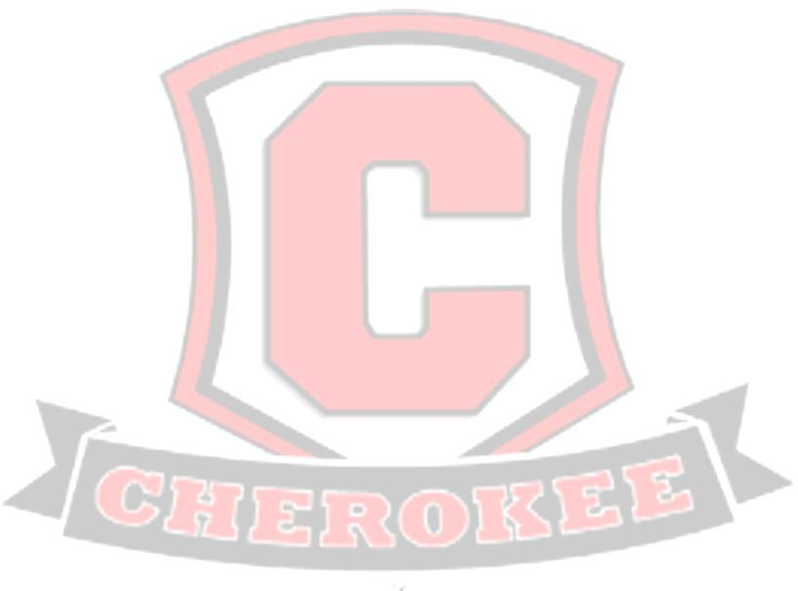
- See that my child is on time and attends school regularly.
- Support the school in its efforts to maintain proper discipline.
- Set a time for homework and review it regularly.
- Teach social skills to promote positive interaction with all stakeholders
- Be responsible for supporting my child’s learning by participating in decisions that relate to their education.
- Return signed report cards/compacts and attend parent conferences and meetings
- Read with my child and let my child see me read
Parent’s Signature
Student Agreement

It is important that I work to be the best of my ability. Therefore, I shall strive to do the following:
- Attend school regularly.
- Come to school with an attitude focused on learning.
- Come to school each day with pencils, notebook paper, or tablets.
- Do assigned classwork and homework.
- Follow the rules of SCS Student Code of Conduct.
- Respect their peers, respect the teachers, and respect themselves.
- Take responsibility for my actions and grades and cooperate with others in all learning environments.
Student’s Signature
Teacher Agreement

It is important that students achieve. Therefore, I shall strive to do the following:
- Have high expectations for all students.
- Provide homework assignments for students that will reinforce high-quality classroom instruction.


- Provide necessary assistance to parents so that they can help with the assignments.
- Use special activities in the classroom to make learning enjoyable.
- Determine the student’s educational needs and adjust instruction to accommodate those needs.
- Provide a “Parent-Friendly, Open-Door” environment.
- Provide on-going communication with parents through weekly progress reports and phone conversations.
Teacher’s Signature
School Responsibility

I support this form of parent engagement. Therefore, I shall strive to do the following:
- Have high expectation and respect for teacher, students, staff, and parents.
- Provide a safe and appealing environment that allows for positive communication between the teacher, parent and student on an ongoing basis.
- Provide teachers with new information, ongoing training and new resources to help supply students with high-quality curriculum and instruction.
- Provide tutorial and other intervention programs to assist children in a timely manner.
- Hold parent/teacher conferences to discuss the school compact.
- Provide high-quality curriculum and instruction in a supportive and effective learning environment.

Provide parents with reasonable access to staff, as well as to volunteer, participate and observe in the child’s class.

Principal’s Signature



Reviewed 2025

