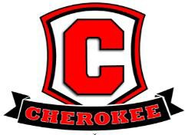
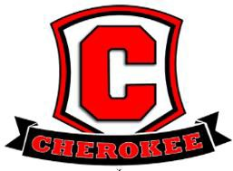

2025-2026
Cherokee Elementary School-Wide Family Engagement Plan

Cherokee Elementary School has established expectations for parent involvement in the educational process. The
administration and faculty believe that Family Engagement is one of the most important links to academic success. We are committed to increasing Family Engagement within our school and the community by providing opportunities for parents to actively participate in the education of their child/children in the following ways:
- Developing jointly with parents, agreeing on with parents, and distributing to parents, a Family/Community Engagement Plan
- Providing opportunities for parents to respond to surveys and questionnaires expressing their ideas and/or concerns to improve the educational process
- Providing interpreter services when necessary
- Encouraging parents to attend school events and use their talent/resources to enhance the instructional program
- Providing parents access to written materials in their native language
- Providing a flexible number of regularly scheduled parent meetings during the morning, afternoon, and evening hours
- Providing descriptions/explanations of curriculum, academic assessments, and student proficiency levels
- Providing training to help parents work with their children to improve their achievement
- The school will use Title I funds to help remove barriers to parent/guardian’s participation in school activities and meetings.

Title I Involvement

The administrators, faculty and parents will jointly develop, review, revise, and implement the Cherokee Elementary
School Improvement Plan, Title I Family Engagement Plan, and School Compact requirements according to the guidelines set forth by law and by Shelby County Schools. To build capacity for involvement with parents and the community, Cherokee Elementary School will:
- Hold an Annual Title I Parent Meeting and other parent meetings, at flexible times and invite all parents to attend
- Invite feedback from parents and respond to parent questions and concerns in a timely manner
- Provide all communications in a format and language that is easily understandable to all parents
- Invite parents to observe Cherokee Elementary School programs and visit classrooms
- Communicate with parents on a regular basis through weekly newsletters, weekly folders, and student progress reports
- Provide scheduled parent-teacher conferences and requested parent-teacher conferences to discuss student progress
- Provide parents and the community with assessment results and overall district and building performance
- Provide parents and community stakeholders a copy of the Cherokee Family/Community/Engagement Plan and a copy of the Shelby County Schools Title I Parent Involvement Policy #7009
- Provide meetings and activities to assist parents in understanding the curriculum, academic assessments, and student proficiency levels
- Provide parents and community stakeholders accessibility of LEA policies and curriculum
- Provide an information board of current events updated website information, and distribute notices and communications in a timely manner to inform parents of school activities and academic programs
- Utilize partnerships with community organizations and adopters to improve student achievement
- Coordinate and integrate activities and programs through PACE (Parent and Community Engagement)

To ensure Cherokee Elementary School parents participate in the school’s programs, we will:

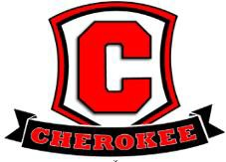
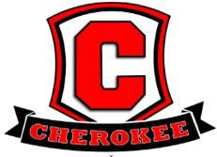
- Provide annual meetings to explain the requirements of Title I, the school’s participation in the Title I program, and parents’ right to be involved
- Provide flexible times for our parents to attend parent meetings during the morning, afternoon and evening
- Offer training and workshops in parenting skills
- Provide opportunities for parents to jointly develop, review, and revise the Cherokee Parent-School Compact, the Cherokee Family/Community Engagement Plan, and the School Improvement Plan
- Provide opportunities for parents to give suggestions and comments about the Cherokee Parent-School Compact, the Cherokee Family/Community Engagement Plan, and the School Improvement Plan and respond to parent comments and suggestions in a timely manner.
- Distribute copies of the Parent-School Compact and the Family/Community Engagement Plan in a timely manner to all students, parents, and community stakeholders and acquire appropriate signatures
- Provide opportunities for parents to be involved in an organized, ongoing, and timely way in the planning and review of school programs
- Provide access to community and support services
- Provide parent meetings to explain the curriculum, assessments, formative assessments and expected student proficiency levels
- Provide parents opportunities for regular meetings for suggestions, decision-making, and responses
- Provide responses to parent suggestions, questions and concerns through newsletters, written and phone communication
- Provide opportunities for parents to participate in professional development available to staff and parents
- Provide ESL parents information on assisting their children in attaining English proficiency and in achieving academic success
- Involve parents in an organized, ongoing, timely way, in planning, and reviewing the Cherokee Family/Community Engagement Plan
- Provide two scheduled parent-teacher conferences during the school year to discuss student progress and to review the School-Compact and Family/Community Engagement Plan
- Provide timely information about parent programs

Reviewed 2025

