Maria L. Varisco-Rogers Charter School, Inc
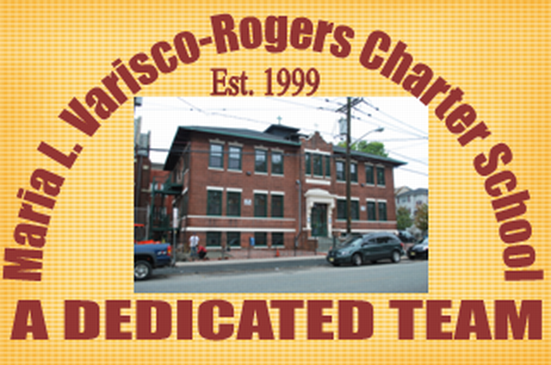
Providing new alternatives for a better education
233 Woodside Avenue
Newark, NJ 07104
Tel: (973) 481-9001 Fax (973) 481-9009
Board of Trustees Meeting Minutes
Wednesday, March 16, 2022
Board Members Present: Ms. Carmen Lebron, Ms. Maria Camacho, Ms. Carmen Baez, Ms. Marta Nieves, Ms. Carmen Vasquez, Ms. Cindy Castillo, Ms. Carmen Perez and Mr. Luis Ulerio
Board Members Not Present: Ms. Migdalia Concepcion, Ms. Rosa Hermida, Mr. Roberto DelRios, and
Ms. Rosa Martinez,
Staff Present: Mrs. Teresa Segarra, Ms. Eneida Perez, Mr. Jose Segarra, and Ms. Gynise Gotto
- The Meeting was called to order at 5:00 pm. The board was reminded that the meeting is held in accordance with the Sunshine Open Public Meeting Act.
- Roll call was taken and quorum was present.
- No one was present for Open Public Comment.
- The minutes from February were presented to the board. Motion to approve Ms. Lebron, seconded Ms. Nieves, and carried unanimously.
- The student report was given by Mr. Luis Ulerio.
- Lead Person/Executive Director Report
  - An update was given on the current status of operation of the school in regards to the pandemic response.
  - An update was given in regards to the completion of WIDA testing for ELL students.
  - An update was given on NJSLA preparation and planning for this year’s test.
  - The board was reminded of their School Ethics submission, to be completed online.
- SBA/Board Secretary Report
  - The financial report for the month of February 2022 was presented to the board. Motion to approve Ms. Lebron, seconded Ms. Nieves, and carried unanimously.
  - The Payroll was presented to the board. Motion to approve Ms. Lebron, seconded Ms. Nieves, and carried unanimously.
  - The proposed 2021-2022 School Budget was presented to the board. Motion to approve by Ms. Perez, seconded by Ms. Lebron, and carried unanimously.
- The board moved to closed session. Motion to approve Ms. Perez, seconded Ms. Nieves, and carried unanimously.
  - An update on the TD Bank incident was presented to the board.
  - An update on NJ Department of Labor was presented to the board.
- Motion to adjourn the meeting at 5:25 pm. Motion to approve Ms. Perez, seconded Ms. Nieves, and carried unanimously.
Resolutions for March
03-22-01 APPROVED
Resolution to approve the monthly financial reports.
03-22-02 APPROVED
Resolution to approve the payrolls.
03-22-03 APPROVED
Resolution to approve FY 23 Budget submission.

