Maria L. Varisco-Rogers Charter School, Inc
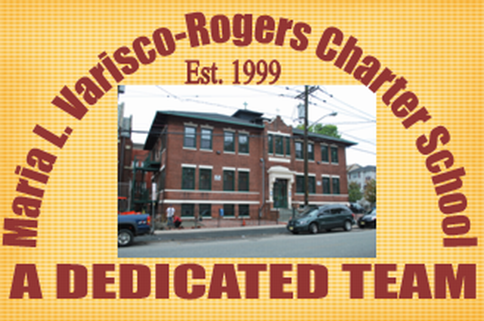
Providing new alternatives for a better education
233 Woodside Avenue
Newark, NJ 07104
Tel: (973) 481-9001 Fax (973) 481-9009
Board of Trustees Meeting Minutes
Wednesday, April 27, 2022
Board Members Present: Ms. Carmen Lebron, Ms. Maria Camacho, Ms. Carmen Baez, Ms. Marta Nieves, Ms. Carmen Vasquez, Ms. Cindy Castillo, Ms. Carmen Perez, Ms. Migdalia Concepcion, Ms. Rosa Hermida and Mr. Luis Ulerio
Board Members Not Present: Ms. Carmen Vasquez, Mr. Roberto DelRios, and Ms. Rosa Martinez,
Staff Present: Mrs. Teresa Segarra, Ms. Eneida Perez, Mr. Jose Segarra, Ms. Jennifer Fumero and Ms. Gynise Gotto
- The Meeting was called to order at 5:05 pm. The board was reminded that the meeting is held in accordance with the Sunshine Open Public Meeting Act.
- Roll call was taken and quorum was present.
- No one was present for Open Public Comment.
- The minutes from March were presented to the board. Motion to approve Ms. Perez, seconded Ms. Hermida, and carried unanimously.
- The student report was given by Mr. Luis Ulerio.
- The Assistant Lead Person presented on the NJ School Performance Report.
- Lead Person/Executive Director Report
  - The board was informed of the school’s plan for a Summer Program to support learning during the Summer months.
  - The board was provided with an update on NJSLA testing and WIDA testing.
  - An update on School Ethics filing was provided. Anyone that had not filed yet was reminded to file in order to meet the April 30th Deadline.
- SBA/Board Secretary Report
  - The financial report for the month of March 2022 was presented to the board. Motion to approve Ms. Hermida, seconded Ms. Nieves, and carried unanimously.
  - The Payroll was presented to the board. Motion to approve Ms. Lebron, seconded Ms. Nieves, and carried unanimously.
  - The board was informed of the school’s continued participation in the Fresh Fruit and Vegetable Program for the 22-23 school year. Motion to approve Ms. Perez, seconded Ms. Hermida and carried unanimously.
  - The board was informed that the finance department amended the ESEA grant to move funds from Title IIA and Tile IVA to Title III to support the ESL Program. The Amendment was approved and funds were transferred to appropriate funding lines. Motion to approve Ms. Lebron, seconded Ms. Nieves, and carried unanimously.
- The board moved to closed session. Motion to approve Ms. Perez, seconded Ms. Hermida, and carried unanimously.
  - An update on the TD Bank incident was presented to the board.
  - An update on NJ Department of Labor was presented to the board.
- Motion to adjourn the meeting at 5:32 pm. Motion to approve Ms. Perez, seconded Ms. Hermida, and carried unanimously.
Resolutions for April
04-22-01 APPROVED
Resolution to approve the monthly financial reports.
04-22-02 APPROVED
Resolution to approve the payrolls.
04-22-03 APPROVED
Resolution to approve participation in the FFVP FY 23
04-22-04 APPROVED
Resolution to approve the transfer of Title IIA and IVA funds to Title III

