Maria L. Varisco-Rogers Charter School, Inc
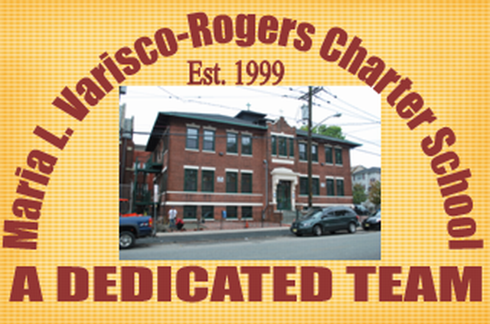
Providing new alternatives for a better education
233 Woodside Avenue
Newark, NJ 07104
Tel: (973) 481-9001 Fax (973) 481-9009
Board of Trustees Meeting Minutes
Wednesday November 17, 2021
Board Members Present: Ms. Carmen Baez, Ms. Carmen Lebron, Ms. Marta Nieves, Ms. Maria Camacho, Ms. Migdalia Concepcion, Ms. Carmen Vasquez, Ms. Carmen Vasquez, Ms. Rosa Martinez and Mr. Luis Ulerio
Board Members Not Present: Ms. Rosa Hermida and Mr. Roberto DelRios
Staff Present: Mrs. Teresa Segarra, Ms. Eneida Perez, Mr. Jose Segarra, and Ms. Gynise Gotto
- The Meeting was called to order at 5:07 pm. The board was reminded that the meeting is held in accordance with the Sunshine Open Public Meeting Act.
- Roll call was taken and quorum was present.
- No one was present for Open Public Comment.
- The minutes from October were presented to the board. Motion to approve Ms. Lebron, seconded Ms. Concepcion, and carried unanimously.
- The student report was given by Mr. Luis Ulerio.
- Lead Person/Executive Director Report
  - An update was given on the current status of school reopening.
  - The Safety Plan statement of assurance was presented. Motion to approve by Ms. Nieves, seconded by Ms. Lebron, and carried unanimously.
  - The Memorandum of Agreement with Local Law Enforcement was presented. Motion to approve by Ms. Lebron, seconded by Ms. Concepcion, and carried unanimously.
  - The revised Nutrition Wellness Policy was presented. Motion to approve Ms. Concepcion, seconded Ms. Lebron, and carried unanimously.
- SBA/Board Secretary Report
  - The financial report for the month of October 2021 was presented to the board. Motion to approve Ms. Concepcion, seconded Ms. Nieves, and carried unanimously.
  - The Payroll for October 2021 was presented to the board. Motion to approve Ms. Martinez, seconded Ms. Lebron, and carried unanimously.
  - The Annual School Fiscal Questionnaire was presented. Motion to approve by Ms. Lebron, seconded by Ms. Vasquez, and carried unanimously.
- The board moved to closed session. Motion to approve Ms. Lebron, seconded Ms. Martinez, and carried unanimously.
  - An update on the TD Bank incident was presented to the board.
  - An update on NJ Department of Labor was presented to the board.
- Motion to adjourn the meeting at 5:30 pm. Motion to adjourn Ms. Lebron, seconded Ms. Nieves, and carried unanimously.

Resolutions for November
11-21-01 APPROVED
Resolution to approve the monthly financial reports.
11-21-02 APPROVED
Resolution to approve the payrolls.
11-21-03 APPROVED
Resolution to approve the Safety Plan SOA.
11-21-04 APPROVED
Resolution to approve the MOU with LLE
11-21-05 APPROVED
Resolution to approve the Revised Nutrition policy.
11-21-06 APPROVED
Resolution to approve the fiscal questionnaire
Closed session approval for 11-21-07 and 11-21-08

