Maria L. Varisco-Rogers Charter School, Inc
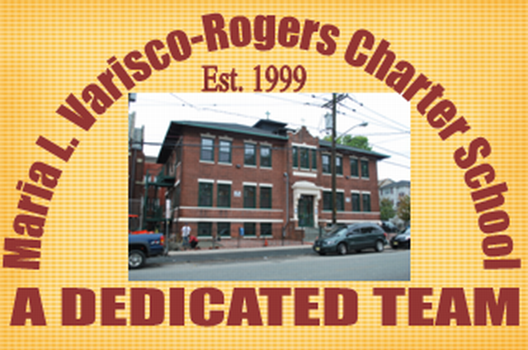
Providing new alternatives for a better education
233 Woodside Avenue
Newark, NJ 07104
Tel: (973) 481-9001 Fax (973) 481-9009
Board of Trustees Meeting Minutes
Wednesday, January 19, 2022
Board Members Present: Ms. Carmen Lebron, Ms. Maria Camacho, Ms. Migdalia Concepcion, Ms. Cindy Castillo, Ms. Carmen Baez, Mr. Luis Ulerio, Ms. Rosa Martinez and Mr. Roberto DelRios
Board Members Not Present: Ms. Carmen Perez, Ms. Carmen Vasquez, Ms. Marta Nieves, Ms. Rosa Hermida
Staff Present: Mrs. Teresa Segarra, Ms. Eneida Perez, Mr. Jose Segarra, Ms. Jennifer Fumero and Ms. Gynise Gotto
Guest: Mr. Brian Ko, Nisivoccia, LLC.
- The Meeting was called to order at 5:10 pm. The board was reminded that the meeting is held in accordance with the Sunshine Open Public Meeting Act.
- Roll call was taken and quorum was present.
- No one was present for Open Public Comment.
- The minutes from December were presented to the board. Motion to approve Ms. Lebron, seconded Ms. Concepcion, and carried unanimously.
- The student report was given by Mr. Luis Ulerio.
- The Auditor, Brian Ko of Nisivoccia, LLC, was present to present the CAFR and AMR report.
- The Assistant Lead Person was presented by Ms. Jennifer Fumero.
  - Ms. Fumero presented the data from the Fall 2021 NJ Start Strong Assessment to the board.
  - Ms. Fumero conducted the 2022-2023 student lottery live via SchoolMint. Motion to approve by Ms. Martinez, seconded by Ms. Concepcion, and carried unanimously.
- Lead Person/Executive Director Report
  - An update was given on the current status of operation of the school in regards to the pandemic response.
  - The Statement of Assurance for the School Safety Checklist was presented to the board. Motion to approve by Ms. Lebron, seconded by Ms. Camacho, and carried unanimously.
- SBA/Board Secretary Report
  - The financial report for the month of December 2021 was presented to the board. Motion to approve Ms. Concepcion, seconded Ms. Lebron, and carried unanimously.
  - The Payroll was presented to the board. Motion to approve Ms. Concepcion, seconded Ms. Lebron, and carried unanimously.
  - The auditor report and corrective action plan were presented to the board. Motion to approve Mr. DelRios, seconded Ms. Lebron, and carried unanimously.
- The board moved to closed session. Motion to approve Ms. Concepcion, seconded Ms. Lebron, and carried unanimously.
  - An update on the TD Bank incident was presented to the board.
  - An update on NJ Department of Labor was presented to the board.
- Motion to adjourn the meeting at 5:45 pm. Motion to adjourn Ms. Lebron, seconded Ms. Concepcion, and carried unanimously.
Resolutions for January
01-22-01 APPROVED
Resolution to approve the monthly financial reports.
01-22-02 APPROVED
Resolution to approve the payrolls.
01-22-03 APPROVED
Resolution to approve the School Enrollment Lottery.
01-22-04 APPROVED
Resolution to approve the School Safety Checklist Statement of Assurance
01-22-05 APPROVED
Resolution to approve the auditor report and corrective action plan.

