Maria L. Varisco-Rogers Charter School, Inc
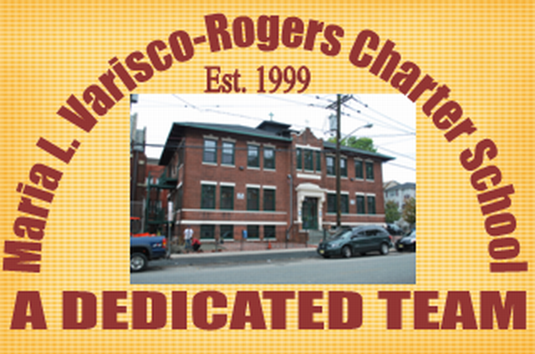
Providing new alternatives for a better education
233 Woodside Avenue
Newark, NJ 07104
Tel: (973) 481-9001 Fax (973) 481-9009
Board of Trustees Meeting Minutes
Wednesday, December 15, 2021
Board Members Present: Ms. Carmen Lebron, Ms. Rosa Hermida, Ms. Maria Camacho, Ms. Migdalia Concepcion, Ms. Cindy Castillo, and Ms. Carmen Perez
Board Members Not Present: Ms. Carmen Baez, Ms. Carmen Vasquez, Ms. Marta Nieves, Ms. Rosa Martinez, Mr. Luis Ulerio and Mr. Roberto DelRios
Staff Present: Mrs. Teresa Segarra, Ms. Eneida Perez, Mr. Jose Segarra, and Ms. Gynise Gotto
- The Meeting was called to order at 5:10 pm. The board was reminded that the meeting is held in accordance with the Sunshine Open Public Meeting Act.
- Roll call was taken and quorum was present.
- No one was present for Open Public Comment.
- The minutes from November were presented to the board. Motion to approve Ms. Hermida, seconded Ms. Concepcion, and carried unanimously.
- The student report was not given. Mr. Luis Ulerio was excused.
- Lead Person/Executive Director Report
  - An update was given on the current status of operation of the school in regards to the pandemic response.
  - An update was provided on the school’s virtual winter concert and how to view the concert online.
  - The school safety checklist was presented to the board. Motion to approve by Ms. Concepcion, seconded by Ms. Hermida, and carried unanimously.
  - The updated mentor plan was presented to the board. Motion to approve by Ms. Lebron, seconded by Ms. Hermida, and carried unanimously.
  - The New Board Member, Ms. Carmen Perez, was presented to the board. Motion to approve Ms. Castillo, seconded by Ms. Hermida, and carried unanimously.
- SBA/Board Secretary Report
  - The financial report for the month of November 2021 was presented to the board. Motion to approve Ms. Concepcion, seconded Ms. Lebron, and carried unanimously.
  - The Payroll was presented to the board. Motion to approve Ms. Concepcion, seconded Ms. Lebron, and carried unanimously.
  - The Title Change for Mr. Brown was presented to the board. Motion to approve by Ms. Castillo, seconded by Ms. Lebron, and carried unanimously.
- The board moved to closed session. Motion to approve Ms. Concepcion, seconded Ms. Perez, and carried unanimously.
  - An update on the TD Bank incident was presented to the board.
  - An update on NJ Department of Labor was presented to the board.
- Motion to adjourn the meeting at 5:30 pm. Motion to adjourn Ms. Lebron, seconded Ms. Concepcion, and carried unanimously.
Resolutions for December
12-21-01 APPROVED
Resolution to approve the monthly financial reports.
12-21-02 APPROVED
Resolution to approve the payrolls.
12-21-03 APPROVED
Resolution to approve the School Safety Checklist.
12-21-04 APPROVED
Resolution to approve the Mentor Plan
12-21-05 APPROVED
Resolution to approve the New Board Member.
12-21-06 APPROVED
Resolution to approve the Title Change: Mr. Brown.

