Maria L. Varisco-Rogers Charter School, Inc
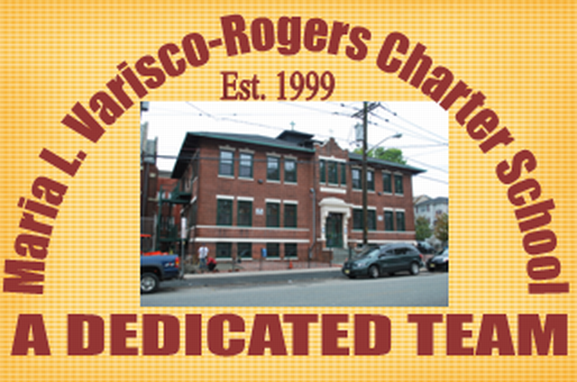
Providing new alternatives for a better education
233 Woodside Avenue
Newark, NJ 07104
Tel: (973) 481-9001 Fax (973) 481-9009
Board of Trustees General Meeting Minutes
Wednesday, September 21st, 2022
Board Members Present: Ms. Carmen Baez, Ms. Carmen Lebron, Ms. Maria Camacho, Ms. Carmen Baez, Ms. Marta Nieves, Ms. Carmen Perez, Ms. Carmen Vasquez, and Ms. Ana Cecilia Cordero Conde
Board Members Not Present: Ms. Migdalia Concepcion, Ms. Cindy Castillo, Mr. Roberto DelRios, and Ms. Rosa Martinez
Staff Present: Mrs. Teresa Segarra, Ms. Eneida Perez, Mr. Jose Segarra, Ms. Jennifer Fumero and Ms. Gynise Gotto
Visitors Present: Mr. Vincent Cozzarelli
- The Meeting was called to order at 5:00pm. The board was reminded that the meeting is held in accordance with the Sunshine Open Public Meeting Act.
- Roll call was taken and quorum was present.
- The student report was presented by Mr. Luis Ulerio.
- The Assistant Lead Person provided the NJSLA and WIDA data reports.
- Lead Person/Executive Director Report
  - The acceptance of resignation of board members Ms. Cindy Castillo and Ms. Rosa Martinez were presented to the board. Motion to approve Ms. Lebron, seconded by Ms. Nieves, and carried unanimously.
  - The acceptance of new board member, Mr. Vincent Cozzarelli, was presented to the board. Motion to approve by Ms. Lebron, seconded by Ms. Perez, and carried unanimously.
  - An update on school opening and operations was provided.
  - The board was informed of the Charter Renewal process and date of visit, October 24, 2022.
  - The 2022-2023 Grievance Committee was presented to the board. Motion to approve by Ms. Perez, seconded by Ms. Nieves, and carried unanimously.
  - The Chapter 27: Emergency Virtual and Remote Instruction Plan was presented to the board. Motion to approve by Ms. Lebron, seconded by Ms. Nieves, and carried unanimously.
- SBA/Board Secretary Report
  - The Financial Reports for June, July, and August were presented to the board. Motion to approve by Ms. Nieves, seconded by Ms. Perez, and carried unanimously.
  - The payroll was presented to the board. Motion to approve by Ms. Perez, seconded by Ms. Nieves, and carried unanimously.
  - The contract with Dr. Hanes for the 2022-2023 school year was presented to the board. Motion to approve by Ms. Lebron, seconded by Ms. Nieves, and carried unanimously.
  - The board was informed that the consultant would be starting full-time as of October 17, 2022.
- The board moved to closed session. Motion to approve Ms. Perez, seconded Ms. Lebron, and carried unanimously.
  - An update on the TD Bank incident was presented to the board.
  - An update on NJ Department of Labor was presented to the board.
- Motion to adjourn the meeting at 5:43 pm. Motion to approve Ms. Perez, seconded Ms. Lebron, and
carried unanimously.

Resolutions for September
09-22-01 APPROVED
Resolution to approve the financial reports.
09-22-02 APPROVED
Resolution to approve the payroll.
09-22-03 APPROVED
Resolution to approve the acceptance of resignation- Cindy Castillo.
09-22-04 APPROVED
Resolution to approve the acceptance of resignation-Rosa Martinez.
09-22-05 APPROVED
Resolution to approve the new board member, Vincent Cozzarelli.
09-22-06 APPROVED
Resolution to approve the Grievance Committee.
09-22-07 APPROVED
Resolution to approve Chapter 27 Emergency Virtual and Remote Instruction Plan.
09-22-08 APPROVED
Resolution to approve the contract with Dr Hanes.
09-22-09 APPROVED
Resolution to approve the contract with Therapy Source.

