CCS 1/1/2024-12/31/2024
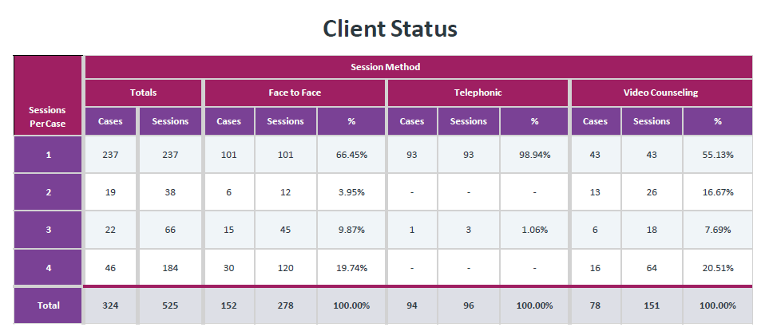

- CIRS Hours: 6 hours
- Training Hours: 6 hours
- Manager Support Hours: 5 hours

CCS 1/1/2025-6/30/2025
- CIRS Hours: 7.3 hours
- Manager Support Hours: 25.3
- In-Person Session: 32%
- Average In-Person Sessions per case: 2.8
- Virtual Sessions: 68%
- Average Video Sessions per case: 2.5
