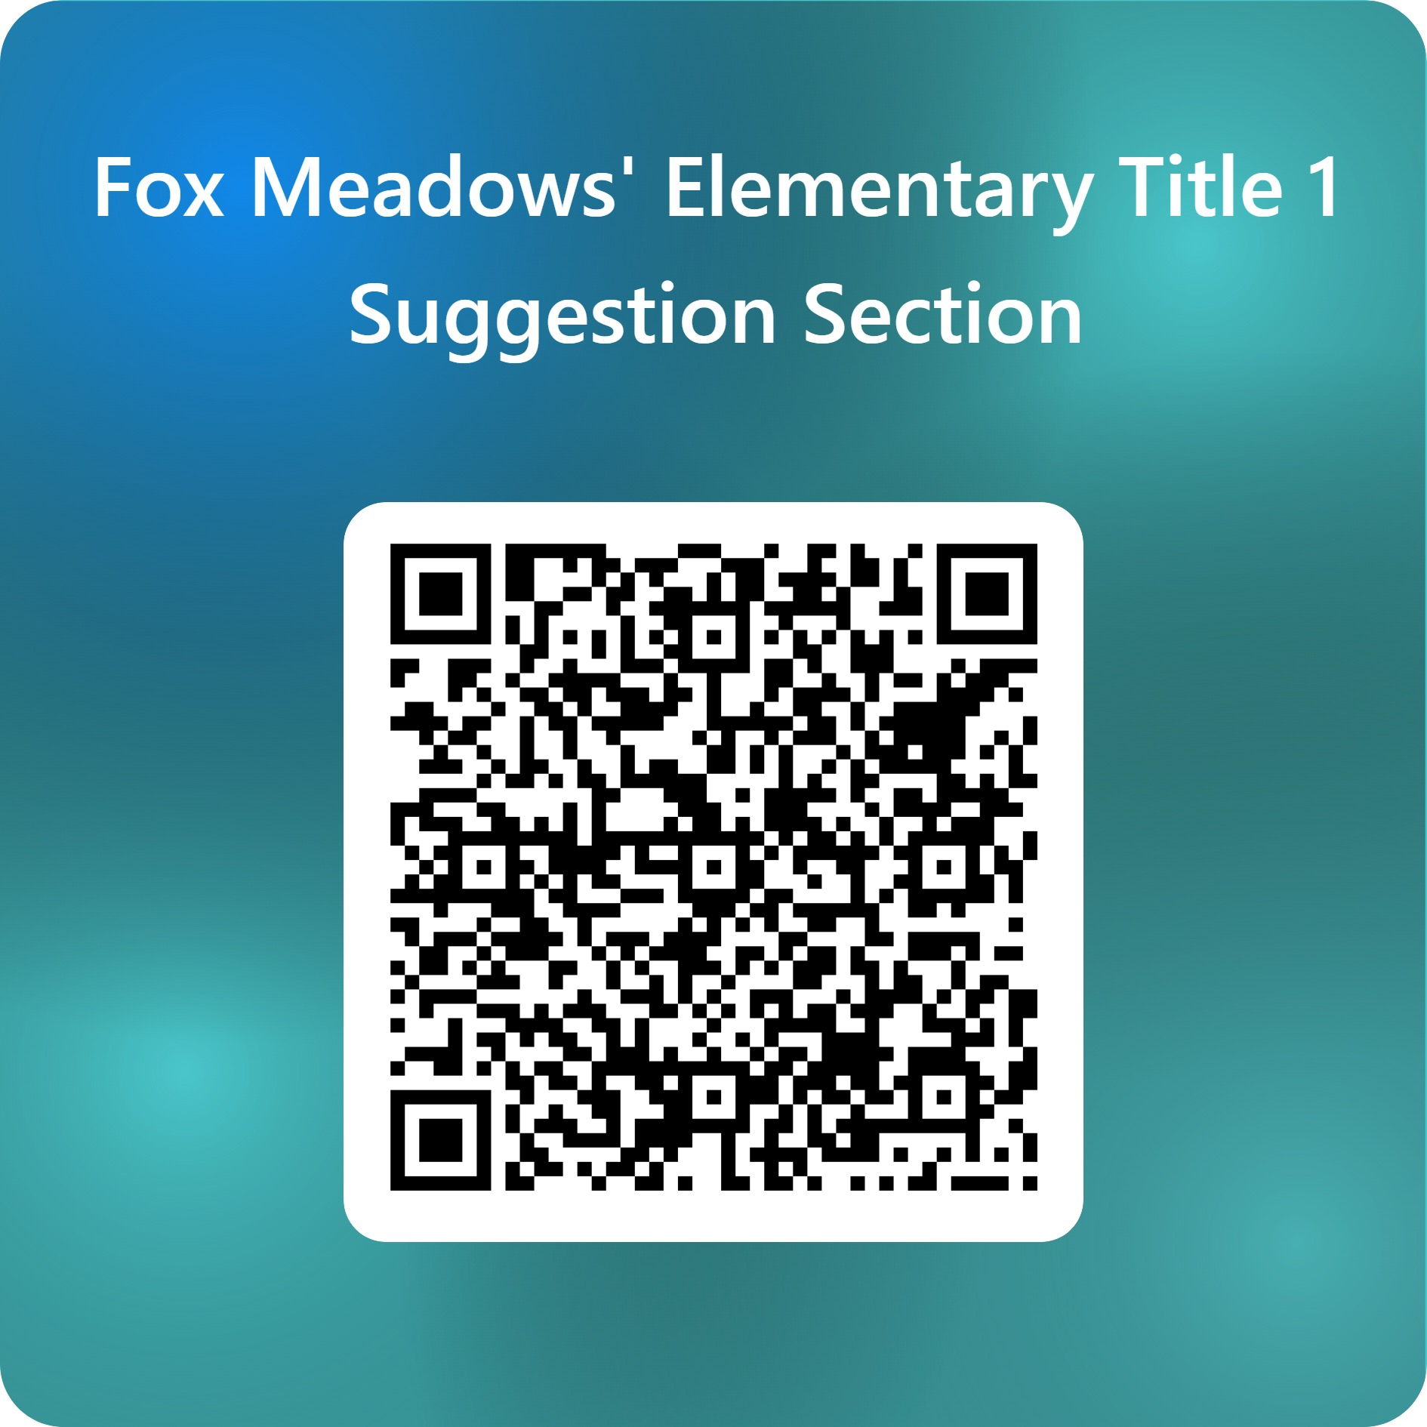

Fox Meadows’ Elementary Title 1 Suggestion Section –
Fill out form

