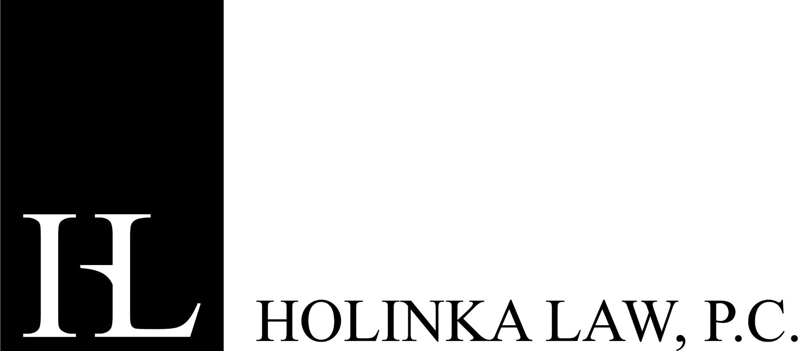
P.O. Box 190164, Boise, ID 83719 ♦ (208) 572-3355 ♦ jsh@holinkalaw.com

MEMORANDUM
TO: Idaho School Districts
FROM: Holinka Law, P.C.
DATE: December 19, 2025
RE: Fourth Quarter 2025 Model Policy Updates

Attached, please find model policy updates for the third quarter of 2025. The included policies and forms are intended to reflect and be consistent with current Idaho and federal law as of the date of this memorandum.

In an effort to assist your district or charter school with implementing these policies, I would like to invite you to attend a live virtual meeting detailing the policy changes in this round of updates. The live virtual meeting will be held on Thursday, January 15, 2026 at 11:00 am MOUNTAIN TIME. Please plan to review this memorandum and the policies prior to meeting, if possible. Here is how you can join the meeting:

Fourth Quarter 2025 Model Policy Updates
Jan 15, 2026, 11:00 AM – 12:00 PM (America/Denver)
Please join my meeting from your computer, tablet or smartphone.
https://meet.goto.com/602649293
You can also dial in using your phone.
Access Code: 602-649-293
United States: +1 (571) 317-3122
Get the app now and be ready when your first meeting starts:
https://meet.goto.com/install
Each policy provided in this update set is identified below by number with a short descriptor identifying why the policy was developed or amended, or why it should be deleted. In addition to a clean Word version of each policy, a redlined version of each of the updated policies is included in Word format so you and your staff can more easily identify the changes that have been made and modify the policy as appropriate. Note: There is no redline version for NEW policies or forms.

Each policy below is accompanied with ***, **, or *:

*** Indicates a policy that requires immediate board attention
** Indicates a policy that should be adopted by the board, but does not necessarily require immediate attention
* Indicates a policy that is optional or has only minor changes

The following policies were updated to reflect minor clarifications and/or updates to legal references:

SECTION 500: STUDENTS

**502 – Student Handbooks. We have added some optional language to this policy, as well as language from Idaho Code §33-512 relating to requirements to make discipline policies available at the beginning of each school year. We also included a cross-reference to policy 540 (maintenance of orderly conduct).

**549 – Prohibition of Gang Activities. We are updating this policy to provide additional and more specific prohibited conduct, definitions, and prevention/education. Specifically, using the definition of “criminal gang” in Idaho law as a guide, we are defining a “gang” as a group of three or more persons that have a common name or common identifying sign or symbol, and associate or conspire together to advocate, conspire, or commit criminal acts or other acts, though not criminal, threaten the safety or well-being of persons or property. We also specifically refer to the definition of criminal gang in Idaho law, which specifies additional types of crimes which would constitute a “pattern of criminal gang activity” under Idaho law. We have set forth additional prohibited conduct. We have also included a new section on prevention and education, which includes staff training to recognize early warning signs of gang involvement or affiliation, partnerships, and family notification. Such prevention and education is recommended by the National Gang Center in its Gangs in Schools guide, which can be accessed here: Gangs in Schools.

**559 – Food Allergies. We are updating this policy to add some optional language that more broadly identifies a food allergy management program which includes education, prevention, awareness, communication and emergency response. We are also adding optional language identifying that among the protocols schools can utilize to assist students with food allergies are individual written allergy management plans and emergency response plans. Other optional language is added relating to allergen exposure and staff training. We also updated the policy reference in the section, “Administering Epinephrine,” as the epinephrine auto-injector policy was incorporated into policy 561 since this policy was last updated. We also included cross-references to other policies.

SECTION 800: BUSINESS PROCEDURES

**814 – Budget Implementation and Execution (changed from Monthly Budget and Treasurer’s Report). We have updated this optional policy to more broadly refer to budget implementation and execution once the budget is adopted by the board of trustees. The change in title reflects this change. We also updated the legal references and added a cross-reference to policy 810 (budget planning and adoption).

***818 – School District Tax-Exempt Status. This NEW policy is intended to affirm school districts’ status as tax-exempt entities. We heard from at least one school district who had been informed by the State Department that this policy is necessary. The policy follows the provisions of state and federal law identifying school districts as tax-exempt entities. We have identified the business office as responsible for maintaining a district’s tax-exempt certificates and provided copies thereof upon request; however, this could be another person or department depending on the structure of your district’s organization. The policy also includes obligations of district employees to ensure that they comply with purchasing procedures so that unnecessary tax charges and/or financial loss do not occur. Employees that fail to comply with purchasing procedures that result in tax charges or financial loss may be subject to disciplinary action and may be held personally liable for unapproved tax expenses.

**832 – Revenues (changed from Income from Sale or Use of School Property). We have updated this policy to more broadly describe sources of revenue and how those funds will be accounted for. The change in the policy title reflects the broader scope of the policy. We have included a reference to gifts, grants and bequests as forms of revenue that may be accepted by the district under the terms of policy 830 (gifts, grants, and bequests). We have updated the legal reference and added a cross-reference to policy 830.

**834 – Fees (changed from Increase in Fees). The name of this policy is modified to reflect that it applies to both new fees and increases in fees. We have included a statement from Idaho Code §63-1311 that requires all fees to be reasonably related to, but not exceeding, the actual cost of the service being provided. Since the definition of newspaper as set forth in Idaho Code §60-106 has additional components that would be too lengthy to set forth in the policy, we are simply referring to that definition within the policy. We have also clarified that public notice is required for all new fees, as well as any fee increase over 5% of the fee last collected. We have also clarified that the notice should include a short description of the reasons for the proposed new fee or fee increase. Finally, we updated the legal references.

*857.50 – Contracted Educational Services. We have made minor updates to this policy, including a clarification to the statement that contracted service providers are not employees. We have also updated the legal references.

SECTION 1000: COMMUNITY RELATIONS

***1012F1 – Patron Complaint Form. This NEW, OPTIONAL form is a companion to policy 1012 (patron complaints). Like other complaint forms, the form is intended to allow the patron to provide information regarding their complaint, as well as for the district to include information about the steps taken to respond to the complaint. The form notes that other policies and procedures may apply (e.g., those relating to civil rights, Title IX, or library resources).

**1056 – Web Accessibility. This policy is being updated to align with the new federal regulations on web accessibility released in April 2024. The new rule has an implementation date of April 26, 2027 for states and local governments, including school districts. Thus, school districts must be compliant with the new standards by that date. The new rule provides that the Web Content Accessibility Guidelines (WCAG) 2.1, Level AA is the technical standard web content must meet. “Web content” includes the information and experiences available on the web, like text, images, sound, video, and documents. The rule also applies to mobile applications the district provides or makes available. There are several exceptions to the requirement to use WCAG 2.1 Level AA, which are included in the updated policy. The fact sheet on the new rule can be found here: Fact Sheet: New Rule on the Accessibility of Web Content and Mobile Apps Provided by State and Local Governments | ADA.gov. The fact sheet provides examples regarding when an exception might apply and when it might not. It also provides other helpful information and links to the final official rule.

