 | CHILD CARE  North Point Early Childhood Training Program |  |  |  |  |  | Contact our director:  Lisa Willett  lwillett@ccboe.com
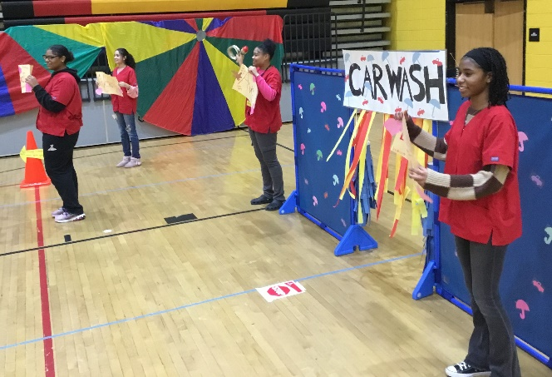
North Point Child Care  This developmentally appropriate childcare program offers a healthy and joyful environment where children learn and grow through play. Daily activities are intentionally planned to support both individual development and group learning.  The program is staffed by trained early childhood professionals as well as students from the Child Development Professions (CDP) CTE Program at North Point High School. Through this program, high school students gain real-world experience working with young children under professional supervision.  All staff members—including teachers and high school students—meet the licensing requirements set by CCPS and the Maryland State Department of Education’s Office of Child Care.   |  |  |  |   
 |  |  |  | High school students in the Child Development Professions CTE Program plan and implement lessons with the children (ages 2-5) in our childcare.
 |  |  |  | Our Philosophy How Do I Apply?
 |  |  |  | We believe that children develop best when school and parents work together with the child’s best interest as the primary goal.  We believe that a center should be a very warm, loving, happy place with cheerful and positive attitudes.  We believe that children need years of play with real objects and events before understanding symbols.  We believe that children should have many opportunities daily to develop social skills such as helping, cooperating, negotiating, and talking with others.  We believe that outdoor experiences should be provided for all children.  We believe that good discipline or guidance is a learning experience for children. |  | Complete a  Contact Information Form  You can obtain a form by:  - Click HERE  - Picking up a copy in the Main Office at North Point High School.  - Emailing the director to request a copy of the form.  How Do I Get More Information?  Contact the director, Lisa Willett: lwillett@ccboe.com  *Tours must be scheduled*
North Point Early Childhood
Training Progam
“Home of the Little Eagles”

Hours of Operation  Child Care runs each school year,  August-June.  Monday-Friday:  6:30 a.m. – 5:00 p.m.  The Child Care follows the Charles County Public School calendar for holiday closures. Child Care is closed for staff development days planned by Child Care staff. |  |  | Eligibility  - Children ages 2–5 years old  - CCPS employees only  - Program capacity: 40 children  - Enrollment is secured with a $100 holding fee  Tuition (paid bi-weekly)  - 2-Year-Olds: $195 per week  - 3-Year-Olds: $185 per week  Holding Fee  - $100 (required to reserve a spot) |  | Location  North Point High School  2500 Davis Road  Waldorf, MD 20603  301-753-1759 ext. 159113  

