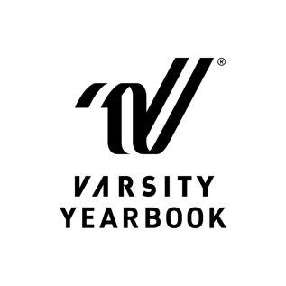
PRESS RELEASE
Natasha Akery
843-746-1300
natasha_akery@charlestoncountyschools.gov

Academic Magnet High School Selected for Inclusion in Varsity Yearbook's Portfolio Volume 31
North Charleston, SC — February 18, 2026— Academic Magnet High School proudly announces that its yearbook has been selected for inclusion in Varsity Yearbook’s distinguished Portfolio, a national showcase recognizing the most outstanding yearbooks produced by Varsity Yearbook.
This achievement places Academic Magnet High School among only 686 schools featured in this year’s edition, selected from more than 900 submissions reviewed with great care. From that impressive group, just 62 yearbooks earned a place in the highly coveted Anthology section, honoring the very finest in scholastic journalism, innovative design and compelling storytelling.
“I’m thrilled to have our yearbook cover featured in this year’s portfolio. It was a great experience for our students to work with a graphic designer to bring our vision to life,” Natasha Akery, Yearbook Advisor of Academic Magnet High School said.
Portfolio recognizes yearbooks that demonstrate sustained excellence in writing and visual presentation, comprehensive and meaningful coverage and exceptional photography. As a collection of the top books printed by Varsity Yearbook, Portfolio celebrates the dedication, creativity and teamwork that define each staff’s work.
“We’re proud to present Portfolio, a showcase of the most exceptional work in journalism and design,” Doug McWilliams, executive vice president of Varsity Yearbook, said. “This collection represents the very best in the nation, and we are honored to highlight the talent and creativity of these remarkable students.”
For more information about Academic Magnet High School’s recognition in Varsity Yearbook’s Portfolio, please contact Natasha Akery at natasha_akery@charlestoncountyschools.gov.

About Varsity Yearbook:
Varsity Yearbook, a division of Varsity Spirit, is committed to helping schools create yearbooks that are not only high-quality and meaningful but also reflect the heart of the student experience. Through innovative tools, top-tier training and dedicated support, Varsity Yearbook empowers schools to celebrate their stories and preserve their memories with pride. For more information about Varsity Yearbook, visit varsity.com/yearbook.

