Washington Families,
It is state testing season! 3rd through 6th Grade students will start testing the week after Spring Break, March 23rd -28th. Testing will resume after Spring Break. The state test that we take is called the Wisconsin Forward Exam. The Forward Exam is a high quality, research-based, customized assessment that meets Wisconsin’s expectations. By working together, we can make your child’s test experience positive and successful. Here are suggestions to help your child succeed:

- Make sure your child gets a good night’s rest.
- Have your child eat a healthy breakfast at home or in the cafeteria at school.
- Make sure your child arrives at school on time.
- Gently encourage your child to do their best.

Your child’s teacher will be sending home a more detailed schedule on exact testing times to help avoid any scheduling conflicts. Students will be testing in their classrooms and utilizing their individual iPad.

Thank you for your help!

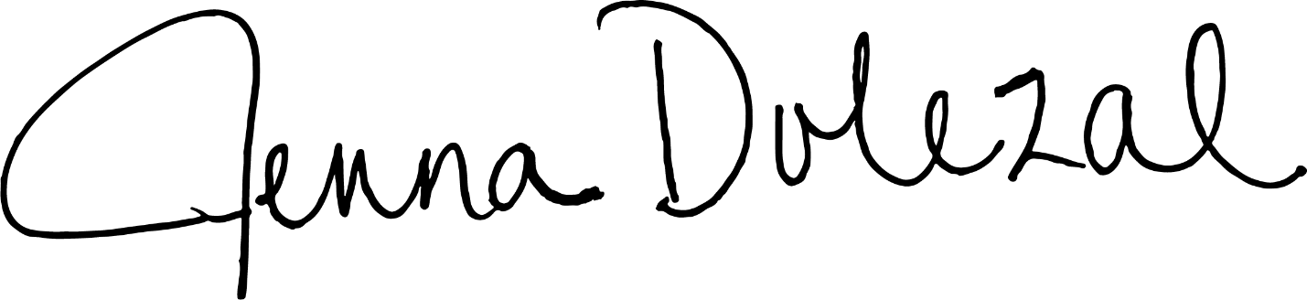

Mrs. Dolezal

