YOUR LAST EMAIL WILL LOOK LIKE THIS:
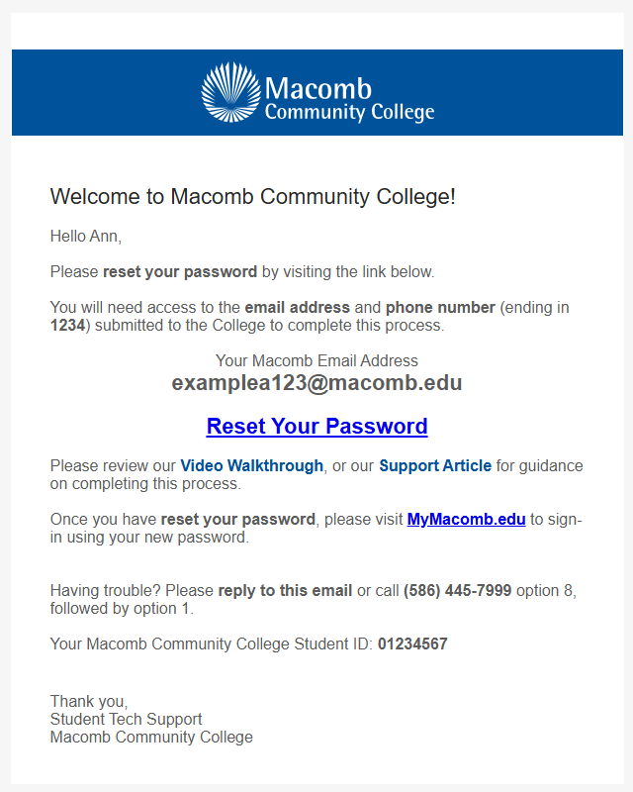
AFTER YOUR MY MACOMB STUDENT PORTAL IS CREATED YOU CAN REGISTER FOR COURSES:
Log into your “My Macomb Student Portal ” and click on “SELF SERVICE” at the top of the page
then follow the directions below:
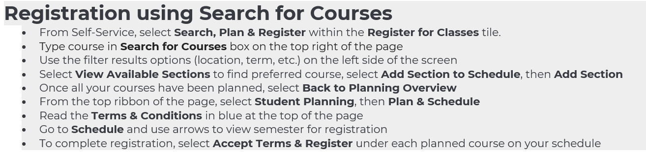
Here is a link with an instructional video that may be helpful: https://macomb.hosted.panopto.com/Panopto/Pages/Viewer.aspx?id=f30f3181-8e90-4673-a251-b2aa00f0964d

