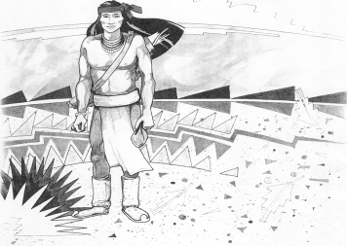
Cochise School District No. 26

5025 N. Bowie Ave.
P.O. Box 1088
Cochise, AZ 85606

(520) 384-2540 (520) 384-4836 Fax
Karl Uterhardt, Superintendent

NOTICE & AGENDA OF GOVERNING BOARD MEETING
COCHISE ELEMENTARY SCHOOL DISTRICT NO. 26

Notice is hereby given that the School District Governing Board will hold a public meeting on
February 4, 2026, at 6:00pm in the Cochise Elementary School Library.
The agenda for the meeting is as follows:

I. Call to Order Time _________

- Pledge of Allegiance to the Flag

- Adoption of Agenda Motion ____/____Vote____

- Call to the Audience (3 minute limit)

- The Governing Board may vote to go into Executive Session under A.R.S. 38-431.03 (A)(3) to receive legal advice either in person or telephonically, on any item on the Consent or Action agenda.

VI. Consent Agenda
- Approve minutes of Regular Meeting of January 7, 2026
- Approve fund balances report for January 2026
- Approve policy advisories 906-916; First Reading (Omit 911 & 916)
- Approve ESS procedural manual
- Approve vouchers #14-16 (Payroll) & #2614-2616 (Expense)
- Approve letter of bid refusal for financial audit Motion ____/____Vote____

- Action Agenda
- Mr. Chris Ochoa discussion with the Board Discussion Only
- Approve Mr. Gus Morales employment to part time Motion____/____ Vote____
- Approve Mr. Chris Ochoa to full time employment for maintenance/transportation Motion____/____ Vote____
- Approve old lawnmower bid Motion____/____ Vote____
- Approve Certified Salary Schedule SY2026-2027 Motion____/____ Vote____
- Approve District Calendar for SY2026-2027 Motion____/____ Vote____
- Approve policy advisory 808 under emergency provision in BGB policy review Motion____/____ Vote____
- Approve FY2025 Audit Bid Motion____/____ Vote____

VIII. Summary of reports about current events
A. Superintendent’s Report
1. February calendar of events: BB game Feb. 6, BB game away Feb 12, No School Feb. 16, BB tournaments Feb. 20 girls, Feb. 21 boys
2. Next Board meetings: March 4, April 1, May 6
B. Governing Board member’s report

IX. Adjourn Motion ____/____Vote____ Time ____

