DHS Registration Resources for 2026-2027
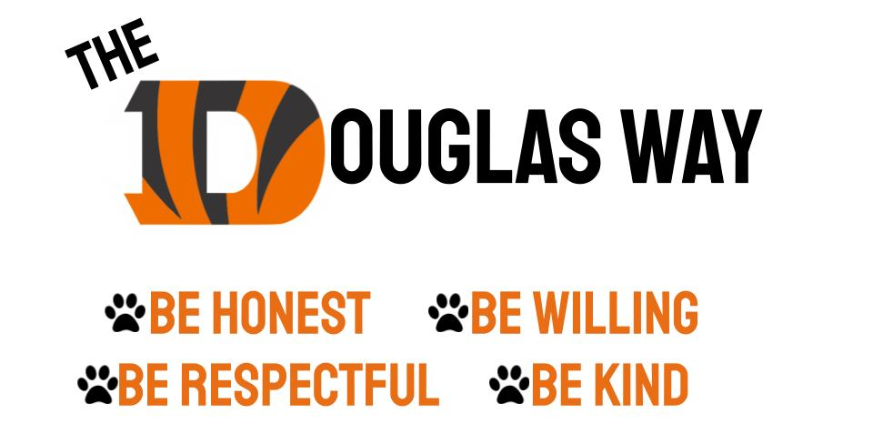

Registration Timeline

26-27 DHS Course List
26-27 DHS Course Catalog

Class of 2030 Presentation
Class of 2030 Course Selection Form
Feb 4th 8th grade parent night flyer
Class of 2029 Presentation
Class of 2028 Presentation
Class of 2027 Presentation

Career and Technical Education (CTE) Info & Videos
Physical Education Video
World Language Video

Mrs. Reymer: Last name A-Di
https://mreymer.youcanbook.me/
Ms. Mossholder: Last name Do-K
https://roxannmossholder.youcanbook.me/
Ms. Brown: Last name L-Ra
https://kirabrown.youcanbook.me/
Ms. Flores: Last name Re-Z
https://efloresa.youcanbook.me/

