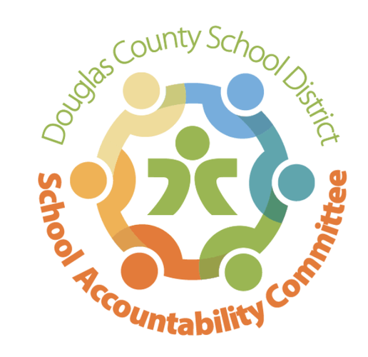
2025-2026
Ranch View Middle School
School Accountability Committee (SAC)

Agenda for meeting on:
Date: 1/26/26
Time: 4:15-5:15
Location: RVMS Library

Meeting Logistics: Erin Turley (3 minutes)
- Introductions & Quorum
- Prior Meeting Minutes approved 11/21/25 and posted to RVMS website

Celebrations & School-Wide Past Happenings: Erin Kyllo (10 minutes)
- Winter Play “Never Eat a Talking Lobster” (11/14 & 11/15)
- Turkey Trot (11/21)
- Pod War monthly update
- Spelling Bee (1/22)
- Passport to Excellence, SAC represented w/info table (1/15 incoming 6th graders & 1/22 incoming 7th graders)
- 6th Grade Registration Elementary School Visits

New Business: Erin Kyllo (40 minutes)
- Updates on the upcoming 2026/2027 School Year
  - Enrollment Numbers: 1100
  - Coffee Talk for incoming families: 2/5 4:00-5:00
  - School Tours (1/30 1:45-2:45, 2/12 7:45-8:45)
  - Mid Year iReady data

- School-wide Happenings:
  - Parent-Teacher Conferences: 2/10
  - Possible Valentine’s Day Dance (2/12)
  - 2nd Annual RVMS Career Day: 2/27
  - Grizzly Gives Week: March 2-6
    - T-shirt sale & donation link
    - Stop the Clock
    - Penny Wars
    - Theme Days/Spirit Week
  - Spring Musical: March 5-7
  - Choir Concert: 3/10 at TRHS
  - Orchestra Concert: 3/11 at TRHS
  - Band Concert: 3/12 at TRHS
  - Last day of 3rd Quarter: 3/13
  - Spring Break: March 16-20
  - CMAS Testing: April 6-21

Standing Reports: (20 minutes)
- Teacher Report: Craig Moody
- DAC (District Accountability Committee): Chris Michael
- PIT Crew (Parent Teacher Organization) Report: Alicia Stemmerman
  - Staff Appreciation: Carmel Apple Bar, Cookie Extravaganza, Stay Well Gift Bags, coordinated Gift Crowd, stocked Recharge Room twice
  - Upcoming Staff Appreciation: Parent Teacher Conference Dinner (2/10), Opening Day Lunch (3/26), Tom’s Coffee Truck (4/15), Staff Appreciation Week (in May)
  - Upcoming Mtgs/Events: Meetings (3/6 10:00AM & mtg April includes nominations for new board members). EOY Event/Volunteer Appreciation at Max Taps date TBA
- Community Report: Dan Gomer
- Principal’s Wrap-Up: Erin Kyllo

Open forum for guests: Chair (5 minutes), Community Members (3 min. max)

Next SAC Meeting: May 11th @ 4:15 in the RVMS Library

