BAYVALE ELEMENTARY SCHOOL
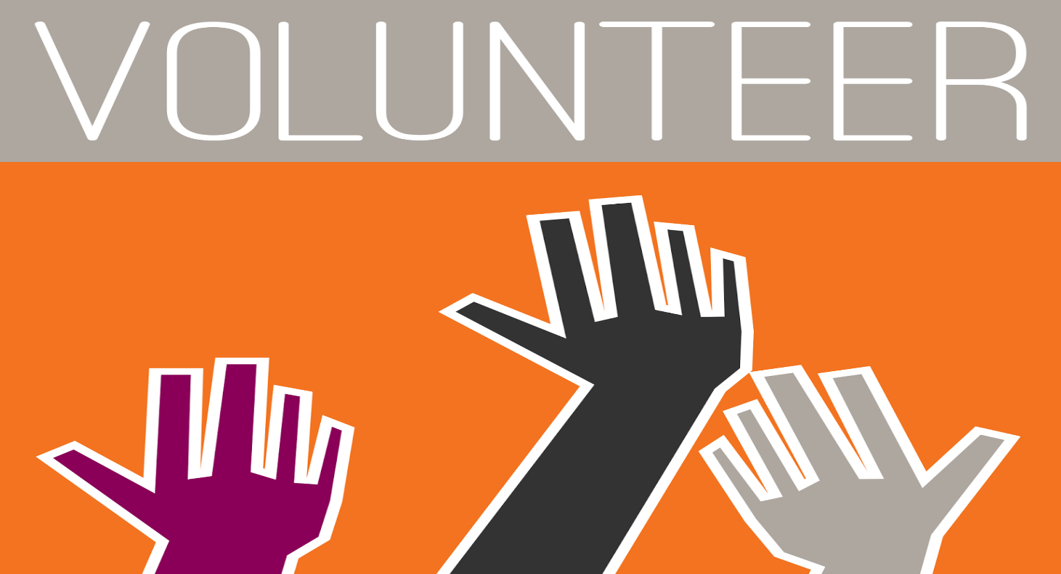
This Photo by Unknown Author is licensed under CC BY-NC-ND

VOLUNTEER TRAINING CLASSES
Tuesday & Wednesday
9:00 a.m. – 11:00 a.m.
1:00 p.m. – 2:00 p.m.

Contact: Ms. Sharlotte D. Gainous (Parent Facilitator) (706)737-7255 ext. 4712

