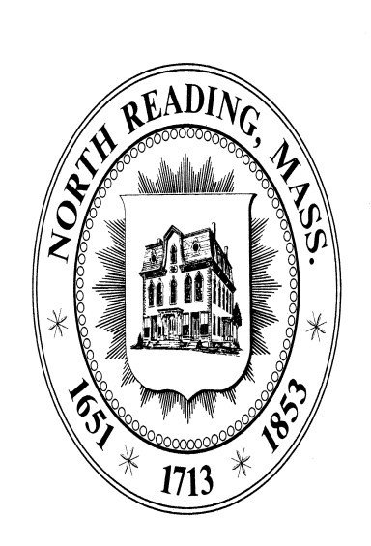

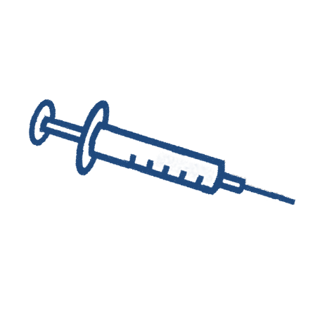
TO W N
O F
N O R T H
R E A D I N G
2026 VACCINATION CLINIC

VACCINATION CLINIC

WHEN: Wednesday January 14, 2026 from 5:00PM to 8:00PM
D E PA R T M E N T
WHERE: North Reading Town Hall, Room 14, located at 235 North Street in North Reading, MA

The following vaccines will be available:
- Influenza
H EA LT H
- High dose Influenza(for those over 65 years old)
- COVID 19 – Ages 3 and up

SCAN QR HERE FOR CDC VACCINE INFORMATION
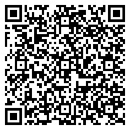
https://www.shaws.com/vaccinations/group-clinic/Northreadingvax
