4th Grade Syllabus

Mrs. Reeves, Mrs. McClendon, Mrs. Butler, Mrs. Sherwood, Mrs. Seawright, Mrs. De la Torre, Mrs. Anderson– Corinth Elementary School

Spring 2026
Dear Parents and Guardians,
Welcome to 4th Grade at Corinth Elementary! This syllabus outlines what your child will learn this semester, and how you can support their success. As required by Texas law (Senate Bill 12), this document serves as the instructional plan and is available for your review. We are excited to partner with you for a great semester!

What Your Child Will Learn
This semester, we’ll focus on building skills in the following subjects, based on Texas state standards (TEKS). This is the instructional plan for your child’s class:
- Reading & Language Arts
  - Unit 5: Treasure Island: X Marks the Spot
    - Learning objectives: This unit examines the fiction genre through a classic novel, Treasure Island. Students focus on character development, setting, plot, and literary devices while reading an abridged version of Robert Louis Stevenson’s popular adventure story. They also trace the development of plot, characters, and literary elements over the course of the novel and engage in an extended writing project while continuing to practice the various stages of the writing process. Students draft a character sketch, then write, publish, and share an original adventure story. Throughout these writing activities, students focus on character development, dialogue, verb choice, and revision methods.
  - Unit 6: Poetry: Wondrous Words
    - Learning objectives: This unit gives students tools and strategies for approaching poetry, training them in the methods and devices poets use, and equipping them to read and interpret both formal and free verse poems. The poems in this unit represent a wide variety of time periods, from Kshemendra’s 12th century treatise on the responsibilities of poets to the work of living writers such as Harryette Mullen. The poets come from many backgrounds including European, Asian, African American, Native American, and Hispanic. A key aspect of the Poetry Unit is providing opportunities for students to write original poems using the poetic devices they have learned in the reading components of each lesson, including rhymes, similes, and metaphors, repetition, anaphora, and alliteration.
  - Unit 7: Geology: This Rock You’re Standing On
    - Learning objectives: This unit focuses on the composition of the earth and the forces that change its surface. Students learn about the theory of plate tectonics and how it explains the presence of volcanoes, mountains, underwater trenches, ridges, and other geological features. Students will also study geological processes like rock formation, weathering, and erosion in order to understand how the earth changes over time and why it looks the way it does. They review the stages of the writing process as they draft an informational pamphlet about tsunamis, write a wiki entry about a specific volcano, and create a descriptive paragraph about a type of rock or item in the rock cycle. Students will incorporate literary devices such as alliteration, personification, and simile into their writing.
  - Unit 8: Energy
    - Learning objectives: Students will sequentially construct a timeline of energy development starting in the 19th century with the discovery of oil in Texas. They will build an understanding of the myriad energy sources available today, including fossil fuels and renewable fuels. Working collaboratively, students will research and analyze the challenges and successes of early energy innovators and recognize the role these foundational achievements played in the evolution of the field of energy development. As part of the informational writing process, students will generate research questions about energy and conduct research using primary and secondary sources to answer those questions. Students will write an argumentative essay making their case for a fuel of the future, and they will create energy proposals to showcase their innovative thinking.
  - Unit 9: Novel Study: Hello Universe
    - Learning objectives: This unit is based on the award-winning novel Hello, Universe by Erin Entrada Kelly, and is a story about bravery and friendship. It reminds readers how uniquely important each and every person is, and how the universe connects us all. This novel study will help students improve their reading abilities and their enjoyment of authentic texts and will also encourage them to appreciate other people’s perspectives and experiences. Throughout the unit, students will analyze the relationships among the characters in the story to deepen their understanding of the author’s message, and to reflect on their own relationships with family and friends. Students will also use a variety of graphic organizers to synthesize and analyze character and plot development as they move toward preparing a character analysis oral presentation.
- Math
  - Module 5: Fraction Equivalence, Ordering, and Operations
    - Learning objectives: This module bundles student expectations that address equivalence, comparisons, representations, and operations with fractions and mixed numbers using a variety of models. According to the Texas Education Agency, TEKS Mathematical Process Standards for Grade 4, including tools and techniques, communication, relationships, and justifications, should be integrated (when applicable) with content knowledge and skills so that students are prepared to use mathematics in everyday life, society, and the workplace.
  - Module 6: Introduction to Decimals and Financial Literacy
    - Learning objectives: This module bundles student expectations that address developing an understanding of decimal numbers via their relationship to fractions with denominators of 10 or 100; comparing decimals; adding and subtracting decimals and fractions; and exploring financial literacy concepts.
  - Module 7: Exploring Measurement with Multiplication and Data
    - Learning objectives: This module bundles student expectations that address solving measurement problems involving customary and metric unit conversions, representing data, and solving problems using data representations.
- Science
  - Unit 6: Investigating Natural Resources
    - Learning objectives: This unit bundles three student expectations about Earth’s resources. Students identify and explain the advantages and disadvantages of using Earth’s renewable and nonrenewable natural resources. Students explain the critical role of energy resources to modern life and how conservation, disposal, and recycling of natural resources impact the environment. Students determine the physical properties of rocks which allow Earth’s natural resources to be stored there.
  - Unit 7: Investigating Earth’s Patterns of Change
    - Learning objectives: This unit is about Earth’s changing surface. Students model and describe how water, wind, and ice contribute to the weathering, erosion, and deposition of rock and the impact on Earth’s surface.
  - Unit 8: Investigating Patterns Among the Sun, Earth, and Moon
    - Learning objectives: Students will collect and analyze data to discover patterns in the appearance of the Moon from the vantage point of standing on the surface of the Earth looking up at the sky. Students will also use typical characteristics of each season by identifying patterns of heating and cooling and different amounts of daylight. In addition, they will use patterns to predict when to expect cooler temperatures, shorter periods of daylight, and the appearance of a Full Moon.
  - Unit 9: Investigating Ecosystems
    - Learning objectives: This unit combines student expectations that focus on the changes that occur in ecosystems of the past and present. Students will explain how producers use photosynthesis to make food and use food webs to describe how matter and energy move through an ecosystem. In addition, they will describe past environments based on fossil evidence.
  - Unit 10: Investigating Structures and Functions of Organisms
    - Learning objectives: These student expectations involve how organisms undergo similar life processes and have structures that function to help them survive within their environments.
- Social Studies
  - Unit 6: Revolution in Texas
    - Learning objectives: This unit bundles student expectations that relate to the events of the revolt in Texas that brought about independence for the region from Mexico. As tensions grew in Texas, Mexican officials attempted to impose more control over the settlers. Eventually, political changes in Mexico forced settlers in Texas to pursue independence. While the movement towards independence had been growing for years, it took less than a year for Texans to gain independence. During that time, Texans met to form a new government as well as battle Mexico’s army at Gonzales, the Alamo, Goliad, and San Jacinto. The victory at San Jacinto signified the end of Mexican rule in Texas. A study of the Texas Revolution is important for understanding the relationship between Texas, the United States, and Mexico today.
  - Unit 7: Republic of Texas and Statehood
    - Learning objectives: This unit bundles student expectations that relate to the establishment of the Republic of Texas and the annexation of Texas to the United States. After the Texas Revolution, Texans were challenged to create a new political system for Texas, to deal with the threats from American Indians in the region, and to establish the boundary of Texas. The new republic was modeled after the U.S. republic and some Texans wanted Texas to join the United States. Early leaders of the Texas republic worked to provide security for Texans, establish government services, and address financial issues. Eventually, Texans decided that many of the financial problems faced by the republic could be solved by joining the United States. The annexation of Texas triggered a boundary dispute with Mexico and war broke out between Mexico and the United States. The treaties that ended the war established the borders of Texas. An examination of the challenges faced by the leaders of the Republic of Texas is necessary for understanding why Texas eventually became a part of the United States.
  - Unit 8: Texas During the Civil War and Reconstruction
    - Learning objectives: This unit bundles student expectations that relate to changes taking place in Texas during the mid-nineteenth century, including increasing immigration, the Civil War, and Reconstruction. Prior to the Civil War, the availability of cheap land fueled an influx of immigrants from Europe to Texas. Those immigrants benefited economically from the free enterprise system in the United States and many established businesses in Texas. In 1861, Texans voted to secede from the United States and join the Confederate States of America. Many Texans had emigrated from the southern United States and some Texans were slaveholders, especially in East Texas where enslaved African Americans worked on plantations. Texans served in the Confederate Army and some battles of the American Civil War were fought in Texas. The Texas coast was blockaded by the Union for the entire war. After the end of the war, Texans began the process of Reconstruction eventually writing a new constitution for Texas and reestablishing institutions in Texas. Studying about the various immigrant groups that have come to Texas is important for understanding the cultural mosaic of Texas. An examination of the Civil War and Reconstruction in Texas is important for understanding the debates that continue about the nature of federalism.
  - Unit 9: Settling the Texas Frontier
    - Learning objectives: This unit bundles student expectations that relate to the settlement of the Texas frontier. In the latter half of the nineteenth century the cattle industry in Texas flourished, while the agricultural sector also expanded. Many new innovations were introduced at this time, such as windmills that facilitated economic development in Texas. It was also during this time that railroads were built across Texas facilitating further economic growth and the first moves towards urbanization in the state. Eventually the railroads and the enclosure of land, brought about by the invention of barbed wire, resulted in the closing of the Texas frontier. An examination of the development of the cattle industry and the expansion of the railroads is important for understanding the development of the Texas economy.
  - Unit 10: Economic Development and Urbanization in Texas
    - Learning objectives: This unit bundles student expectations that relate to the economic development and urbanization of Texas in the early twentieth century. At the beginning of the twentieth century the Texas coast was devastated by a hurricane. Rebuilding after the hurricane brought political and economic changes to Galveston and Texas. It is also during the early decades of the twentieth century that the oil industry in Texas began. While Texas’ economy was affected by the Great Depression during the 1930s the devastating effects were not as bad in Texas. Many Texans did not invest in the stock market and thereby avoided the effects of the crash of the stock market. However, many Texans were affected by the severe drought and devastation that brought about the Dust Bowl, especially Texans living in the Panhandle. The Second World War brought the Great Depression to an end. Many Texans and Texas played a significant role in the Second World War. Texas was home to training bases for women pilots and to internment camps during the war. Texans were part of the war effort and the Second World War contributed to economic growth in Texas during the 1940s and 1950s. An examination of these developments is necessary for understanding what is characteristic of Texas' economic and population patterns today.
  - Unit 11: Texans Making a Difference
    - Learning objectives: This unit bundles student expectations that relate to the civic and cultural engagement of Texans. Throughout the latter half of the twentieth century several Texans have served as national leaders including two U.S. presidents from Texas. Texans have a civic duty to engage in the political process and Texans continue to make a difference in their communities and state through various civic programs. Texas has long been the home to various immigrant groups and in the latter half of the twentieth century immigrants continued to come to Texas, many to Houston, making it one of the most ethnically diverse cities in the United States. An examination of engagement in the political process, civic affairs, and cultural traditions is important for understanding the expectations of citizens in Texas and contributions made by citizens in Texas.
Thank you for partnering with us to make this semester successful for your child! If you have any questions, feel free to reach out.
Sincerely,
Robin Reeves rreeves@ldisd.net, Kara McClendon kmcclendon@ldisd.net, Vanessa Seawright vseawright@ldisd.net, Hannah Sherwood msherwood@ldisd.net, Catrina Butler cbutler@ldisd.net, Natalie De La Torrendelatorre@ldisd.net, Michelle Anderson mmanderson@ldisd.net

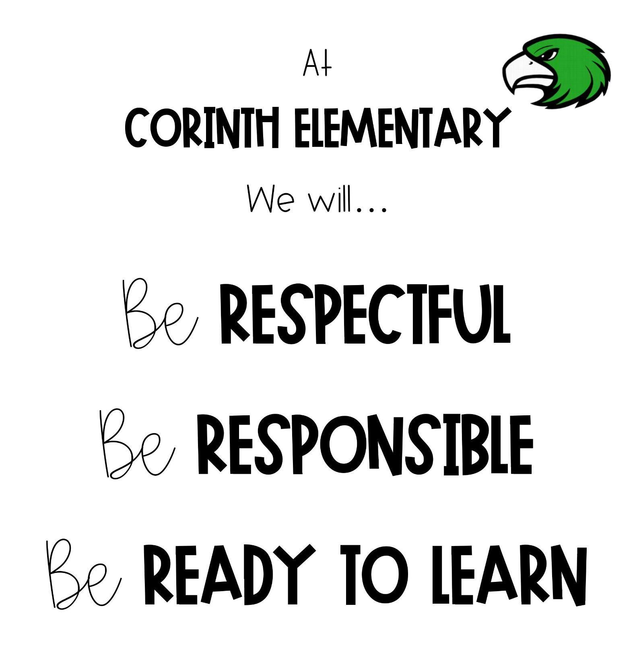
PBIS (Positive Behavioral Interventions and Supports)
What does this look like for your grade level
(tokens, points, treasure box, etc)

PBIS is a decision-making framework
PBIS Goal: to enhance the capacity of schools to educate
ALL students
4 Elements of PBIS:
  - Outcomes
  - Systems
  - Data
  - Practice
Create a school culture of:
  - Predictability
  - Positivity
  - Safety
  - Consistency
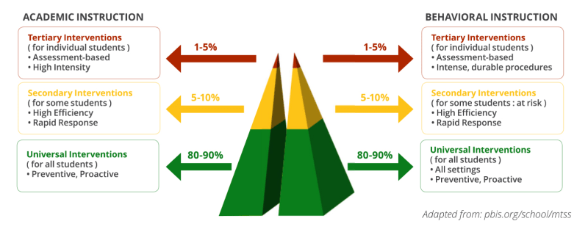
3-tiered model

Leader In Me
At Corinth Elementary, we focus on the 7 Habits of Happy Kids.

