PreKindergarten 4 Syllabus

PK4 - Ms. Garza, Mrs. Roach, Mrs. Baldenegro, Mrs. Biggerstaff –

Corinth Elementary School

Fall 2025
Dear Parents and Guardians,
Welcome to Prekindergarten at Corinth Elementary! This syllabus outlines what your child will learn this semester, and how you can support their success. As required by Texas law (Senate Bill 12), this document serves as the instructional plan and is available for your review. We are excited to partner with you for a great semester!

What Your Child Will Learn
This semester, we’ll focus on building skills in the following subjects, based on Texas state standards (TEKS). This is the instructional plan for your child’s class:
- Reading & Language Arts
  - Unit 1: My School and Friends
    - Learning objectives: As children arrive in their new classroom, it is critical to take time to establish positive relationships, create a structured environment, and set the tone for a nurturing community. Welcome to Pre-K focuses on these goals. Attention is given to establishing rules, routines, and procedures that will support and foster social, emotional, and cognitive development throughout the school year. Such a focus is necessary for establishing a positive classroom environment that runs smoothly the rest of the year. Children will sing songs and chants using names, share in book reading experiences, and participate in activities that teach and reinforce positive social behaviors, including following the rules and routines of the classroom. Through these playful experiences, children will understand that school is a fun, safe environment for learning and making new friends.
  - Unit 2: I’m Me! I’m Special!
    - Learning objectives: Students take an in-depth look at themselves and the people in their lives. Thoughtful experiences throughout the theme will assist children in discovering what makes each of them unique and special. Children will begin to notice similarities and differences between themselves and their classmates—comparing and contrasting homes, families, bodies, senses, and feelings.
  - Unit 3: All Around My Community
    - Learning objectives: Students are given opportunities to understand the places and people that make up a community, the different ways people get around in a community, and the important role construction plays for updating and maintaining a successful community. Children will begin to understand how needs are met by the community and how communities grow and change over time.
  - Unit 4: It’s Harvest Time!
    - Learning objectives: Students build their understanding of the changes that occur in the environment during harvest time, the types of crops that are harvested, and the way people buy and use these crops. Children will learn how crops are gathered and are made available at the market for families to bring home. Through meaningful lessons and activities, children will discover what it means for their food to go from farms to their own tables.
  - Unit 5: The Sky Above Me
    - Learning objectives: Students learn about the importance of each object in the sky and how these objects impact our lives. Children will investigate the different types of clouds and the weather they bring, the important role of the sun in providing light and heat for the Earth, how the moon lights up the night sky, and seasonal changes that occur each year.
- Math
  - Unit 1: September-All About Apples
Learning objectives:
    - Count with 1:1 correspondence within 10
    - Sort objects by color or type
    - Create simple repeating color patterns
    - Compare and order objects by length
    - Build and describe structures with 3-D shapes
    - Use and respond to positional words such as beside, inside, outside, in, out, and so on
  - Unit 2: October-How Does a Pumpkin Grow? & Autumn Counting
Learning objectives:
    - Recognize numerals to 3
    - Form numerals to 3
    - Count with 1-to-1 correspondence to 3
    - Match sets and numerals to 3
    - Identify and name shapes
    - Compose simple shapes to make pictures
  - Unit 3: November-All About Shapes
Learning objectives:
    - Count with 1-to-1 correspondence and cardinality to 4
    - Recognize numerals to 4
    - Subitize quantities to 4
    - Recognize numerals to 5
    - 1-to-1 correspondence to 5
    - Match sets and numerals to 5
    - Compare sets to 5 and tell which has more
    - Identify and draw squares and circles
    - Collect and analyze data
    - Identify and name shapes (triangle, hexagon, rhombus, trapezoid)
    - Compose simple shapes to make larger shapes
  - Unit 4: December-All About Snowflakes
Learning objectives:
    - Count with 1–1 correspondence and cardinality to 5
    - Read and write numerals to 5
    - Compare sets to 5 and tell which has more
    - Collect and analyze data
    - Subitize quantities to 4
    - Count with 1-to-1 correspondence and cardinality to 4
    - Recognize numerals to 4
    - Identify and name shapes (triangle, rhombus, trapezoid)
    - Compose simple shapes to make larger shapes
    - Compare objects by length
    - Use the terms longer than, shorter than, and the same length

- Science
  - Unit 2: I’m Me! I’m Special!
    - Learning objectives: Students explore how they learn about the world through the five senses of sight, hearing, smell, taste, and touch, and how each uses a unique body part to take in information.
  - Unit 3: All Around My Community
    - Learning objectives: Students will learn about earth materials, then investigate and record data for the appearance and weight of rocks, soil, and sand. Students will identify items made from rocks. Students will plan, build, and improve structures made of classroom materials.
  - Unit 4: It’s Harvest Time!
    - Learning objectives: Students will examine, discuss, and compare the texture, color, and sizes of pumpkins. Students will learn the parts of a pumpkin and the life cycle of a pumpkin.
  - Unit 5: The Sky Above Me
    - Learning objectives: Students will investigate objects in the sky observed as characteristics of day and night. Students will observe, describe, and illustrate the Sun, Moon, stars, and objects in the sky, such as clouds. They will identify, describe, and predict the patterns of day and night and their observable characteristics.
- Social Studies
  - Unit 1: My School and Friends
    - Learning objectives: During this unit, students are introduced to a foundational practice of U.S. citizenship, reciting the pledge of allegiance.
  - Unit 2: I’m Me! I’m Special!
    - Learning objectives: During this unit, students will describe a family custom or tradition and compare that custom to another child’s. Students will identify their preferences and compare them to another child’s. Students will vote to participate in making a group decision. Students will link current experiences that cause a specific feeling to past and present, using time-oriented vocabulary.
  - Unit 3: All Around My Community
    - Learning objectives: During this unit, students will recognize that maps help us find our location and see how to get from one place to another. Students explore different locations and workers within a community, and choose a community worker he or she might like to become. Students learn about different safety features and transportation methods in the community and where they can be found.
  - Unit 4: It’s Harvest Time!
    - Learning objectives: During this unit, students will learn about types of clothes people wear when the weather begins to get cooler. Students will learn about the tools a farmer or field worker may use to harvest crops. Students learn and pretend to buy and sell crops at the market.
  - Unit 3: The Sky Above Me
    - Learning objectives: During this unit, students will learn about meteorologists and the different tools that meteorologists use. Students learn about different activities that people do when it is sunny and that the sun follows a routine each day. Students will discuss routines that occur at bedtime. Students will learn about the weather and type of clothing needed for each season. Students will learn about the holidays that fall into each season.

Spring 2026

What Your Child Will Learn
This semester, we’ll focus on building skills in the following subjects, based on Texas state standards (TEKS). This is the instructional plan for your child’s class:
- Reading & Language Arts
  - Unit 6: Animals All Around
    - Learning objectives: Students will explore different types of animals, young and old, found all over the world. Students will discover the unique features, adaptations, habits, and habitats that help animals survive.
  - Unit 7: I’m Healthy! I’m Safe!
    - Learning objectives: Students learn the importance of establishing health and safety habits as part of our everyday lives. Students will discover the importance of being active, of choosing food that is good for their bodies, and of caring for their teeth. They will also learn about ways to stay safe when they are outside and at home, including protecting themselves from germs.
  - Unit 8: Get Moving!
    - Learning objectives: Students will focus on the ways people and objects move through air, over land, and across water. Students will explore how objects can be moved by the wind and by using forces, such as pushing and pulling. Students will also learn the types of transportation that people use for air, land, and water travel.
  - Unit 9: The Earth Around Me
    - Learning objectives: Students will explore the types of landforms, plants, and water that cover the Earth’s surface. Students will learn about the importance of each of these resources as well as how they can help care for the Earth and keep it clean.
  - Unit 10: Creepy Crawly Critters
    - Learning objectives: Students learn to explore different types of insects, spiders, worms, snails, and other small creatures (referred to as critters throughout this guide) found crawling and buzzing around them. Students will discover the unique features, adaptations, habits, and habitats of these critters. Students will also learn which critters are dangerous and should be avoided.
- Math
  - Unit 5: January-Mittens, Scarves & Snow People
Learning objectives:
    - Observe and describe objects
    - Ask questions to gather information
    - Explore the concept of a pair as a set of
two matching objects
    - Count with 1-to-1 correspondence and
cardinality to 10
    - Find and describe repeating and
growing patterns
    - Recognize, verbalize, and extend an
AAB repeating pattern
  - Unit 6: February-Teddy Bears
Learning objectives:
    - Observe and describe objects
    - Ask questions to gather information
    - Count with 1-to-1 correspondence and
cardinality to 10
    - Add 1 to quantities less than 10
    - Recognize, verbalize, and extend an
AAB repeating pattern
    - Describe the location of one object
relative to another object using words
    - such as inside, outside, beside, behind, in
front of, above, below, and so on
    - Place an object in a specified position
    - Count verbally to 20
    - Count with 1-to-1 correspondence and
cardinality to 10
    - Read numerals to 10
    - Match sets and numerals to 10
    - Develop early understandings of
addition and subtraction on a number
line
    - Add small quantities by using concrete
objects and counting all
    - Explore addition doubles through 5 + 5
    - Develop intuitions about odd and even
numbers
  - Unit 7: March-Robots
Learning objectives:
    - Count with 1-to-1 correspondence & cardinality to
10 or more
    - Read numerals to 6
    - Observe and describe objects
    - Ask questions to gather information
    - Sort the same set of objects by two or more different
attributes
    - Identify, name, and describe shapes
    - Compose simple shapes to make pictures
    - Recognize, verbalize, and extend an ABB repeating
pattern
    - Translate a repeating pattern into another format
    - Count forward to 10 or more and backward from 10
    - Count with 1-to-1 correspondence & cardinality to 10
    - Subitize quantities to 6
    - Read numerals to 10
    - Match sets and numerals to 10
    - Give the next number in the counting sequence for
numbers 1–9
    - Order numerals to 10
    - Develop intuitions about combinations for
quantities to 6
    - Add small quantities by using concrete objects and
counting all
    - Count on to add small quantities
  - Unit 8: April-Water Fun
Learning objectives:
    - Observe and describe objects
    - Ask questions to gather information
    - Count with 1-to-1 correspondence & cardinality to 10
    - Make and test predictions
    - Sort objects according to whether they sink or float
    - Sort objects by function
    - Recognize, verbalize, and extend an ABC repeating pattern
    - Translate a repeating pattern into another format
    - Count with 1-to-1 correspondence &
cardinality within 20
    - Read numerals to 20
    - Match sets and numerals to 10
    - Count on to add small quantities
    - Develop early understanding of addition and subtraction on the number line
  - Unit 9: May-Ladybugs & Butterflies
Learning objectives:
    - Observe and describe objects
    - Ask questions to gather information
    - Recognize, verbalize, and extend an
ABB repeating pattern
    - Translate a repeating pattern into
another format
    - Count with 1-to-1 correspondence and
cardinality to 10
    - Read numerals to 10
    - Order numerals to 10
    - Count backward from 10
    - Subtract 1 from quantities within 10
using concrete objects
    - Give the next number in the counting
sequence for numbers 1–9
    - Match sets and numerals to 10
    - Explore addition doubles
    - Explore symmetry

- Science
  - Unit 6: Animals All Around
    - Learning objectives: Students will observe, investigate, describe, and discuss the characteristics of organisms. Students will also observe, investigate, describe, and discuss the relationship of organisms to their environment
  - Unit 7: I’m Healthy! I’m Safe!
    - Learning objectives: Students will observe, describe, and discuss the life cycles of organisms. Students will identify good habits of nutrition and exercise.
  - Unit 8: Get Moving!
    - Learning objectives: Students will observe, investigate, describe, and discuss position and motion of objects.
  - Unit 9: The Earth Around Me
    - Learning objectives: Students will observe, investigate, describe, and discuss earth materials, and their properties and uses.
  - Unit 10: Creepy Crawly Critters
    - Learning objectives: Students will observe insect sizes, shapes, and colors. Compare critters’ actual sizes to how they look in close-up pictures. Students will observe, investigate, describe, and discuss the characteristics of organisms.

- Social Studies
  - Unit 6: Animals All Around
    - Learning objectives: Students will discuss the job of a veterinarian by reading a book, showing pictures, or watching a short video clip of a veterinarian in action. Point out the different tools that veterinarians use. Explain that veterinarians work not only with pets, but with animals that live in zoos, on farms, or even in the wild.
  - Unit 7: I’m Healthy! I’m Safe!
    - Learning objectives: Students will see pictures of local gyms and workout studios in the community, along with the types of equipment that are used at these locations. Students will learn that these places are situated in communities so residents have places to get healthy and be active.
  - Unit 8: Get Moving!
    - Learning objectives: Students will discuss the roles and responsibilities of community helpers such as pilots and bus drivers. Students will learn how boats can be used as people’s homes and will compare and contrast the features of this type of shelter to those of a home on land.
  - Unit 9: The Earth Around Me
    - Learning objectives: Students will see pictures of different landforms found on Earth, and discuss the features of each. Students will also learn of the different types of bodies of water found on Earth, and discuss the features of each.
  - Unit 10: Creepy Crawly Critters
    - Learning objectives: Students will learn about the job of an entomologist by reading a book, looking at pictures, or watching a short video clip of an entomologist in action. Students will learn about the different tools that the entomologist uses. Students will also learn which insects are harmful to people but how they are also helpful to people.

Thank you for partnering with us to make this semester successful for your child! If you have any questions, feel free to reach out.
Sincerely,

PK4 - Ms. Garza, Mrs. Roach, Mrs. Baldenegro, Mrs. Biggerstaff
Include:
Daily Schedule
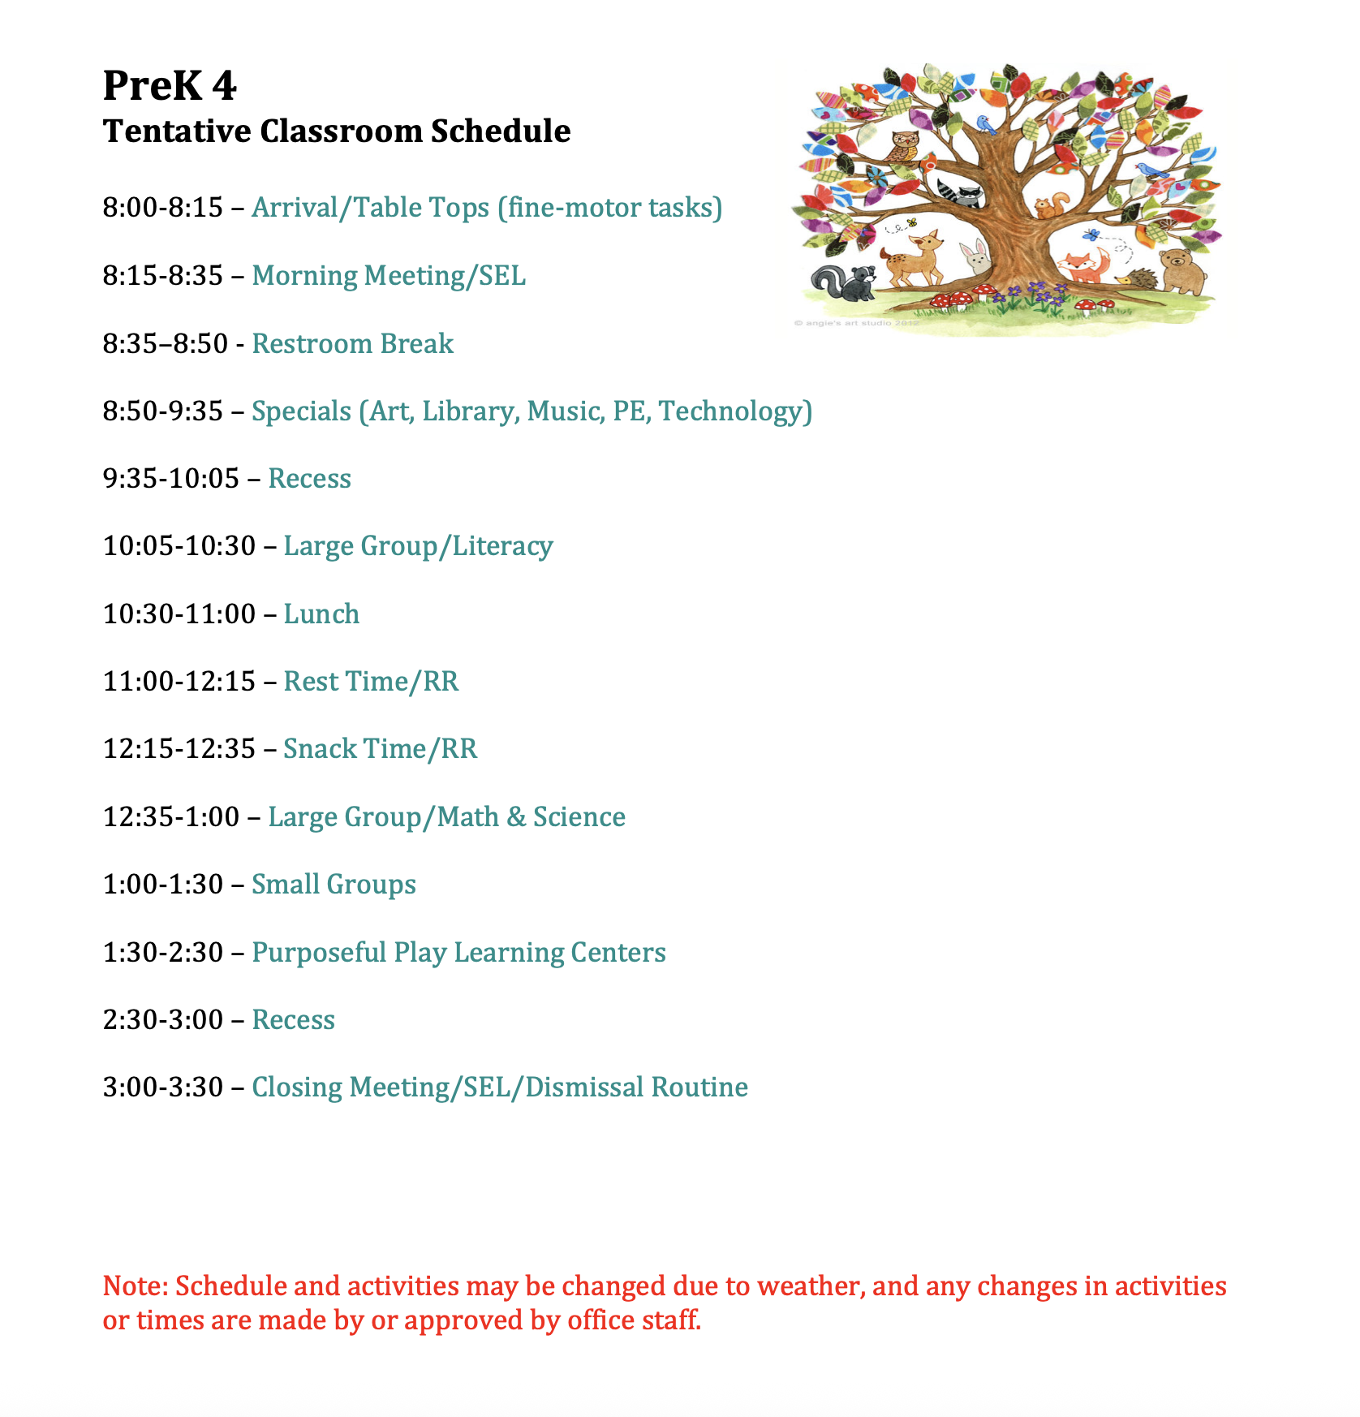
PreK 4 Team:
Ms. Garza - clgarza@ldisd.net
Mrs. Roach - jdroach@ldisd.net
Mrs. Baldenegro - sbaldenegro@ldisd.net
Mrs. Biggerstaff - sbiggerstaff@ldisd.net
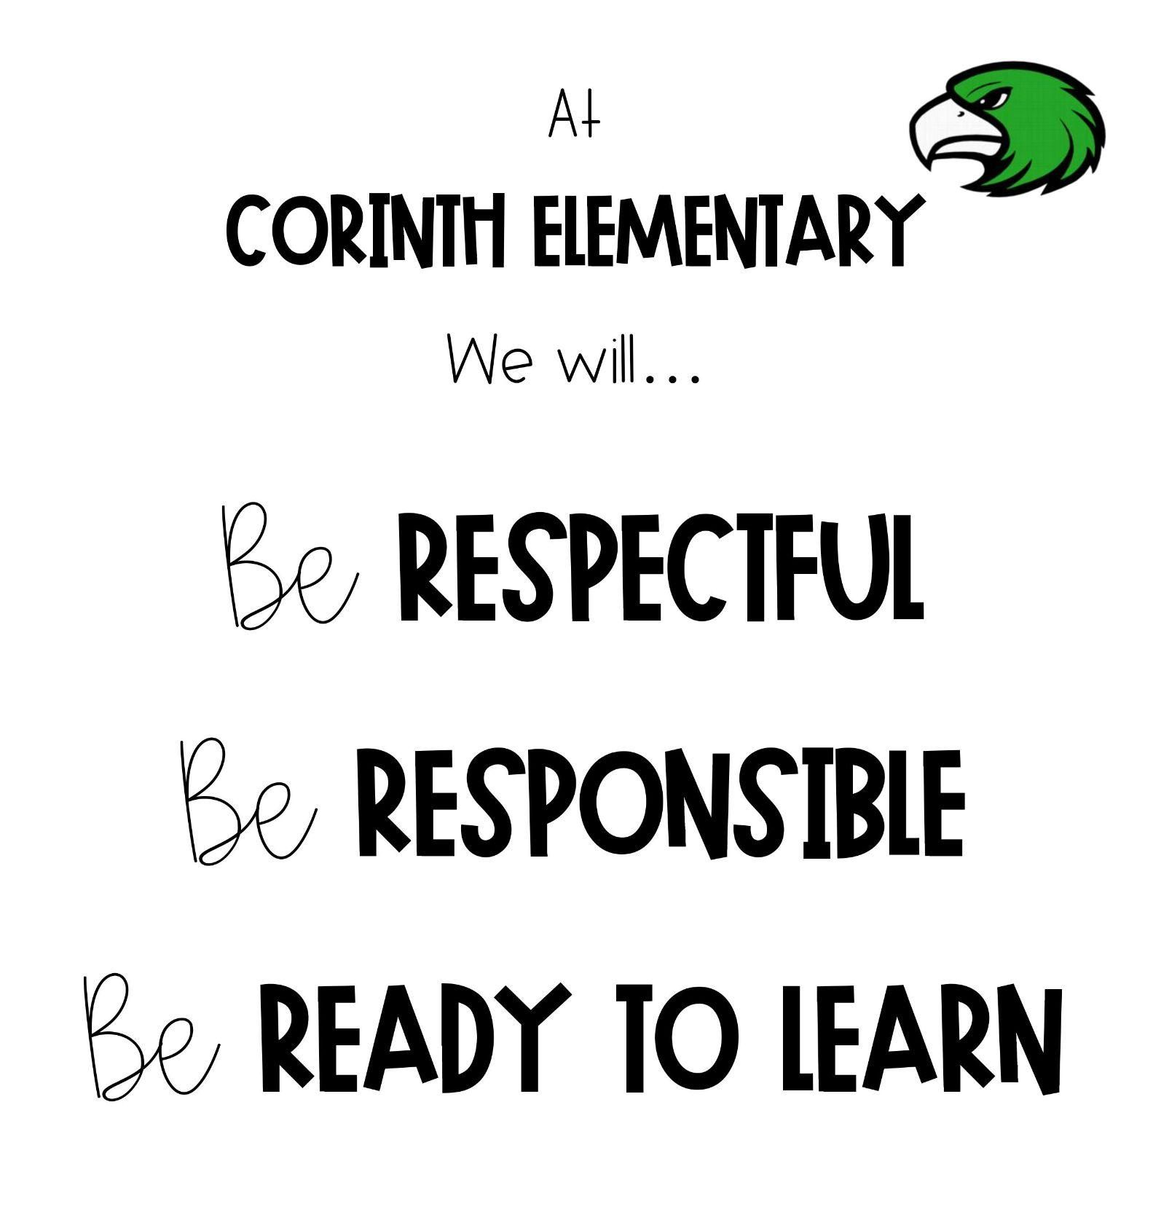
Behavioral Interventions and Supports)

This year in Prekindergarten, students will learn and follow the expectations of Corinth Elementary by being Respectful, Responsible, and Ready to Learn—the 3Rs of CE.
To encourage positive behavior, we will use a token system along with the PBIS app to reward students who demonstrate these values. Tokens and points can be exchanged for rewards such as treasure box items, special stickers, pencils, or classroom privileges like Stuffed Animal Day or extra recess.
If a student is not following the expectations at Corinth Elementary, they may receive a minor or major consequence in the PBIS system. This will depend on the severity of the behavior and typically follows several reminders, warnings, or previous communication with a parent.
Please make sure you're signed up for the PBIS app to receive updates. If your child receives a minor or major consequence, their teacher or a principal will reach out to you directly.
Each day, your child will bring home a green Take-Home Folder containing a monthly calendar. Teachers will use this calendar to communicate your child’s daily behavior, either with a positive note or stamp, or with a brief note if any behavior concerns arose that day.

PBIS is a decision-making framework
PBIS Goal: to enhance the capacity of schools to educate
ALL students
4 Elements of PBIS:
  - Outcomes
  - Systems
  - Data
  - Practice
Create a school culture of:
  - Predictability
  - Positivity
  - Safety
  - Consistency
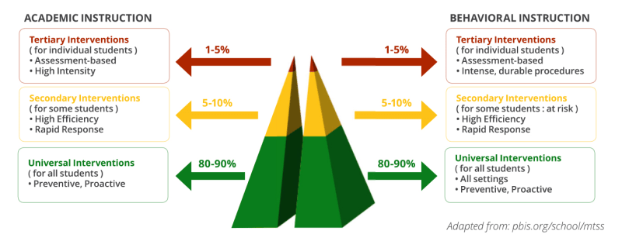
3-tiered model

Leader In Me
At Corinth Elementary, we focus on the 7 Habits of Happy Kids.

