5th Grade Syllabus

Corinth Elementary School

Mrs. Broadstreet, Mrs. Hoffman, Mrs. Lymbery, and Mrs. Wilson

Spring 2025
Dear Parents and Guardians,
Welcome to 5th Grade at Corinth Elementary! This syllabus outlines what your child will learn this semester, and how you can support their success. As required by Texas law (Senate Bill 12), this document serves as the instructional plan and is available for your review. We are excited to partner with you for a great semester!

What Your Child Will Learn
This semester, we’ll focus on building skills in the following subjects, based on Texas state standards (TEKS). This is the instructional plan for your child’s class:
- Reading & Language Arts
  - Unit 6: Introduction to Shakespeare: A Midsummer Night’s Dream
    - Learning objectives: The A Midsummer Night’s Dream unit is an immersive Quest that treats Shakespeare’s comedy as both literature and a living text for interpretation and performance. Over the course of the Quest, students read, write, act, direct, design, and watch scenes from A Midsummer Night’s Dream. Students think about scenes through the frames of character action (what a character wants, what stands in their way, and what they will do to achieve it) and character traits (what a character’s actions tell us about them, what adjectives we would use to describe this character). Students engage in close reading, creative writing, and theater activities to enhance their understanding of the play and engage their imaginations, as they further their skills in reading, writing, speaking, and listening.
  - Unit 7: Native Americans and the United States
    - Learning objectives: In this unit, students will learn how intricately Native Americans in the 1800s were connected to the land, and understand how this was the foundation for their cultures and traditions. This framework enables students to recognize how the policies of the American government in the 1800s and contact with settlers, missionaries, traders, and explorers affected Native American cultures and their relationship with the land. Students will write an argumentative essay in which they argue that a chosen image best shows the connection between Native Americans and the land. In this writing, students focus on note-taking, incorporating evidence, and crafting an argument. They also revise, edit, and share their writing.
  - Unit 8: Chemical Matter: Detectives, Dinosaurs, and Discovery
    - Learning objectives: In this unit, students learn chemical content through a fictional work, The Badlands Sleuth, which tells the story of a fossil dig in which a number of fossils go missing and the protagonist, Amy, must use the chemistry she is learning to solve the mystery. Because the unit is both literary and informational, writing tasks vary accordingly. The key skills that students build in this unit include appropriate organization of content for a range of purposes, combining informational and literary details, applying recently learned insights to convey information and understanding to others, integrating information from multiple sources to explain concepts and ideas, and revising writing in response to peer feedback. The culminating writing task for this unit asks students to write Amy’s next case: another detective story which uses scientific content to solve a mystery.
  - Unit 9: Beyond Juneteenth: 1865 to Present
    - Learning objectives: Students will build on their background knowledge of President Lincoln’s Emancipation Proclamation in order to reach a deeper understanding of the significance of Juneteenth in American history and recognize specific contributions of African Americans from 1865 to present day. Students will participate in a virtual field trip to Emancipation Park in Houston, an experience which will help them collaboratively generate research questions about Juneteenth, The Great Migration, innovators and inventors, education, the humanities, activists, and allies. Through Read-Alouds, independent reading, and partner reading, students will gather information, find answers to their generated questions, and write a four-chapter book: Beyond Juneteenth.
  - Unit 10: Novel Study: The Science of Breakable Things
    - Learning objectives: This unit centers on the award-winning novel The Science of Breakable Things by Tae Keller. This innovative approach provides a platform for students to engage with high-quality literature in a supported setting. The protagonist is a young girl confronted with many issues and concerns, some of which may be familiar to students this age. The flexible implementation plan for this unit provides ample opportunities for discussion of themes, characters and moments, with support for teachers and students alike. Students will write daily journal entries which will become the basis for the culminating activity presentation.
- Math
  - Module 4: Multiplication and Division of Fractions
    - Learning objectives: This module bundles student expectations that address multiplication of a whole number by a fraction and division of a whole number by a unit fraction and a unit fraction by a whole number. This module also applies multiplication of whole numbers, fractions, and decimals to Personal Financial Literacy. According to the Texas Education Agency, TEKS Mathematical Process Standards for Grade 5, including tools and techniques, communication, and relationships, should be integrated (when applicable) with content knowledge and skills so that students are prepared to use mathematics in everyday life, society, and the workplace.
  - Module 5: Addition and Multiplication with Volume and Area
    - Learning objectives: This module bundles student expectations that address volume of rectangular prisms, area and perimeter of rectangular figures, and the classification of two-dimensional figures based on their attributes.
  - Module 6: Problem Solving with the Coordinate Plane and Data
    - Learning objectives: This module bundles student expectations that address the coordinate system for the first quadrant of the coordinate plane, including relationships between points, ordered pairs, patterns, lines, and the rules that generate them. This module also addresses data representations and analysis, including frequency tables, bar graphs, dot plots, stem-and-leaf plots, and scatterplots.
- Science
  - Unit 6: Investigating Earth’s Rotation
    - Learning objectives: This unit includes student expectations that address the Earth’s rotation and its effects on Earth. Students will create models to demonstrate Earth’s rotation and explain: the day / night cycle, the appearance of the Sun moving across the sky.
  - Unit 7: Investigating Weather and the Water Cycle
    - Learning objectives: This unit includes a student expectation that addresses weather and the water cycle. Students will investigate how heat from the Sun and proximity to an ocean impact weather. In addition, they will analyze patterns and use that as evidence to explain how the Sun and oceans interact.
  - Unit 8: Investigating Earth’s Patterns of Change
    - Learning objectives: This unit includes student expectations that address changes to Earth’s surface. Students will construct models to demonstrate and describe the formation of sedimentary rock, fossil fuels, and landforms.
  - Unit 9: Investigating Structures and Behaviors of Organisms
    - Learning objectives: This unit bundles student expectations that address how the structures and functions of organisms, along with their instinctual and learned behaviors, can increase their chances of survival. Students will analyze organisms in the same environment to identify patterns in the structures and functions while also determining if their behaviors are instinctual or learned.
  - Unit 10: Investigating Ecosystems
    - Learning objectives: This unit bundles student expectations that address how organisms survive by interacting with biotic and abiotic factors in a healthy ecosystem. Students will predict how changes in an ecosystem affect the cycling of matter and flow of energy in a food web.
  - Unit 11: Investigating Ecosystem Management
    - Learning objectives: This unit bundles student expectations that address how human activities can be beneficial or harmful to a healthy ecosystem. Students will identify cause-and-effect relationships related to human interactions with the environment and design and explain solutions to minimize their environmental impact. Additionally, students will describe how innovative solutions impact society.
  - Unit 12: Student-Designed Investigations and Solutions
    - Learning objectives: This unit bundles student expectations that focus on student-designed scientific investigations and engineering solutions. Students will revisit concepts previously explored in this course to focus on the practices of scientists and engineers.
- Social Studies
  - Unit 6: An American Identity: Becoming the Land of the Free and the Home of the Brave
    - Learning objectives: This unit bundles student expectations that address the Louisiana Purchase, the War of 1812, the beginnings of industrialization, and the development of the American identity. During the early history of the United States, expanding the frontier and fighting the War of 1812 served to solidify an American identity that was no longer colonial in nature. This new identity was reflected in the art and literature produced at the time. Studying these events is important for understanding the unique character, culture, and sectional cultural differences that developed in the United States.
  - Unit 7: Migration Westward: Expanding the United States
    - Learning objectives: This unit bundles student expectations that address westward expansion. During the first half of the nineteenth century the United States expanded territorially with the acquisition of the Louisiana Territory, the annexation of Texas, and the addition of the Mexican Cession and Oregon Territory. This expansion brought political, economic, and geographic changes as Americans acted on the concept of Manifest Destiny seeking new opportunities in the newly acquired territories. A study of westward migration is important for understanding the geographic scope of the United States as well as the sectional distinctions within the United States.
  - Unit 8: Civil War: Dividing and Rebuilding the Union
    - Learning objectives: This unit bundles student expectations that address the causes and consequences of the American Civil War. In the fifth-grade course students study a very broad overview of the history of the United States and for that reason the fifth-grade standards do not address the Civil War in detail, but rather focus on students building an understanding of the context of the Civil War. An examination of the Civil War facilitates an understanding of the debates that continue in the United States about the nature of a federalist system and the impact of race on American society.
  - Unit 9: A New Century: Transitioning to a Modern America
    - Learning objectives: This unit bundles student expectations that address the economic and social changes that occurred in the United States at the beginning of the twentieth century. This period of U.S. History is characterized by rapid industrialization coupled with increasing urbanization and immigration. Studying about these economic changes along with the accompanied social changes provides students with an understanding of the how the United States’ economy shifted from agriculturally based to industrial, how settlement patterns shifted from rural to urban, and how immigration impacts the American identity.
  - Unit 10: Challenging Times: Emerging as a World Power
    - Learning objectives: This unit bundles student expectations that address the participation of the United States in the world wars and the economic challenges faced by Americans during the Great Depression. Students in fifth grade gain a broad understanding of these events, as more depth is given to these events in the high school course of U.S history. U.S. involvement in world affairs was first marked by the Spanish American War just before the beginning of the twentieth century. The pattern of increasing U.S. involvement in world affairs continued throughout the twentieth century, most significantly with participation in two world wars. It is important for student to understand that in the early twentieth century the United States became more involved in world affairs, and that government expanded in the United States to address an economic depression. The role of the United States in world affairs and the role of government in the economy continue to be topics of debate.
  - Unit 11: An Anxious Nation: Creating a More Perfect Union
    - Learning objectives: This unit bundles student expectations that address the challenges facing the United States following the Second World War. Those challenges included addressing the Soviet threat of spreading communism, the need for civil rights for all Americans, and the eventual dangers posed by terrorism. An anxious nation entered into a Cold War, experienced rapid social change during the Civil Rights Movement, and responded to an attack on America on September 11, 2001. A study of these events is important for students to understand the policies that have shaped American society in the latter half of the twentieth century.
Thank you for partnering with us to make this semester successful for your child! If you have any questions, feel free to reach out.

Sincerely,

The 5th Grade Team

Mackenzie Broadstreet mgbroadstreet@ldisd.net
Bethany Hoffman bhoffman@ldisd.net
Rachel Lymbery rlymbery@ldisd.net
Rebekah Wilson rwilson@ldisd.net

**The best way to reach your student’s teacher is through ParentSquare**

Daily Schedule
8:00 Morning Announcements
8:05-8:15 Leadership Block
8:15-8:20 Group Bathroom Break
8:20-10:25 Block 1
10:25-10:55 Recess
10:55-11:00 Group Bathroom Break
11:00-12:10 Block 2
12:10-12:40 Lunch
12:40-1:45 Continue Block 2
1:45-2:30 Specials
2:30-2:35 Group Bathroom Break
2:35-3:20 Falcon Time
3:30 Dismissal

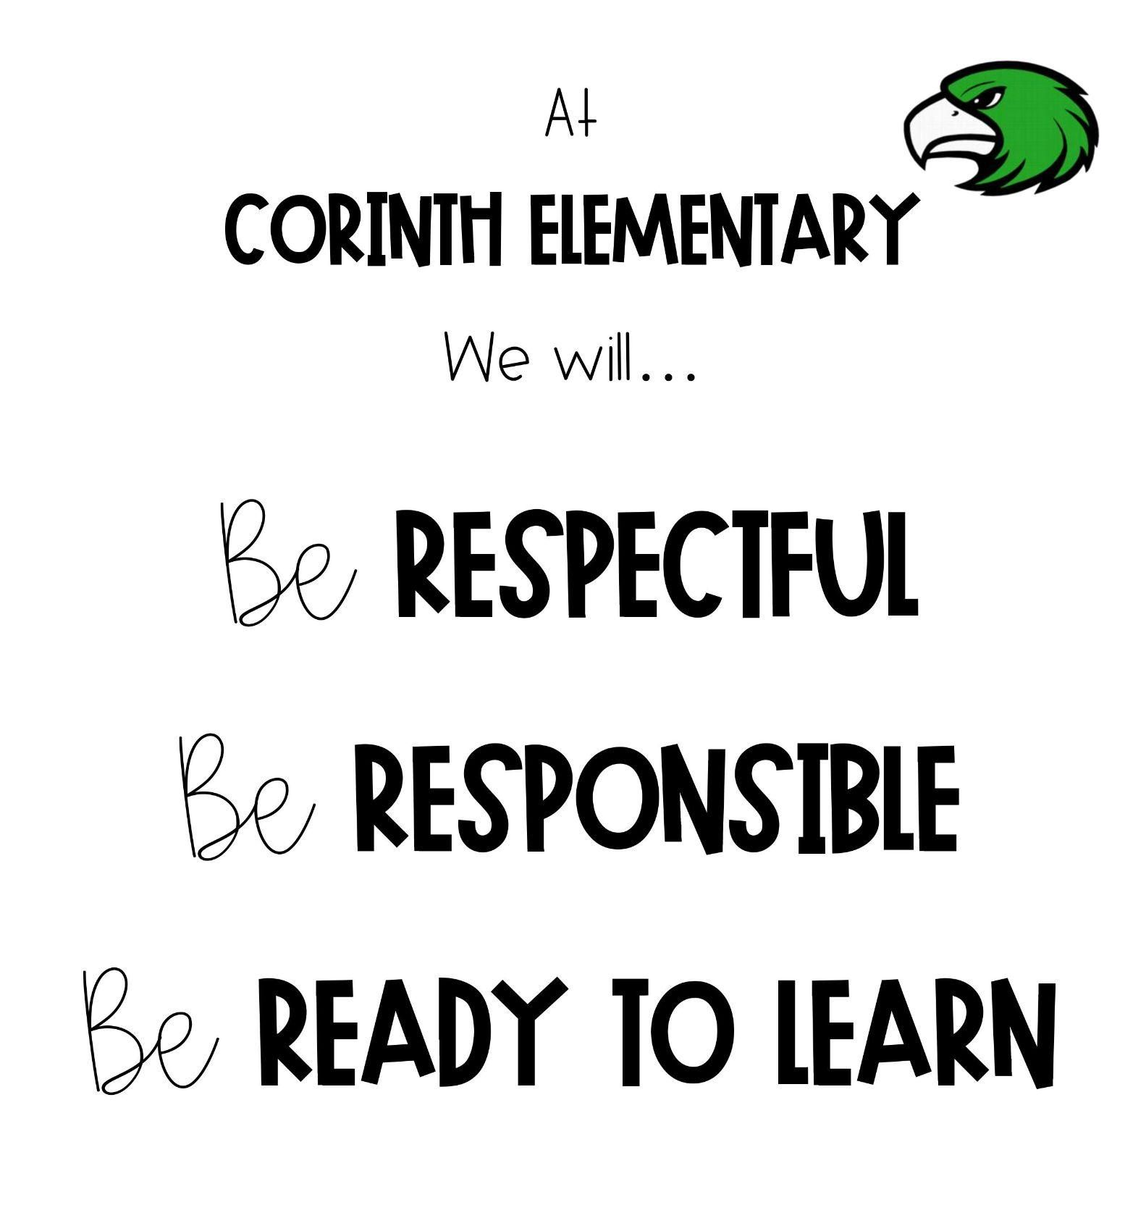
PBIS (Positive Behavioral Interventions and Supports)
What does this look like for your grade level
(tokens, points, treasure box, etc)

PBIS is a decision-making framework
PBIS Goal: to enhance the capacity of schools to educate
ALL students
4 Elements of PBIS:
  - Outcomes
  - Systems
  - Data
  - Practice
Create a school culture of:
  - Predictability
  - Positivity
  - Safety
  - Consistency
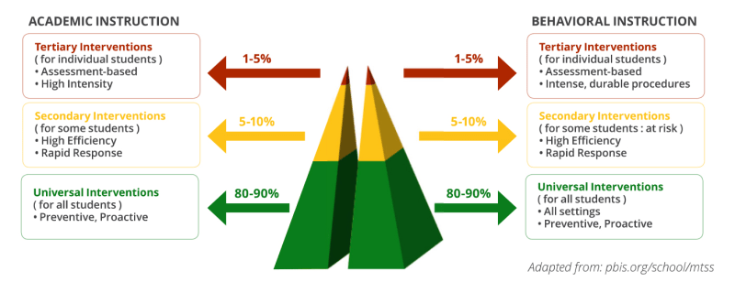
3-tiered model

Leader In Me
At Corinth Elementary, we focus on the 7 Habits of Happy Kids.

