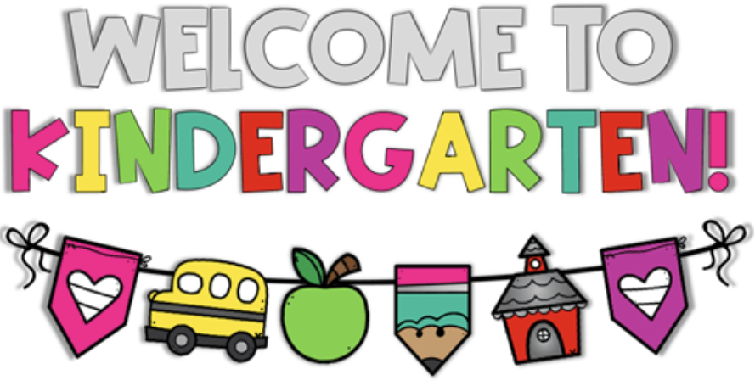
Kindergarten Syllabus
Corinth Elementary
Mrs. Echols, Mrs. Holland, Mrs. Huckabee, Mrs. Prince

Spring 2026
Dear Parents and Guardians,
Welcome to Kindergarten at Corinth Elementary! This syllabus outlines what your child will learn this semester and how you can support their success. As required by Texas law (Senate Bill 12), this document serves as the instructional plan and is available for your review. We are excited to partner with you for a great semester!

What Your Child Will Learn
This semester, we’ll focus on building skills in the following subjects, based on Texas Essential Knowledge and Skills (TEKS) standards. This is the instructional plan for your child’s class:

- Reading & Language Arts
  - Unit 6: Native Americans: Tradition, Heritage, and the Land
    - Learning objectives: Students will understand how conditions in different geographical regions influenced the tribes’ cultures, traditions, and way of life.
  - Unit 7: Kings and Queens
    - Learning objectives: Students will sequence story events and compare and contrast stories about kings, queens, and royal families to understand the responsibilities, lifestyle, and customs associated with royalty throughout history.
  - Unit 8: Seasons and Weather: As the Earth Turns
    - Learning Objectives: Students will learn that weather follows sequential, seasonal patterns and varies in different regions of Earth throughout the year. Students will connect their understanding of changes in weather to the calendar and begin to recognize patterns and characteristics of weather and how these elements affect their daily lives. Writing activities will include journaling and preparing an oral presentation.

  - Unit 9: Colonial Towns and Townspeople: Once Upon America
    - Learning Objectives: This unit will deepen students’ knowledge of the early history of the United States by exploring what daily life was like for people in colonial times, particularly as it compares to life today. This foundational unit provides crucial background knowledge for the subsequent study of specific historical events that moved the nation toward independence. Student writing will focus on sequencing and retelling information.
  - Unit 10: Taking Care of the Earth
    - Learning Objectives: Students continue to grow their knowledge of the interdependence of all living things on Earth, and become aware of the importance of environmental awareness and conservation of natural resources. The students will orally describe details from informational text, use a graphic organizer to organize and retell information, sequence events based on information in the text, write short phrases and sentences, and draw pictures based on details in the text.
  - Unit 11: Presidents and American Symbols: Uniquely American
    - Learning Objectives: Students will gain an understanding of the branches of government as well as the role of a president, and will be able to compare that role to that of a king. Students are also introduced to several national symbols, including the American flag, the Statue of Liberty, the White House, and Mount Rushmore. In writing, students will practice sequencing skills in order to create timelines of events in American history as well as events in the lives of individual presidents.
  - Unit 12: Art and the World Around Us
    - Learning Objectives: This unit introduces students to artists from different time periods, countries, and cultures. Throughout the unit, students will learn about different kinds of art and how artists use the world around them as they make art. Students will connect this to what they have already learned about the Earth, plants, and animals in the domain Farms: From the Ground Up. They will also connect this to what they have learned about sculptors in the Presidents and American Symbols: Uniquely American domain. Students will work toward compiling a class book by identifying a question they have about art and following a research plan to create a page.
- Math
  - Module 4: Number Pairs, Addition and Subtraction to 10
    - Learning objectives: Using number sense and the ability to work with embedded numbers to reason about and solve addition and subtraction expressions and equations.
  - Module 5: Number 10-20, Counting to 100, and Understanding Work
    - Learning objectives: Understanding the meaning of 10 ones and some ones within a teen number, composing and decomposing numbers 11-20, counting to 100, and personal financial literacy.

  - Module 6: Analyzing, Comparing, and Composing Shapes
    - Learning objectives: Identifying two- and three-dimensional figures and their attributes, identifying the two-dimensional components of three-dimensional objects, classifying and sorting two- and three-dimensional figures, and creating two-dimensional figures.

- Science
  - Unit 6: Investigating Weather
    - Learning objectives: Students will observe and describe weather changes from day to day and over seasons. In addition, there is the expectation that students will learn about the relationship between wind and air: 1) air is all around us, and 2) wind is the movement of air.
  - Unit 7: Investigating Needs of Organisms
    - Learning objectives: Students will observe plants’ and animals’ dependence on things around them for survival.
  - Unit 8: Investigating Structures of Organisms
    - Learning objectives: Students will identify structures of plants and animals.
  - Unit 9: Investigating Plant Life Cycles
    - Learning objectives: Students will observe the life cycle of a plant.

- Social Studies
  - Unit 4: Community Celebrations, Customs, and Family Traditions
    - Learning objectives: During this unit, students are introduced to the idea that communities are unified by and distinguished by their culture. Students specifically study American patriotic national holidays, their culture, and that of their classmates, and family traditions. In these contexts, students explore the question – “What is the culture of our community like?”
  - Unit 5: Citizens in the Community
    - Learning objectives: During this unit, students study the contributions made by several historical figures and how voting is used as a process for making community decisions, including electing authority figures. In this unit, students should examine the question of “What makes people want to change their communities?”
  - Unit 6: Working Together in a Community
    - Learning objectives: During this unit, students learn about how individuals have basic wants and needs, as well as about how people work jobs to meet their needs and wants. Students also study the role technology plays in jobs. In this unit students should begin to explore the question, “How can I become financially responsible?”

Thank you for partnering with us to make this semester successful for your child! If you have any questions, feel free to reach out.
Sincerely,
Kindergarten Teachers
Mrs. Echols, Mrs. Holland, Mrs. Huckabee, Mrs. Prince
Contact Information:
Salma Echols - sechols@ldisd.net or through Parent Square
Jennifer Holland - jholland@ldisd.net or through Parent Square
Ariel Huckabee - ahuckabee@ldisd.net or through Parent Square
Abigail Prince - aprince@ldisd.net or through Parent Square

Daily Schedule
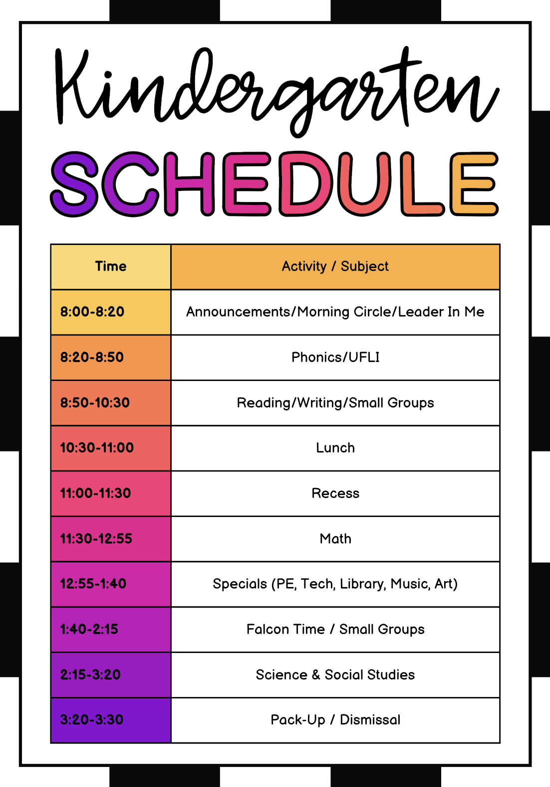
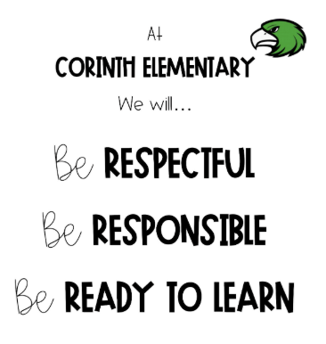
PBIS
(Positive Behavioral Interventions and Supports)
This year in Kindergarten, students will learn and follow the expectations of Corinth Elementary by being Respectful, Responsible, and Ready to Learn—the 3Rs of CE.
To encourage positive behavior, we will use a token system along with the PBIS app to reward students who demonstrate these values. Tokens and points can be exchanged for rewards such as treasure box items, special stickers, pencils, or classroom privileges like Stuffed Animal Day or extra recess.
If a student is not following the expectations at Corinth Elementary, they may receive a minor or major consequence in the PBIS system. This will depend on the severity of the behavior and typically follows several reminders, warnings, or previous communication with a parent.
Please make sure you're signed up for the PBIS app to receive updates. If your child receives a minor or major consequence, their teacher or a principal will reach out to you directly.
Each day, your child will bring home a green Take-Home Folder containing a monthly calendar. Teachers will use this calendar to communicate your child’s daily behavior, either with a positive note or stamp, or with a brief note if any behavior concerns arose that day.

PBIS is a decision-making framework
PBIS Goal: to enhance the capacity of schools to educate
ALL students
4 Elements of PBIS:
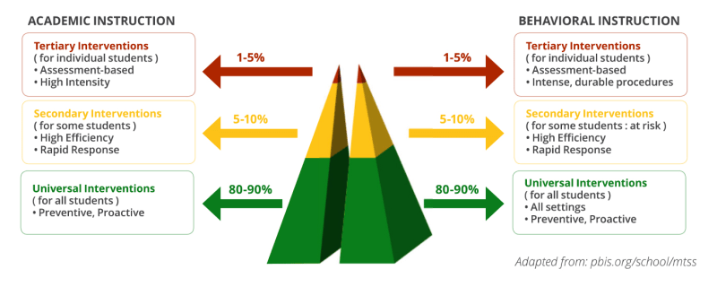
  - Outcomes
  - Systems
  - Data
  - Practice
Create a school culture of:
  - Predictability
  - Positivity
  - Safety
  - Consistency
3-tiered model

Leader In Me
At Corinth Elementary, we focus on the 7 Habits of Happy Kids.
