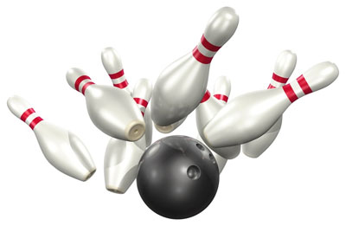
BOWLING “2024-25”
PRACTICE / PRE-SEASON
11/17 | MON |  | PRACTICE | BOWLERO | 4PM
11/19 | WED |  | PRACTICE | BOWLERO | 4PM
11/21 | FRI |  | PRACTICE | BOWLERO | 4PM
11/25 | TUE |  | PRACTICE | BOWLERO | 4PM
REGULAR SEASON
DECEMBER |  |  | OPPONENT | LOCATION | TIME
12/2 |  | TUE | PASSAIC | BOWLER CITY (HACKENSACK) | 4PM
12/4 |  | THU | EASTSIDE | BOWLER CITY (HACKENSACK) | 4PM
12/8 |  | MON | PCTI | BOWLER CITY (HACKENSACK) | 4PM
12/12 |  | FRI | BERGEN TECH | BOWLER CITY (HACKENSACK) | 4PM
12/16 |  | TUE | CLIFTON | BOWLER CITY (HACKENSACK) | 4PM
12/17 |  | WED | PASCACK HILLS | MONTVALE | 4PM
JANUARY |  |  | OPPONENT | LOCATION | TIME
1/5 |  | MON | INDIAN HILLS | BOWLER CITY (HACKENSACK) | 4PM
1/8 |  | THU | BERGENFIELD | BOWLER CITY (HACKENSACK) | 4PM
1/13 |  | TUE | TENAFLY | BOWLER CITY (HACKENSACK) | 4PM
1/15 |  | THU | PASSAIC | T-BOWL | 4PM
1/21 |  | WED | EASTSIDE | BOWLER CITY (HACKENSACK) | 4PM
1/23 |  | FRI | PCTI | BOWLER CITY (HACKENSACK) | 4PM
1/28 |  | WED | BERGEN TECH | BOWLER CITY (HACKENSACK) | 4PM
1/29 |  | THU | CLIFTON | BOWLER CITY (HACKENSACK) | 4PM
FEBRUARY |  |  | OPPONENT | LOCATION | TIME
Note: Schedule dates, sites and times are subject to change. County and State Tournaments to be announced at a later date.
Head Coach: Manuel Rodriguez / manrodriguez@paterson.k12.nj.us / 973-321-1000 ext. 50135
Revised 10/22/2025

