Window Rock USD Gifted Program Referral Form
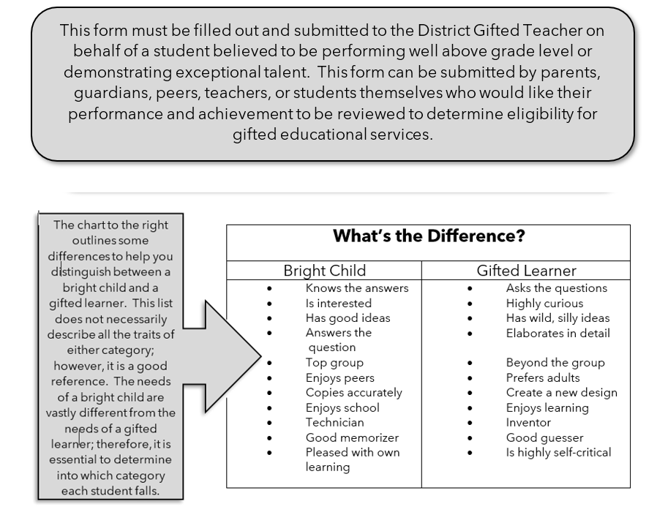

Once this form is received by the District Gifted Teacher, the District Gifted Placement Team will consult and analyze test and performance data to determine if additional assessments are warranted and if the criteria for formal identification have been met. The results of the screening process will be communicated to parents through a meeting, phone call, or letter.
Student’s Name:

Grade:

 | Seldom or Never | Occasionally | Most of the time | Almost all of the time
Learning Characteristics
Possesses a large amount of information about a variety of topics beyond the usual interests of others of the same age or same grade
Reasons things out, thinks clearly, comprehends meaning
Seems to have the same interests as older students or adults in games and reading
Is alert, observant and responds quickly
Makes generalizations and draws conclusions that summarize complex information easily
Can perform more difficult mental tasks than peers
Sees flaws in things, including own work, and can suggest better ways to do job or reach an objective
Has an unusually large vocabulary for their age level and uses terms in a meaningful way
Is able to quickly master and recall factual information
Voluntarily reads a great deal on his/her own
Has a good memory
Develops new skills quickly in many areas
Motivational Characteristics
Exhibits unprompted curiosity. Shows independence in trying to learn more about something
Chooses difficult problems over simple ones
Displays an unusual curiosity about many things
Strives for perfection, very self-critical, not easily satisfied with their own speed or finished product
Is able to work through frustration and maintain focus
Becomes completely absorbed in a current task to the point of blocking everything else out
Is easily bored with simple or routine tasks
Eager for new projects and challenges
Creativity Characteristics
Imagines things to be different than they actually are by wondering “what if?” or “what would happen if?”
Adapts readily to changes; flexible in thought; not disturbed if the normal routine is changed
Uses unique and unusual ways to solve problems
Has many different ways of solving problems
Often offers unusual, unique, or clever responses to a problem
Is not afraid to express opinions, often radical and spirited in disagreement
Is sensitive to beauty in various forms
Sees connections between seemingly unrelated objects, events, ideas, etc.
Finds create ways to escape work
Intrapersonal Characteristics
Is frequently selected by peers for positions of academic leadership
Expresses interest in understanding self and others
Seems to sense what others want and helps accomplish it
Tends to direct others in activities
Challenges authority when sense of justice is offended
Displays a mature sense of humor
Is very concerned with right and wrong, good and bad, and justice
Is interested in many “adult” problems, such as religion, politics, or diversity (more than usual for age level)

In the space below, briefly describe the student’s major interests, hobbies, and other creative endeavors:

In the space below, briefly describe what are your main reasons for referring the student to the WRUSD Gifted Program? (Please Note: Teachers are expected to challenge every student according to his/her abilities. Therefore, a desire to have your child challenged is NOT a reason for Gifted Program referral.)

Please attach any other information which you believe is relevant and would assist us in getting to know the student’s interests and abilities. (Exceptional work samples, academic accolades, outside testing results, evidence of participation in outside educational programs)

