DELAWARE VALLEY MIDDLE SCHOOL
"Where Dreams Become Reality"

THANK YOU, SERVICE MEMBERS: On November 11, DVMS students and staff had the pleasure of hosting many distinguished veterans to be a part of our annual Veterans Day program. This year, we hosted 32 veterans who started their morning with a light breakfast in the Warrior Cafe. From there, they were honored in our assembly that included the Star-Spangled Banner played by the DVMS Orchestra, the playing of "Taps" by student Connor Leighter, various 8th graders presenting the purpose and meaning of Veterans Day, as well as keynote remarks from Gary Williams. Mr. Williams, once again, shared his experience as a veteran and the lessons students can learn from our service men and women. A great day was had by all!

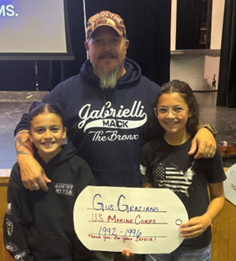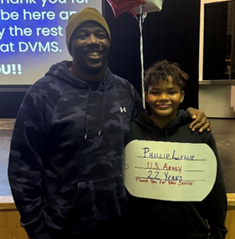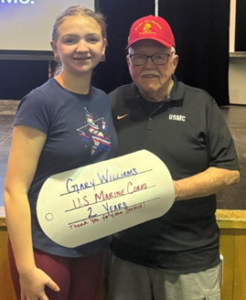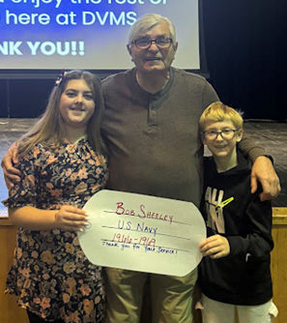

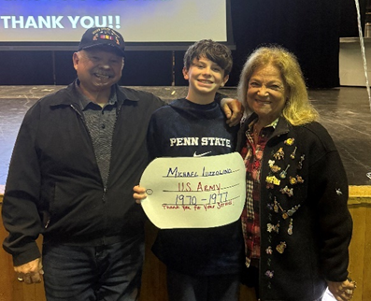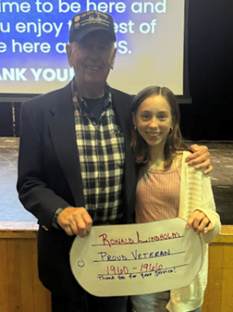

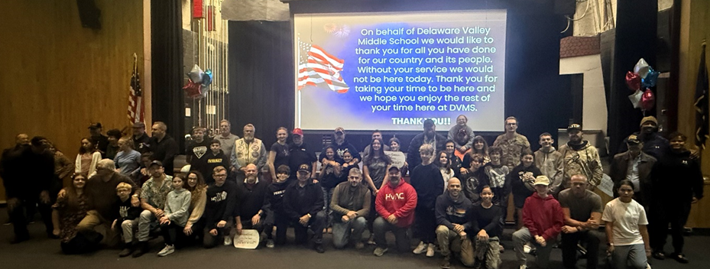
THANK YOU, VETERANS & FAMILIES
HONOR EARNED: On the evening of November 13, the DVMS Chapter of the National Junior Honor Society inducted its newest members! At our induction ceremony, 29 new members were inducted, while 13 current members renewed their membership. This year, our inductees and current members have dedicated nearly 600 hours to improving the lives of those in our community. Individually, they had to maintain a 3.67 GPA, volunteer in the community for a minimum of 15 hours, keep an Outstanding in citizenship, and complete an interview with a DVMS staff member. Much work has gone into becoming a member, and it is no easy feat. This information acts as a testament to the fact that these students are some of the best that DVMS has to offer, as they embody the NJHS Pillars of Service, Scholarship, Leadership, and Character.
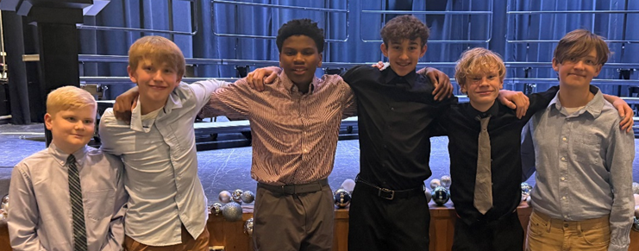
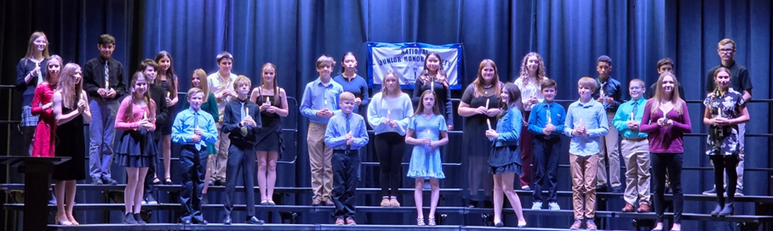
CONGRATULATIONS NJHS 2024-25 INDUCTED MEMBERS

MEETING OUR PARENTS: A combination of parent/teacher conferences was held in the afternoon and early evening of November 25. During the afternoon session, parents and teachers met virtually to discuss how each child is doing in class and to address any success and potential concerns. During the evening sessions, parents came to the school to meet directly with teachers for discussions. Many parents took the time to express their appreciation for the work the teachers are doing with the children.

CONTRIBUTING TO THE CAUSE: Delaware Valley Middle School students and staff participated in the annual Thanksgiving food drive. We were able to provide local families with some support hoping to make their Thanksgiving holiday a bit more enjoyable.

LEGS BROKEN: The cast and crew worked on three stupendous performances of Shrek Jr., the weekend of November 21. The stage and pit music crews created an outstanding environment for our talented actors and actresses. Congratulations to Ms. Tallo, director, Mrs. Sudano, assistant director, and pit band leader, Mr. Bullock and student musicians for a wonderful production. This group worked very hard over the past few months, and their efforts certainly paid off for each of the three audiences!
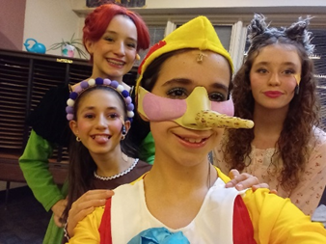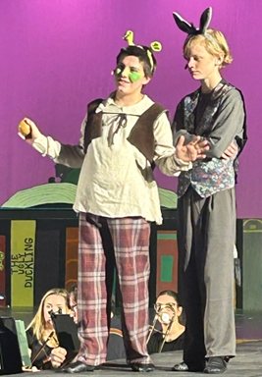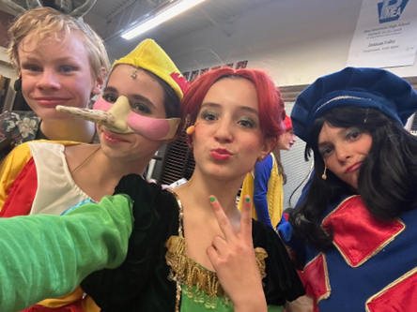
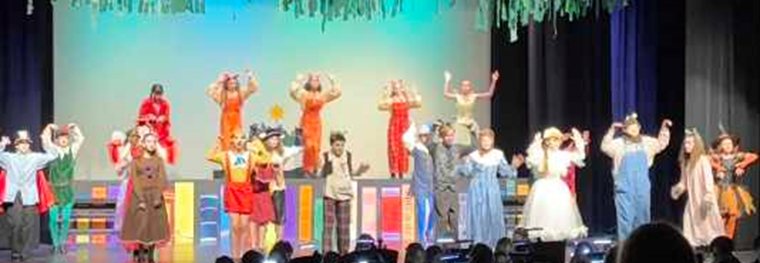
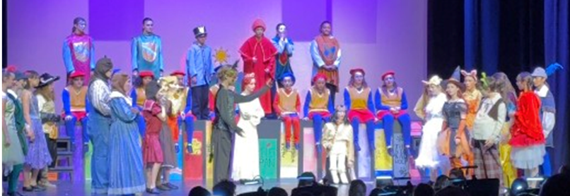
DVMS DRAMA PRODUCTION PERFORMS SHREK, JR.

DVMS WAS FULL OF PEP: The annual DVMS Students vs. Staff basketball game was a highlight of the week, bringing our school community together for a spirited and highly anticipated event. Represented by the 8th-grade boys’ and girls’ basketball teams, the students demonstrated outstanding teamwork, sportsmanship, and determination.
In a competitive and exciting matchup, the students secured a 47–43 victory, marking the FIRST STAFF DEFEAT EVER! Both teams played with exceptional effort, and the event showcased the positive relationships and pride that define the DVMS community.
Congratulations to our student athletes on their well-earned win, and sincere thanks to our staff for participating with enthusiasm and grace. It was a memorable day for all involved and a wonderful celebration of DVMS spirit.

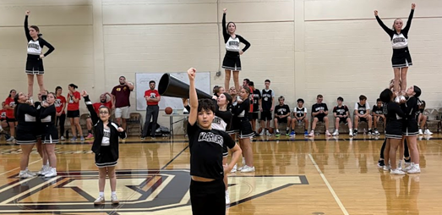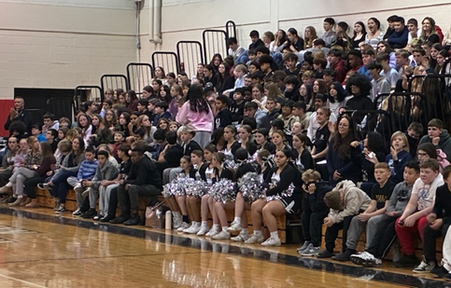
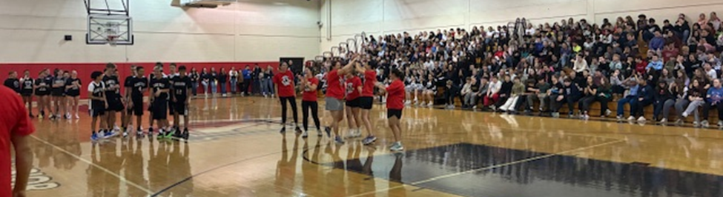
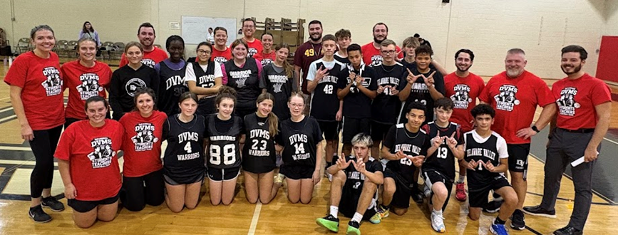
DVMS WINTER PEP RALLY

THE GRANDEST DAY OF ALL: Our 17th annual Grandparents Day was held on Wednesday, November 26 and it was as magical as EVER! 138 grandparents came to celebrate with 78 students. The secretaries decorated the cafeteria creating a very welcoming environment. The tables were decorated with centerpieces created by our art students. Our special guests were greeted by our student ambassadors, and upon entering the cafeteria were entertained by piano players, a cello player, and several songs from our chorus. A continental breakfast was provided by the food service staff and the Warrior Café’. Grandparents and students also each received a photo together reminding them of how special the morning was. This was an outstanding job by everyone involved and remains the best day of the year!
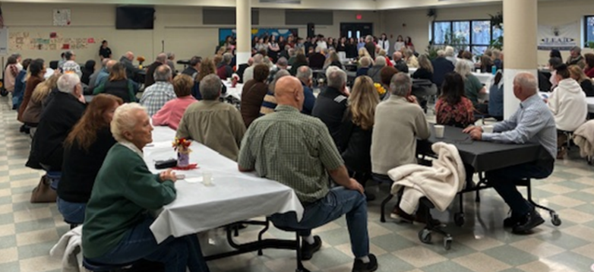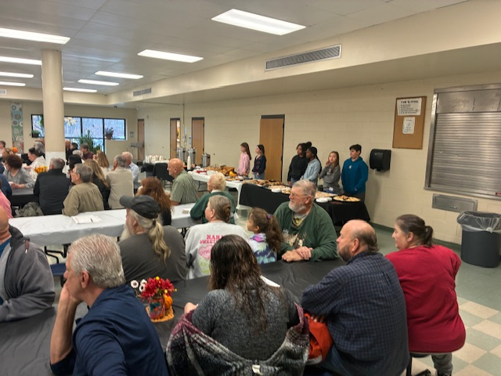
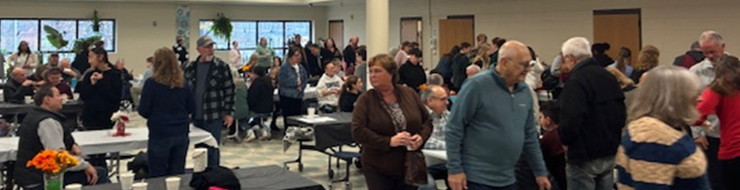
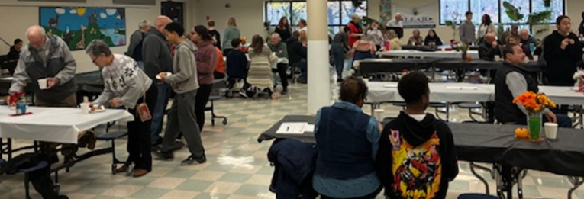
GRANDPARENTS DAY 2025

MUSIC NEWS: The DVMS Band, Chorus, and Orchestra continue to work in preparation for their upcoming concerts. The 7th & 8th Grade Concert will be held on December 8th with a snow date of December 15th. The 6th Grade Concert will be held on December 11th with a snow date of December 15th. The free concerts will be held in the DVHS Auditorium at 6:30PM. Also, thank you DVMS Chorus for singing a few songs for the grandparents during Grandparents Day.

CHIPPING AWAY TO HELP OTHERS SMILE: Mrs. Peters 8th grade FACS students worked together to prepare 100 packages of homemade chocolate chip cookies to donate to the Ecumenical Food Pantry’s monthly community luncheon. All guests at the lunch were able to have a sweet treat to take home and enjoy!
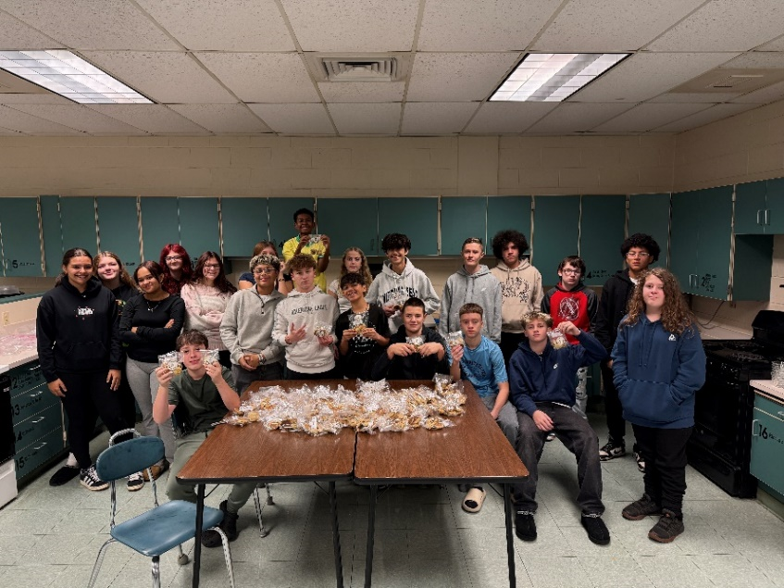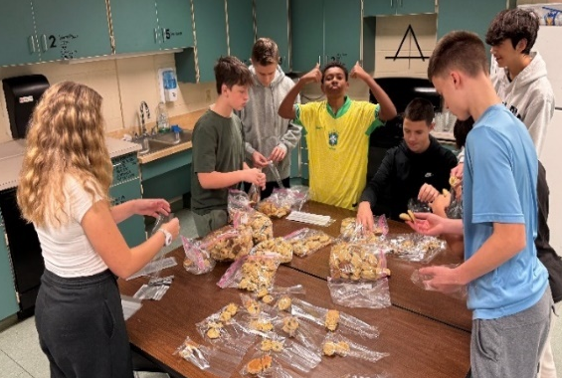
Mrs. Peters GRADE 8 FACS Classes

NEW STAFF HIGHLIGHTS 25-26

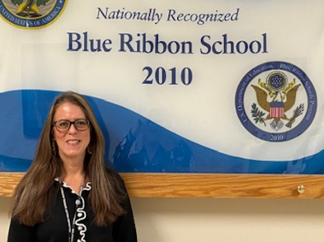
Mrs. Palmer, Financial Secretary
What made you decide to become a secretary?
Since I was a little girl, I loved playing “office” when I went to work with my dad at the steel yard. When it came to get my first office job, I got to sample many different departments at an insurance company during my senior year in high school which led me in the secretarial direction.

What do you love most about working in an office?
Helping to keep the office working smoothly and efficiently is what I strive for and working with like-minded individuals who get the work done but don’t take themselves too seriously.

What do you enjoy doing in your leisure time?
I love gardening, bike riding, going to concerts and enjoying time with family.

Who is your best role model and why?
My best role models have always been and will always be my parents.

NOVEMBER STAFF MEMBER OF THE MONTH

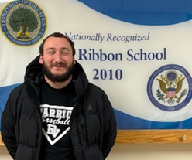
Mr. Sprague, Physical Education Teacher
CO-CURRICULAR STUDENTS OF THE MONTH

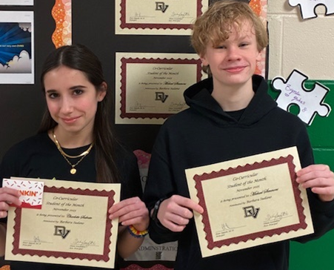
Charlotte Salvato & Michael Simmons

NOVEMBER STUDENTS OF THE MONTH NOMINEES

Logan Tully Liam Woodward Eduardo Arias Adelyn Gamer
Jayde Lazier Zamaya Sarabia Jackson Cabrera Bora Kurtolli
Griffin Navitsky Victoria Benyovszki Matthew Wagner Alexis DeGraw
Chloe Sybrandy Penelope Cordova Darendra Ramnauth Ava-Marie Smith
Brennan Cyrek Mackenzie McAdam Morgan Kulisz Mia Pavinich

NOVEMBER STUDENTS OF THE MONTH

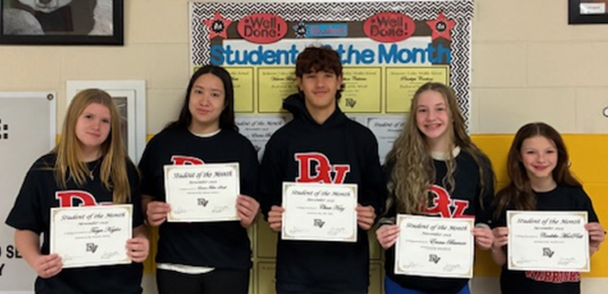
Taryn Kaylor, Emma Fuller-Smith, Chase Kurz, Emma Bauman, Cardelia MacPeek

DECEMBER HAPPENINGS

December 8 Grades 7 & 8 Band, Chorus, Orchestra Concert, HS Auditorium 6:30PM (Snow Date, December 15)
December 11 Grade 6 Band, Chorus, Orchestra Concert, HS Auditorium 6:30PM
(Snow Date, December 15)
December 23 Early Student Dismissal 11:15
December 24 –
January 4 Schools Closed, “Winter Recess”
**Please be reminded that school will resume on MONDAY, JANUARY 5, 2026**
December has rolled in very quickly and the cold air seems to be following. As we approach break, please continue to commit to being the best student and citizen you can be. More than ever, a kind word or gesture goes so far! While Maya Angelou has many famous quotes, one of the most frequently cited is, “I've learned that people will forget what you said, people will forget what you did, but people will never forget how you made them feel.”

We are coming off one of the best months ever and I am hoping the positive momentum will take us all through the remainder of the calendar year. As we head into our winter sports season, I would like to wish all our participants and coaches the very best. Play loose, work hard, have fun! Parents, please continue to encourage your children to get involved.

I would like to extend a very happy and healthy holiday season to all! Enjoy the time off with your family and friends! It is very well-deserved!

Sincerely,

Pete Ioppolo, Ed. D.
Principal

