Hi Washington School Community,

Winter weather is here! To make sure that everyone is prepared, please review the information below.

1. Due to the location of our school, it gets quite windy. Children are expected to go outside for recess when the wind chill is 0 or above, please make sure that they have boots, jackets, caps, mittens, and snow pants.

2. For school closings, an automated text or voicemail from the district will be sent out to guardians. Please make sure your Skyward information is up to date. Other resources you may use are the radio Stations WDLB (AM 1450), WOSQ (FM 92.3), Channels 7, Channel 9, and the district website: www.marshfieldschools.org.

3.) Substitute Information: Interested individuals can work as frequently as they wish, being that there are “unfilled” positions on a regular basis throughout the district. Whether an individual would be interested in subbing only at Washington Elementary, or at any other schools, your help would be greatly appreciated. If interested, feel free to access the following School District of Marshfield Human Resources link to learn more substitute positions.
Substitute Information - School District of Marshfield

Thank you for your time & Happy 2026!

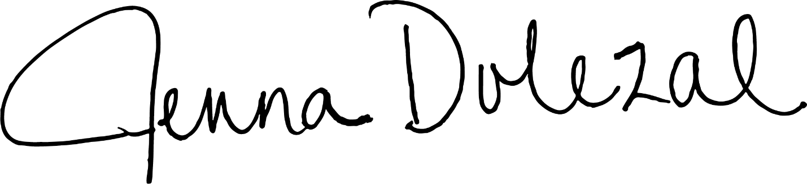
Mrs. Dolezal

