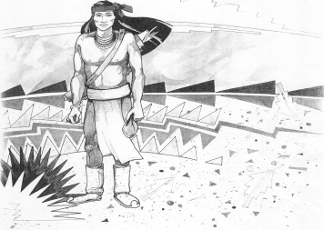
Cochise School District No. 26

5025 N. Bowie Ave.
P.O. Box 1088
Cochise, AZ 85606
(520) 384-2540 (520) 384-4836 Fax
Karl Uterhardt, Superintendent

COCHISE ELEMENTARY SCHOOL DISTRICT NO. 26

Notice is hereby given that the School District Governing Board will hold a public meeting on
December 3, 2025 following the public hearing in the school library, approximately 6:00pm.
The agenda for the meeting is as follows:

I. Call to Order Time _________

- Pledge of Allegiance to the Flag

- Adoption of Agenda Motion ____/____Vote____

IV. Call to the Audience (3 minute limit)

- The Governing Board may vote to go into Executive Session under A.R.S. 38-431.03 (A)(3) to receive legal advice either in person or telephonically, on any item on the Consent or Action agenda

VI. Consent Agenda
- Approve minutes of Regular Meeting of November 5, 2025
- Approve fund balances report for November 2025
- Approve auction of cafeteria dishwasher
- Approve first reading of policy advisories 876-905
- Approve vouchers Payroll #10-11 and Expenditure #2511-2513 Motion ____/____Vote____

VII. Action Agenda
- Approve $500.00 one time pay for all non-teaching employees
Mr. Morales, Mrs. Cavey, Mrs. Williammee, Mr. Dave Brown, Mrs. Retana,
Ms. Acuna, Mrs. Kauffman, Mr. Uterhardt, Mr. AJ Brown (75%),
Mrs. Leksell (40%) Mr. Chris Ochoa, Mrs. Peterson Motion____/____ Vote____
- Approve Classroom Site Fund payment for all eligible teachers in the amount
Of $3,000.00; teachers to include: Mrs. Martinez,, Mrs. White
Mrs. Graham, Ms. Estrella, Mr. Spitzer, Mrs. Hirshouer, Mrs. Mascarenas,
Mr. Joaquin Ochoa, and Mrs. Oscar Motion____/____ Vote____
- Discussion of superintendent’s evaluation Discussion only
- Approval of the superintendent’s evaluation for SY25-26 Motion____/____ Vote____

VIII. Summary of reports about current events
A. Superintendent’s Report
1. December calendar of events: December 10 BB games home; December 16th Christmas concert 6PM; last day of school December 19th, Christmas Break December 22nd -January 2nd, school resumes January 5th.
2. Future board meeting dates: January 7, 2026, February 4, March 4
B. Governing Board member’s report

IX. Adjourn Motion ____/____Vote____ Time ____

