

Attendance is key to school success
Students need to attend school to achieve in school. Families need to send their students to school on time every day. Staff and community members also play a role in ensuring that students attend school – every student, every day. We want all students to attend school at least 90 percent of the time – missing no more than 15 days a year for any reason.

The problem:
In 2023-24, only 79.8 percent of Columbia Public Schools students attended 90 percent of the time. Absenteeism cuts across gender, income, age and cultural boundaries. We
can’t teach students when they are not in school.

Why do students miss school?
The district closely tracks student and staff attendance. In a deep dive into the 2023-24 attendance information, we found of our 5,048 chronically absent students, 1,086 were in our middle school population (grades 6-8) and 2,338 were in our high school population (grades 9-12) accounting for 67.8 percent of our chronically absent students (1,086 +2,338 divided by 5,048 = 0.678288431061807). We also compared this to the previous four years, accounting for the global Covid-19 pandemic.

Looking further into our student populations, we discovered during the 2023-24 school year the most common reasons for absences were Parent Excused (families are allowed up to 7 days of excused absences for any reason) accounted for 38.9 percent; Unexcused Parent Notified (Families have exceeded the 7 days of Excused absences, but called in the absence to the office) accounted for 38 percent; Medical (appointments) accounted for 10 percent of absences; Unexcused Absence (No parent notification was given for the absence) accounted for 9.2 percent; Out of School Suspensions accounted for 3.3 percent; and No Send (usually means the bus was late or didn’t show up) accounted for .5 percent.

The response:
School attendance is a community issue, and it will take the community to solve it. Everyone can play a role in helping improve student attendance – by connecting with students, encouraging them to attend school and making school an interesting and
welcoming place to learn.

The goal:
Research demonstrates, and the district’s strategic plan identifies that attendance is a critical foundation for school success. The district’s goal is for 90 percent of students to
attend school 90 percent of the time by the 2026-27 school year. To achieve this, we will be implementing a district-wide attendance campaign to support school attendance initiatives to assist in meeting the defined checkpoint goals of a four percent decrease in absenteeism in the 2024-25 school year, a three percent decrease in the 2025-26 school year and a three percent decrease in the 2026-27 school year.

Target Audiences:
Three target audiences were identified for this campaign: students, families and staff. Each is affected by and is responsible for student attendance in some way.

Timeline:
The planning period would run from January 2024-early August 2024. The campaign would launch before the district's Jump Start Day on August 19, 2024, and run through the end of the school year, May 23, 2025. The campaign will continue each year until it is determined it is no longer needed.

Every Day Counts
CPS has launched Every Day Counts to:
- Support school attendance initiatives
- Increase district-wide attendance rates
- Increase awareness among families about the importance of attendance
- Engage the community in a shared responsibility model for attendance
- Increase staff commitment to supporting improved attendance

Learn more: cpsk12.org/everyday

Here’s how the Community Relations Department is supporting your school attendance initiatives:
- Parent Messaging: The district uses this communication platform to communicate with staff and families. Parent Messaging allowed the district to send robocalls, text messages, emails and newsletters to families and staff. We will provide scripts and texts for you to read or copy and paste.
- School Social Media: Copy and paste content and images for school and parent organization social media pages. We will also use CPSTV, the district's cable access and on demand channel, to host videos for platform cross-promotion with links for you to share.
- PeachJar: The Community Relations Department will send monthly Attendance flyers to families and track performance.
- Newsletters: The Communication Manager will share specific attendance updates for principals to use in every edition of school Smore Newsletters the Thursday before the weekly message. Of note, schools are required to send at minimum a monthly newsletter to families using SMore.
- School Signage: The Community Relations Department will share posters, table tents and school signage for use around school buildings. Principals can use these as they see fit.
- Every Day Counts Days: CPS is implementing "Every Day Counts Days" on days with historically low attendance. These are often holidays that students assume they have off, the day after a snow day and the days before and after breaks. When we designate a day an Every Day Counts Day, that means there will be more information than usual about being in school on social media and the CPS website. Families and students will also get robocalls reminding them of the date they need to be in school, some of these will be from principals and some may be from local celebrities.
- Updated Data: Continued updated information from the Assessment, Intervention, Data Department with weekly attendance, as well as a more in-depth monthly report that compared that data to the same point last school year.
- Incentive Ideas: The Community Relations Department is keeping a document of incentive ideas that principals can use as they see fit.
- Bulletin Boards: The Community Relations Department is keeping a folder with ideas for attendance tracking bulletin boards.
- Media: In addition to providing information for school board members and district leaders to share in media interviews, the Community Relations Department will use our existing relationships with CoMo Magazine, KBIA, KFRU and COMO 411 to share attendance messaging and reminders. We will also be sharing information in our Quarterly Newsletter.

All resources are available in a shared Google Drive: https://drive.google.com/drive/folders/1LLmt44pBBNdaUNb91tRl0XrdvZmkvjEE?usp=drive_link

Again, all principals will also receive an email on Thursday for the following week with copy-and-paste materials to use as well as suggestions for morning or afternoon announcements.

Major Aspects of Campaign + Key Dates:
Attendance Campaign Launch Event
The need to set the tone for the school year began with targeted back-to-school information before the first day of school on August 20, 2024. The Community Relations Department created and had posters printed and available for schools to use before the open house events and Jump Start Day on August 19, 2024. In addition to the posters, we shared a table tent for schools to place near the student sign-in and sign-out logs. We also shared an attendance tracker in PeachJar and had printed versions available during open house events and Jump Start Day.

On the first day of school in addition to sharing the traditional first day of school information with media, we also shared details on our attendance campaign and links to the resource page on the CPS website.

“Every Day Counts” Days
In order to boost attendance on days with historically low attendance, such as the days before and after breaks and holidays that students may think they have off but do not, such as Columbus Day, Every Day Counts Days were implemented. Using previous attendance data, 17 Every Day Counts Days were identified, specifically:
- Tuesday, September 24 - After Student Day Off
- Monday, October 14 - Columbus Day
- Tuesday, October 1 - Before Student Day Off
- Monday, October 7 - After Student Day Off
- Wednesday, November 6 - After Student Day Off
- Monday, November 11 - Veteran's Day
- Thursday, November 14 - Before Student Day Off
- Tuesday, November 26 - Before Thanksgiving Break
- Monday, December 2 - Day after Thanksgiving Break
- Friday, December 20 - Before Winter Break
- Monday, January 6 - First day back from Winter Break
- Tuesday, January 21 - Day after MLK Day
- Thursday, February 13 - Before Student Day Off
- Tuesday, February 18 - Day after Presidents' Day
- Thursday, February 27 - Before Student Day Off
- Friday, March 21 - Friday before Spring Break
- Monday, March 31 - Monday after Spring Break

We also identified the two weeks before summer break (May 13 – 23) as Every Day Counts Weeks.

Leading up to these days, communication efforts would focus on informing families and students that school was in session on the date via school announcements, robocalls/texts, newsletters and social media. Often, the Community Relations Department would communicate that students may receive incentives for showing up to school.

For our first Every Day Counts Day on Tuesday, September 24, 2024, one lucky student from the elementary school level, middle school level and high school level who attends school will receive a gift such as [basket with tour free movie ticket vouchers from a local movie theater, LevelUp, popcorn, candy, and more]! The Superintendent will deliver the basket to the randomly selected students Tuesday afternoon and we will invite media to attend as well.

Why does attendance matter? Additional suggested messaging for use at any time during the school year:
- When students attend school, they are much more likely to achieve their dreams and enroll in post-secondary education.
- The more involved students are in school, the more likely they are to enjoy school and want to attend school.
- Students who attend school 90 percent of the time are one-and-a-half times more likely to be on-track to graduate on time. They also:
✔ Do better in reading and math
✔ Have fewer suspensions
✔ Are less likely to fail a class
✔ Are more likely to have the credits they need to graduate

How else can you help?
Add the logo to your email signature! If you’d like recommendations for how to do that, please see: https://docs.google.com/document/d/1BoTF6U7acw5TDbujcUV7CxwOIdigJ_X8/edit?usp=drive_link&ouid=114972562750753950243&rtpof=true&sd=true

We are working with our AID department to standardize attendance policies across all schools in the district to ensure consistent tracking of all types of absences, including medical. It is important to record medical absences and have families share medical excuse notes. You can communicate with families to emphasize the importance of submitting medical notes for any absences due to health reasons and if possible scheduling appointment outside of school hours.

What else is the Community Relations Department doing for the Every Day Counts campaign?
Each week, the 5 schools with the largest positive attendance growth will be shared in a variety of ways on a variety of platforms, including the Hero Image on the district home page to celebrate their successes.

Additionally, each week we will recognize the schools that on track to meet the 90/90 attendance goal like how we recognized these schools during our end of the year Admin Council meeting in May 2024.
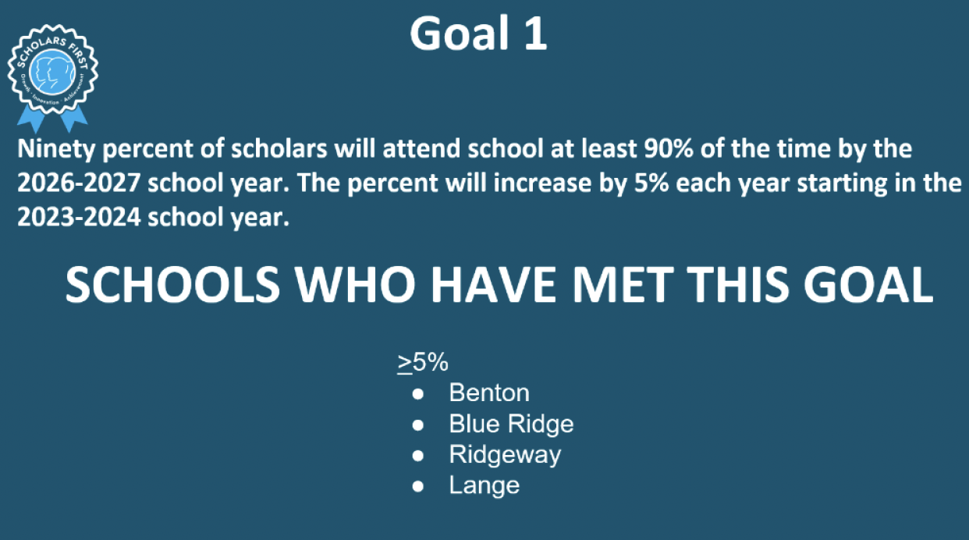
We will also share the On Track Schools in our community Quarterly Newsletter.

Are you on track posts?
“Are you on track?” is a monthly social media post created by the Community Relations Department and shared with schools, aimed at families and students, informing them of the number of days they could have missed at a certain point in the school year to still be on track with attendance. This can also be used in the Smore newsletters.

Where can I access the resources provided by the Community Relations Department?
In addition to accessing the Google Drive, all resources are created in Canva and can be shared to customize as needed.

