CRUZ ECC
Hmieleski ECC School 7 ECC
Media with a Message:
Selecting Appropriate
Content to Watch with Your Preschooler
Presented by: PIRT & Master Teachers December 17th, 2020
Agenda
This Event will Provide Information on:
● Understanding the TV Ratings.

● Suggested TV Shows for Preschool-Aged Children. ● Internet Safety.
● Kids YouTube & YouTube Parental Controls. ● Guided Access on an iPad or iPhone.
● Netflix & Netflix Party.
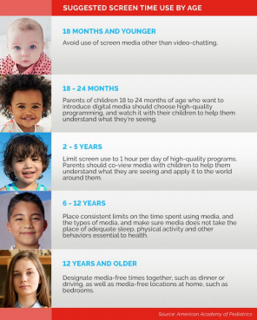
Suggested Screen Time Use by Age
How screen time can influence your child’s behavior

● Childhood Obesity
● Irregular Sleep Patterns
● Behavioral Issues
● Focus & Attention Problems
To read the full article from the National Association for the Education of Young Children, click here:
Technology &
Interactive Media
● Decreased Academic Performance ● Negative Impact on Language Development & Social Skills

Television Rating System Know the Facts:
The television industry designed a TV ratings system – known as the TV Parental Guidelines – to
give parents more information about the content &
age-appropriateness of TV programs.
● Guidelines are modeled after the familiar movie ratings.
● Guidelines apply to most television programs, including those directed specifically to young children.
● The ratings icon and associated content descriptors appear at the beginning of a program in the upper-left corner of the TV screen.
● TV ratings are applied on an episode-by-episode basis.
● Movies and television series may be edited differently based on when and what channel they air.
● Thousands of hours of TV programming are rated every day.

Parental Controls For Television Using Parental Control Tools

● The TV Parental Guidelines work with the V-Chip and other parental control tools to allow parents to block programming they don’t want their children to see.

● V-Chips in television sets and parental control tools offered by cable and satellite providers each work a little bit differently. ● Instructions for programming your television V-Chip can be found in the on-screen menu option or in the television owner’s manual.
Television Guidelines and Ratings
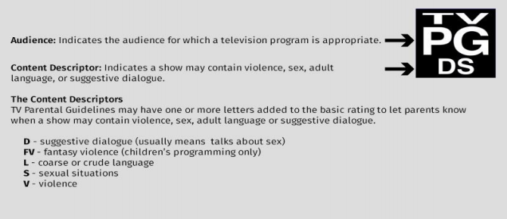
What do the ratings mean?
TV Y This show or movie is for all children.
TV G This show or movie is suitable for all ages but may not be for children.
TV Y7 This show or movie is suitable for children over the age of 7, but parents should watch
first if they want a younger child to watch.
TV Y7 FV This show or movie has a rating of TV Y7, but there is Fantasy Violence (FV), which may be
scary for some children.
TV PG This show or movie should be watched with a parent or guardian.
TV 14 This show or movie is only suitable for people over the age of 14.
TV MA This show or movie is only suitable for adults, or mature audiences.
TV- Y: All Children
● This program is designed to be appropriate for all children.
● Themes and elements in this program are specifically designed for a very young audience, including children from ages 2-6.
● This program is not expected to frighten younger children. Equivalent to EC for video games.
TV- Y7: Directed to Older Children
● This program is designed for children age 7 and above. ● May be more appropriate for children who can distinguish between make-believe and reality. ● This program may include fantasy violence or comedic violence, or may fear children under the age of 7. ● Parents may wish to consider the suitability of this program for their very young children.
TV- G: General Audience
● Most parents would find this program suitable for all ages.
● This rating does not signify that a program is designed specifically for children
● It contains little or no violence, no strong language and little or no sexual dialogue or situations. ● Equivalent to G for movies and E for video games.
Suggested TV shows for your
preschooler
Internet Safety
● The internet allows us to access all sorts of information- some good and some bad.
● If we talk to our children about internet safety, they can get better use of technology.
● With an increasing number of TV channels/ programs and internet usage, it can be hard for parents to monitor what their children are watching.
What is a Guardian’s Role in Internet Safety?
● Guardians play an important role in keeping their children safe from the dangers on the internet.
● It is not always easy to know when and how to step in. It is a caregiver’s job to:
○ Protect Our Children
○ Set Technology Limits
○ Create Rules and Consequences for Using the Internet
Internet Safety Tips Here are some tips to help you help your child when using new technologies while keeping them safe and teaching them to use good judgment:
● Become computer literate.
● Keep devices in a common area & out of their bedroom at night.
● Share an email account with young children. ● Bookmark your child’s favorite sites. ● Spend time together online.
● Use Kid-Safe browsers and set up restrictions in your internet browser’s settings.
● Talk to family and friends about posting pictures of your child on social media.
● Have conversations with your child about talking to strangers online.
● Visit the websites they visit to make sure they are appropriate.
● Remove ads whenever possible.
● Keep private information private!
Kids YouTube & Parental Controls
Age appropriate
YouTube channels to subscribe to:
Blippi Videos
Sesame Street
Plaza Sesamo
Super Simple Songs
Baby First TV
Disney Junior
Guided Access on iPad or iPhone
● Controls what screens a user is allowed to view on an iPad or iPhone.
● Guided Access session can only end when the user enters the passcode to exit.
● Guided Access can help keep children in an app rather than visiting other websites or other parts of the iPad or iPhone. ● Link to Apple Support for iPads and iPhones: Apple Support
Guided Access Tutorial
This is the Home
Screen Button
Netflix & Netflix Party
& Netflix Party
● While Netflix is a service that you are required to pay for, it has access to many child-friendly shows.
● Netflix separates viewers, and always includes an option for Kids Only viewing- this means that children will not have access to inappropriate shows or movies.
● If you have a Netflix account and access to a computer, you can host an interactive viewing party with other family members or friends. ● The benefit of having a Netflix Party would be to give your child the opportunity to socially interact with others while we are still trying to be socially distant.
Additional Resources KidsHealth
Center for Parenting EducationWebMD
Stanford Children’s Health
New York Times

