An Introduction to Teaching
Strategies Gold
Presented by:
Master Teachers
January 14th, 2021

Teaching Strategies Gold Your Child’s Preschool Assessment System
AGENDA:
● What is TSG?
● We will introduce objectives and dimensions used to assess your child's progress throughout the year.
● You will learn what a “color band” is, and what that means for your child’s development.
What is Teaching Strategies Gold?
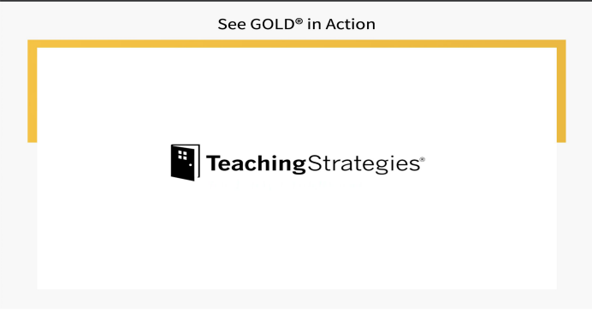See Gold in Action
OBJECTIVES AND DIMENSIONS
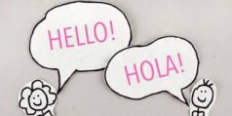
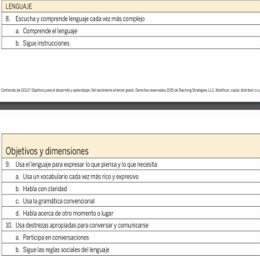
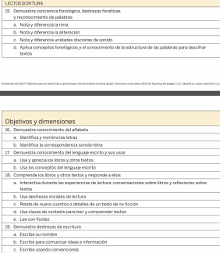
Dual Language classrooms will also use these objectives in addition to the ones we have reviewed

These are the objectives we will assess to see how your child is developing socially and emotionally through observation. See above.
Right now we will look at C.- Interacts with Peers …
The teacher observes and documents your child’s interactions during the school day. He or she chooses the appropriate dimension and will fill in the circle that is aligned with his or her observation.
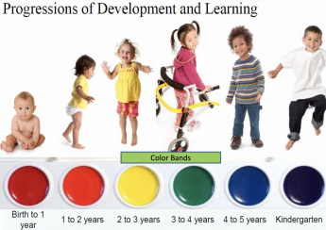
What is a color band and what does it
mean?
Our assessment
system is geared for
children from
stages birth to 3rd
grade.
Understand Each Child’s Needs Based on Developmentally Appropriate Milestones
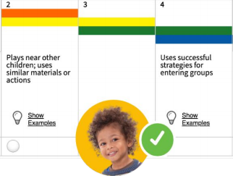
The assessment model used in GOLD® follows widely held expectations for children birth through third grade and enables a whole-child approach to assessment. Color-coded progressions guide teachers toward selecting and adapting activities that support each child’s development and learning. Meaningful reports inform classroom practices and individualized instruction.
How you can help support your child at home
Keep a copy of these objectives and dimensions handy to help scaffold your
child to the next level
● Engage in back and forth conversations with your child ● Incorporate at least 15 minutes of movement into your day ● READ or listen to a story everyday with your child! ● Use everyday experiences to reinforce math skills, language development, and literacy
● Encourage your child to use various writing tools to practice fine motor skills
● Allow for your child to engage in imaginative PLAY!!!!
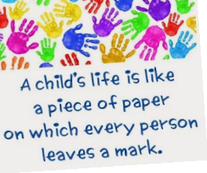Additional Resources for Families

