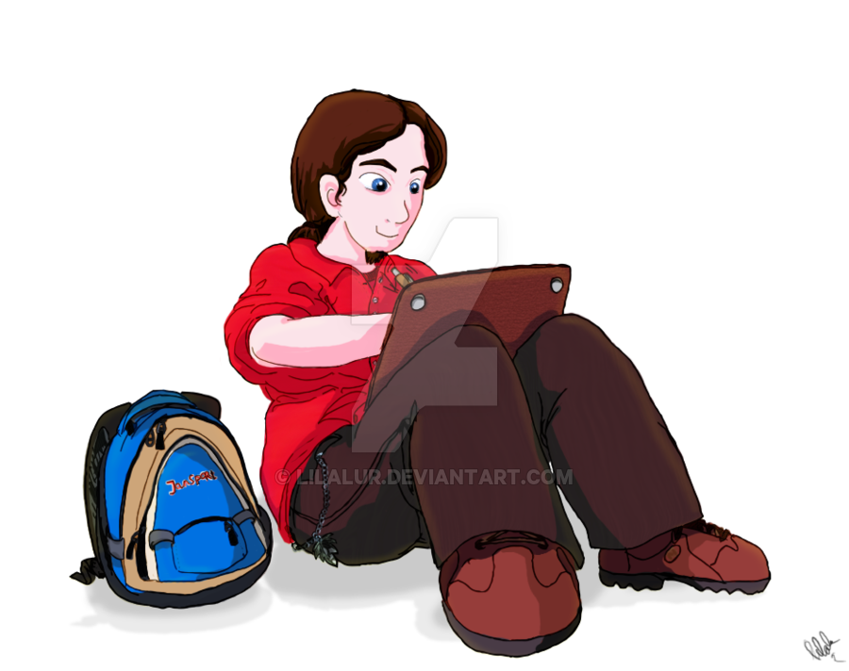
PAHS Athletic Study Hall/Learning Center Hours
Please fill out all requested information

Name of student: | Sport:
Date: | Location of session:
Time started: | Time ended:
Teacher/Librarian signature: | Reason for hours:  If this is for make up hours, include the date(s) you missed.

Please return form to either your coach or Ms. Riggins



