2025-2026
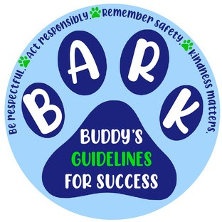

Bardmoor Elementary School

Guidelines For Success
Be Respectful Act Responsibly Remember Safety Kindness Matters

Remember to BARK like BUDDY

Bardmoor Elementary Staff will:

Provide a safe and positive classroom environment that promotes learning and respect.

Help your students achieve their fullest potential.

Provide high-quality curriculum instruction while integrating the use of technology.

Teach self-discipline and student responsibility.

Model what the Guidelines for Success look like in action.

Enforce school and classroom rules fairly and consistently.

Communicate frequently with parents regarding academic performance.

Provide meaningful and appropriate assignments.

Teacher Signature: Date:
Bardmoor Elementary Students will:

Do my best in academic work and behavior. Come to school prepared to learn

Follow all teacher/ adult directions in a respectful manner.

Show respect for myself, peers, adults, and school property.

Know and follow all school rules.

Be responsible for completing homework. Keep materials organized
Be responsible when using the internet, phone and other electronic devices

Student signature: Date:

Conference#1 _____________ (date)
Parent Initials ________ Teacher Initials _____

Conference #2 _____________ (date)
Parent Initials _______ Teacher Initials _____
Bardmoor Elementary Parent/ Guardian will: Assure that my child is at school on time each day. See that my child is in dress code each day.
Do my best to schedule my child's appointments after school.

Provide a home environment that is supportive of school and encourages learning.

Monitor my child's progress and expect my child to complete all class and homework assignments.

Communicate, as necessary, with my child's teacher.

Support school activities such as parent events and conferences.

Encourage students with respect and responsibility while at school.

Parent Signature: Date:

