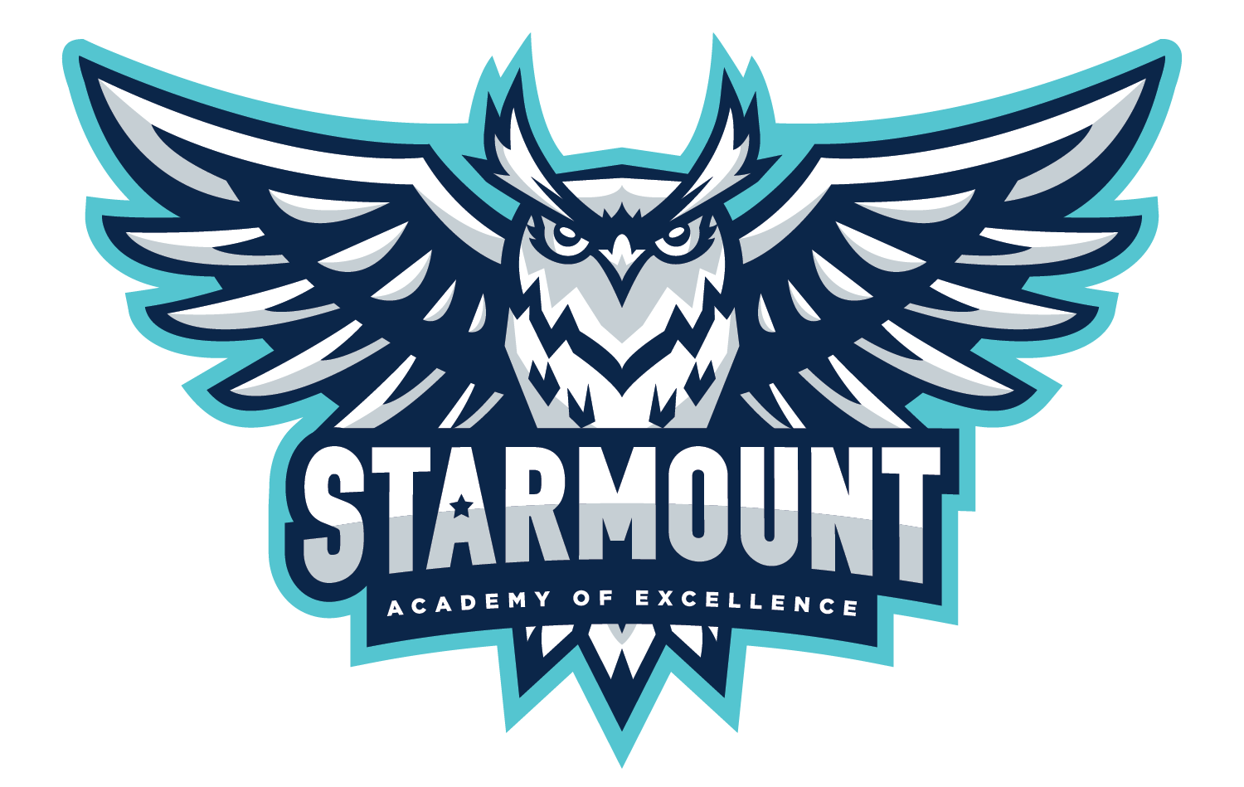

November 2025

Dear Parent/Guardian:

I hope the school year is off to a successful start for you and your child. I am writing this letter to let you know that Starmount Academy of Excellence has been designated as an Additional Targeted Support & Improvement (ATSI) school by the North Carolina State Board of Education. Per ESSA Section 1111(d)(2)(C), schools are identified as ATSI schools in North Carolina because one or more of the following subgroups received a subgroup performance grade score at or below the highest identified CSI-LP school’s All Students group during the identification year; and is on the TSI-CU list for the subgroup(s) for the previous year. Subgroup performance scores are provided for the following subgroups: (1) Students with Disabilities, (2) Economically Disadvantaged, (3) Black, (4) White, (5) Hispanic, (6) Asian-Pacific Islander, (7) Multi-racial, and (8) English Learners. This letter is to notify our parents and guardians of Starmount Academy of Excellence’s intentions to improve educational outcomes for underperforming student subgroups and close achievement gaps for all students.

As an ATSI school, Insert the name of the school is required to develop an Additional Targeted Support and Improvement (ATSI) plan that specifically addresses how the school will improve outcomes for underperforming subgroups. The plan will also include strategies that our district or charter will employ to support Starmount’s improvement efforts. The ATSI plan will address the following areas :

- Standards-aligned Instruction
- Data-Driven Decision Making
- Family and Community Engagement

We have set the following goals for Starmount Academy of Excellence this year:
- The percentage of students scoring Grade Level Proficient (GLP) on Reading End of Grade assessments in grades 3-5 will increase from 16% in SY2024-25 to 35% in SY2025-26.
- The percentage of students scoring Grade Level Proficient (GLP) on Math End of Grade assessments in grades 3-5 will increase from 35.1% in SY2024-25 to 50% in SY2025-26.
- Starmount will increase K-2 Dibels from 61% at or above grade level in the SY2024-2025 to 80% in the SY2025-26
Here are some strategies that we will be implementing to improve student outcomes:
- Utilizing data to ensure individualized small group instruction based on students mastery of the standards
- Quarterly Starmount Parent Academy to share information about how families can help to support their children at home

Also, parent engagement is at the heart of our school improvement efforts. Here are some ways we can work together:
- Ensure that both you and your child know the academic expectations set for your child this school year. A list of learning objectives in student-friendly language is available from your student’s teacher(s).
- Call Starmount at 980-343-3630 if you have questions or concerns about your student or to set up an appointment to meet with a school staff member who will be working with your child.
- Make sure that your child is prepared and attends school each day.
- Monitor your child’s homework.
- Monitor the progress your child is making and attend meetings with your child’s teacher(s).
- Keep track of our website and social media sites https://starmountacademyes.cmsk12.org/
- Volunteer.

Additionally, listed below are a few resources available to help:
- Graduation requirements: www.ncpublicschools.org/gradrequirements/
- K-12 standards in academic subjects: www.ncpublicschools.org/curriculum/
- State student achievement test results: www.ncpublicschools.org/accountability/
- N.C. School Report Cards: https://ncreportcards.ondemand.sas.com/src
We are committed to improving student performance. It is important to remember that just as no single score or grade tells the whole story of a student, neither does it tell you everything about a school's performance or the opportunities that our school provides. The intent of receiving these designations is to improve educational outcomes for all students, close achievement gaps, increase equity, and improve the quality of instruction. We’re excited about this school year and are working to make it a success for your child. Already, we have:
- Helped your child goal set for growing this year
- Held a parent academy and Fall Festival to share with families ways that they can help their child at home
If you have questions about the content of this letter, please contact Principal Collins at kylene.westerholm@cms.k12.nc.us or 980-343-3630
Sincerely,

Kylene Collins

