Announcing the 2024-2025
Jr. High Volleyball
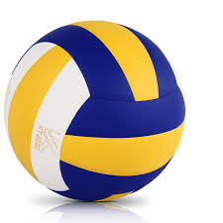
8th Grade Players and Captains

Captains:
Cally Ishman
&
Mia Myers

Players:
Ella Burchell
Anna DiLembo
Mae Esguerra
Randi Flowers
Aryanna Kinard
Mia Lazzaro
Crisanna Lee
Ryleigh Loving
Alicia Martin
Ariyah Moon
Kyliee Mulverhill

CONGRATULATIONS!!!

