Beaumont May News!! 

Beaumont Technical Center
3836 Natural Bridge Ave
St. Louis MO 63107
(314)533-2410
Door 5

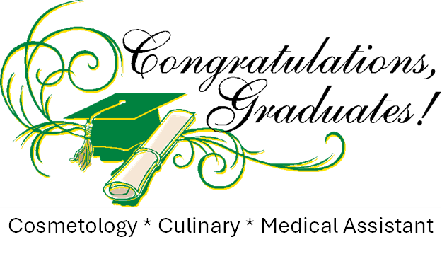

Today we will honor our seniors for their good work, accomplishments, and success!!

Today 04/26/24 at 11am

We are very sorry about the short notice and hope you can make it.

Thank you!

Let’s celebrate Juniors!
Beaumont Technical Center
Junior
Awards Ceremony


Thursday, May 16th 9am for am students.
Thursday, May 16th 1pm for pm students. 16th9am for the am students. Tuesday, May 16th 1pm for the pm students.

On behalf of Beaumont Technical Center, we would like to recognize our students for their ATTENDANCE, achievements, and character.
We are giving a special thanks to our students with %100 attendance, they are the only ones including staff that showed up %100 of the time.
We are proud of them, and we are honored to educate all of them at Beaumont Technical Center.

3836 Natural Bridge Avenue
St. Louis MO 63107
(314)533-2410

Final Schedule and Half Days are as follows:
Monday, May 20 – Exams 1-2 periods
Tuesday, May 21 – Exams 3 -4 periods
Wednesday, May 22 – Exams 5 – 6 periods
Thursday, May 23 – Exams 7 – 8 periods.
May 23, 2024 Last day of school
Friday, May 24 – Make up exams.

It’s HAPPY BIRTHDAY time!!!


Saniah Swinson 05/02
Deria Titsworth 05/07
Nivea Hines 05/15
Angel Mimes 05/23
Jeremiah Arrington 05/24
Dayshia Brandon 05/25
Keonna Williams 05/26

