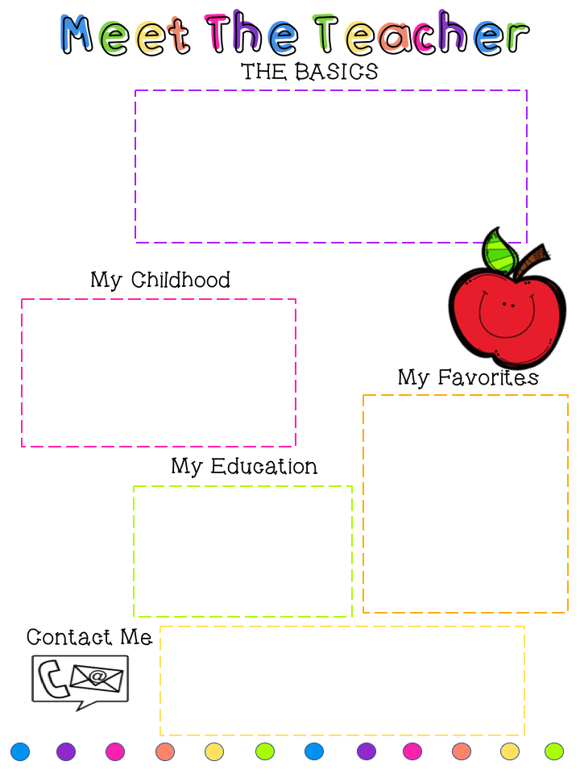
Authors: Mo Willems and RoAld Dahl
Foods: Seafood and Thai
Subjects: Math and Reading
Season: Summer
Holiday: Christmas

Ellen.trinity@slps.org
ellentrinity@yahoo.com
(314)353-8875 (314) 667-9196 C


Madeline is 23
Gwen is 17
Our Dog Charlie

- Bachelor of Science from SIUE
- Masters in Gifted Education
- Certified in Gifted Education



Ellen Trinity
Second Grade Teacher
Betty Wheeler CJA
Ellen.trinity@slps.org

 M
My Family


