Humboldt Academy of Higher Learning’s
Fall-o-ween Costume Parade


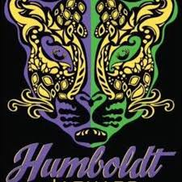
*Pictures will be taken

*Parade in the Gymnasium
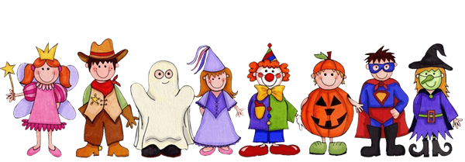

Date: Friday, October 29, 2021
Students only, during the school day

Time: 2:00 -4:00p.m.

Please Bring Your Costumes
Students will be allowed to change into their Costumes after Lunch
(Students may only wear appropriate attire. No costume-face masks because we need to wear COVID protection masks)


For more information: Contact Ms. Belinda Quimby, Principal,
Mrs. Rebecca PriceJones, Family Community Specialist, Mrs. Sierra Blackmon, Secretary. 314-932-5720 or belinda.quimby@slps.org , rebecca.pricejones@slps.org or sierra.moore@slps.org

