Suggested Virtual Learning Books
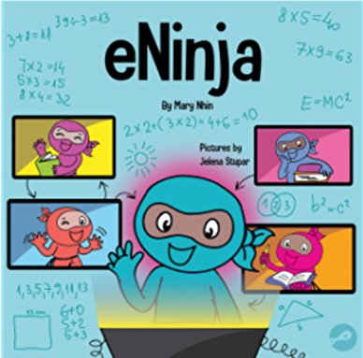
eNinja: A Children’s Book About Virtual Learning Practices for Online Student Success by Mary Nhin
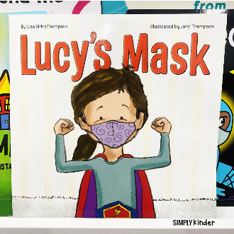
Lucy’s Mask by Lisa Sirkis Thompson
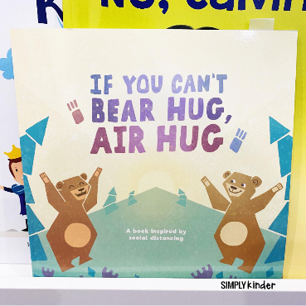
If You Can’t Bear Hug, Air Hug by Katie Sedmak
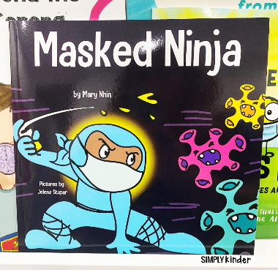
Masked Ninja by Mary Nhin
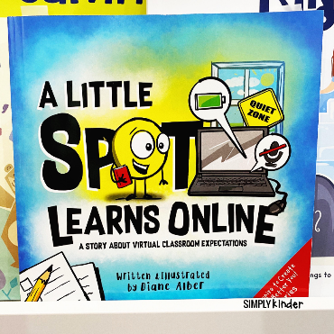
A Little Spot Learns Online by Diane Alber
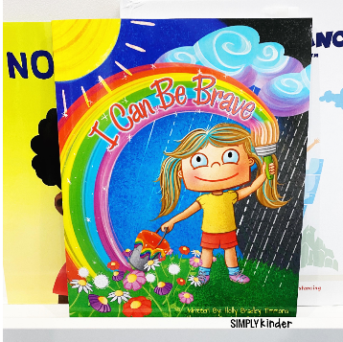
I Can Be Brave by Holly Bradley Timmons

