Resource Packet
Cub Run Counseling
March 13, 2020

- Resources for Talking to Kids About Coronavirus
- Social-Emotional Learning Resources
- Online Learning/Enrichment Resources
- Mental Health Crisis Resources

Resources for Talking to Kids About Coronavirus:

Talking to Children About COVID-19
https://www.fcps.edu/blog/talking-children-about-coronavirus

PBS Kids: How to Talk to Your Kids About Coronavirus
https://www.pbs.org/parents/thrive/how-to-talk-to-your-kids-about-coronavirus?fbclid=IwAR26F2Tmdj3pJN3iv6yAtRyTQoC-AH0P3H1D5QgEqQneurbBPnE_L6Omv30#.XmqzisKG7LA.facebook

Just for Kids: A Comic Exploring the New Coronavirus from NPR
https://m.youtube.com/watch?feature=youtu.be&v=x2EiBzCnn8U

Brain Pop Video About the Coronavirus
https://www.brainpop.com/health/diseasesinjuriesandconditions/coronavirus/

ASCA Coronavirus Resources
https://www.schoolcounselor.org/school-counselors/professional-development/learn-more/coronavirus-resources

Talking to Children About COVID-19 (Coronavirus): A Parent Resource
https://www.nasponline.org/resources-and-publications/resources-and-podcasts/school-climate-safety-and-crisis/health-crisis-resources/talking-to-children-about-covid-19-(coronavirus)-a-parent-resource?fbclid=IwAR2qPcQ9tTi8fF3Ci81foJsGwstAEjhbPt5LLkUCn77w_2rzqWceI_OdFpM

How to Talk to Kids About the Coronavirus
https://m.youtube.com/watch?v=WhVad8ToCiU&feature=youtu.be

Resources to Help You Talk to Your Kids About COVID-19
https://blackwellcounselors.weebly.com/

The Yucky Bug by Julia Cook
https://www.youtube.com/watch?v=ZD9KNhmOCV4

Social-Emotional Learning Resources

Active Screen Time Resource
https://www.gonoodle.com/for-families/

Yoga, Mindfulness and Relaxation Designed for Kids Aged 3+
https://www.youtube.com/user/CosmicKidsYoga

Ultimate Guide to Mental Health and Education Resources for Kids and Teens
https://onlinecounselingprograms.com/resources/ultimate-guide-to-mental-health-and-education-resources/

Help Your Family De-Stress During Coronavirus Uncertainty
https://www.commonsensemedia.org/blog/help-your-family-de-stress-during-coronavirus-uncertainty

Videos for Sleep, Meditation and Relaxation
https://app.www.calm.com/meditate

Progressive Muscle Relaxation for Kids
https://www.youtube.com/watch?v=cDKyRpW-Yuc

Virginia Career VIEW (Vital Information for Education and Work) - Career Information Delivery System for K-8
https://www.vaview.vt.edu/

Interactive Tool for Job Seekers and Students to Learn More About Their Career Options
https://www.mynextmove.org/

Howard B. Wigglebottom Books, Animated Books, Songs, Posters and Lessons
https://wedolisten.org/

Mindfulness Websites/Activities
https://pawsitiveschoolcounselor.files.wordpress.com/2020/02/mindful-resources.pdf

Giant List of Ideas for Being Home with Kids
https://docs.google.com/document/d/1o6kEgCKLn3cyIm2hehhhSTIk7yRTd0C3zx49JS4wwCI/mobilebasic
Character Lessons During the Virus School Closure
https://cardinalrulepress.lpages.co/sunny-side-upbringing-home-school-program/?fbclid=IwAR342r_oWkh4vYKSJVuzMjpnCmo7pNhhRK52IVXt_YmF673teM-yZiIyk-M

Supporting your Children’s Social, Emotional, and Mental Health During the COVID-19 Pandemic
https://confidentparentsconfidentkids.org/2020/03/13/my-kids-school-is-closed-so-now-what/?fbclid=IwAR06lgI5U3ea2sRtlGBKpEVHcLB9LDsDCkoujJKUSecpAZfW2e2AcOYt3Kk

Explore Brain Pop Videos and Activities
https://jr.brainpop.com/health/

Coping Skills Resources
https://depts.washington.edu/hcsats/PDF/TF-%20CBT/pages/cognitive_coping.html

10 Days of Live ‘Choose Love’ Lessons For Parents and Children
https://www.jesselewischooselove.org/blog/2020/03/free-10-day-live-stream-for-parents-and-children/

Kindness Videos
https://www.randomactsofkindness.org/kindness-videos

Online Learning/Enrichment Resources

Education Companies Offering Free Subscriptions Due to School Closings: Amazing Educational Resources
http://www.amazingeducationalresources.com/

Free Personalized Learning Resource
https://www.khanacademy.org/

Free Online Learning Resources for Teaching Your Students Virtually
https://www.weareteachers.com/free-online-learning-resources/?utm_content=1584109337&utm_medium=social&utm_source=facebook#elementary

Library of Resources for Kids, Families, Teachers, and Librarians to Make Sure That Reading & Learning Can Happen Anywhere
https://www.katemessner.com/read-wonder-and-learn-favorite-authors-illustrators-share-resources-for-learning-anywhere-spring-2020/

Kahoot! Offers Free Distance Learning Tools During the Coronavirus Outbreak
https://kahoot.com/coronavirus-remote-offer/

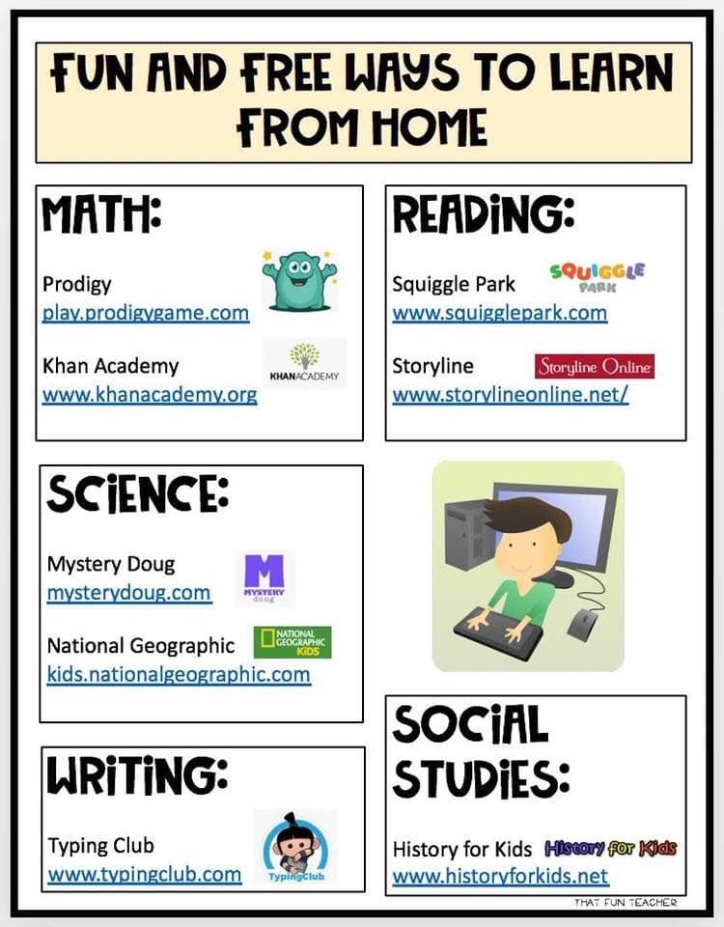
Mental Health Resources

Mental Health Resources and Emergency Services Information (National and Local Crisis Resources)
https://www.fcps.edu/resources/student-safety-and-wellness/school-psychology-services/mental-health-resources-and

