How to access Microsoft Teams using an iPad

Click on the Microsoft Teams app on the iPad.

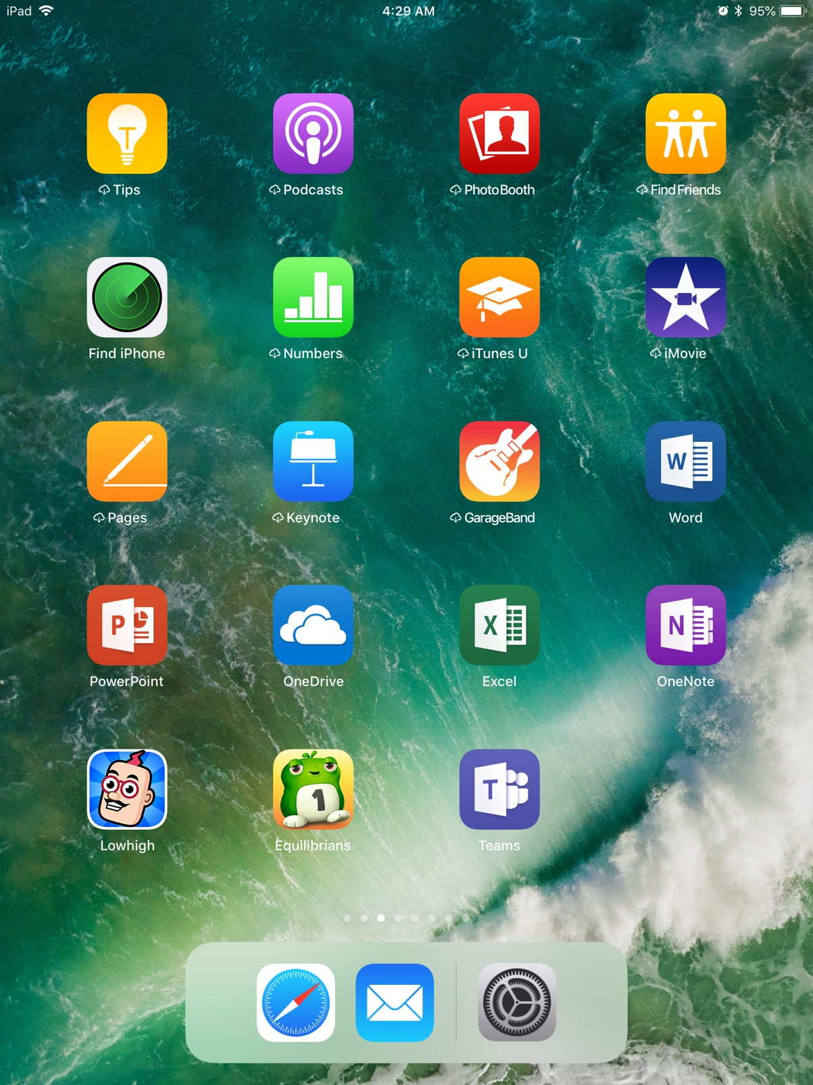

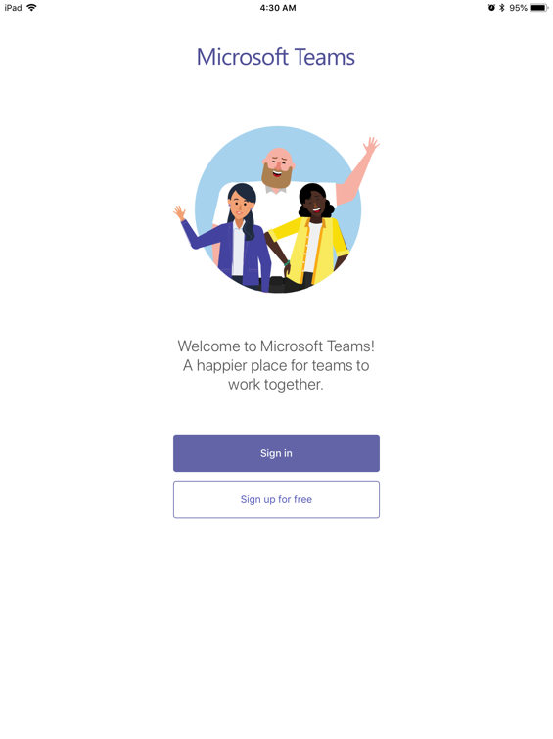
You will get to the login page. You will be asked to sign up or sign up for free. Click Sign in.

You will be asked to sign in using your school Microsoft account. This is the account information assigned to you by your school.

Type your username. Your username is your first initial, first seven letters of your last name, your four- digit id number@slps.org.
For example: jjones1234@slps.org.Click next.

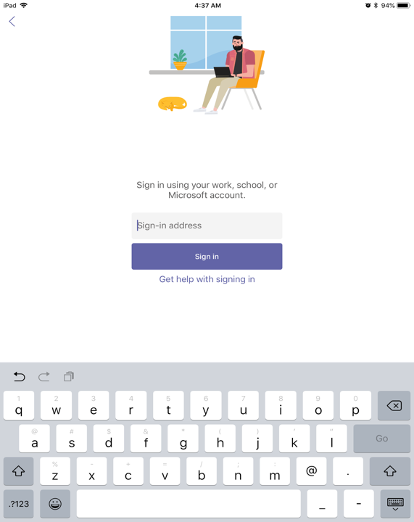

You will take you to your school district’s page. Enter your passcode assigned by your district.

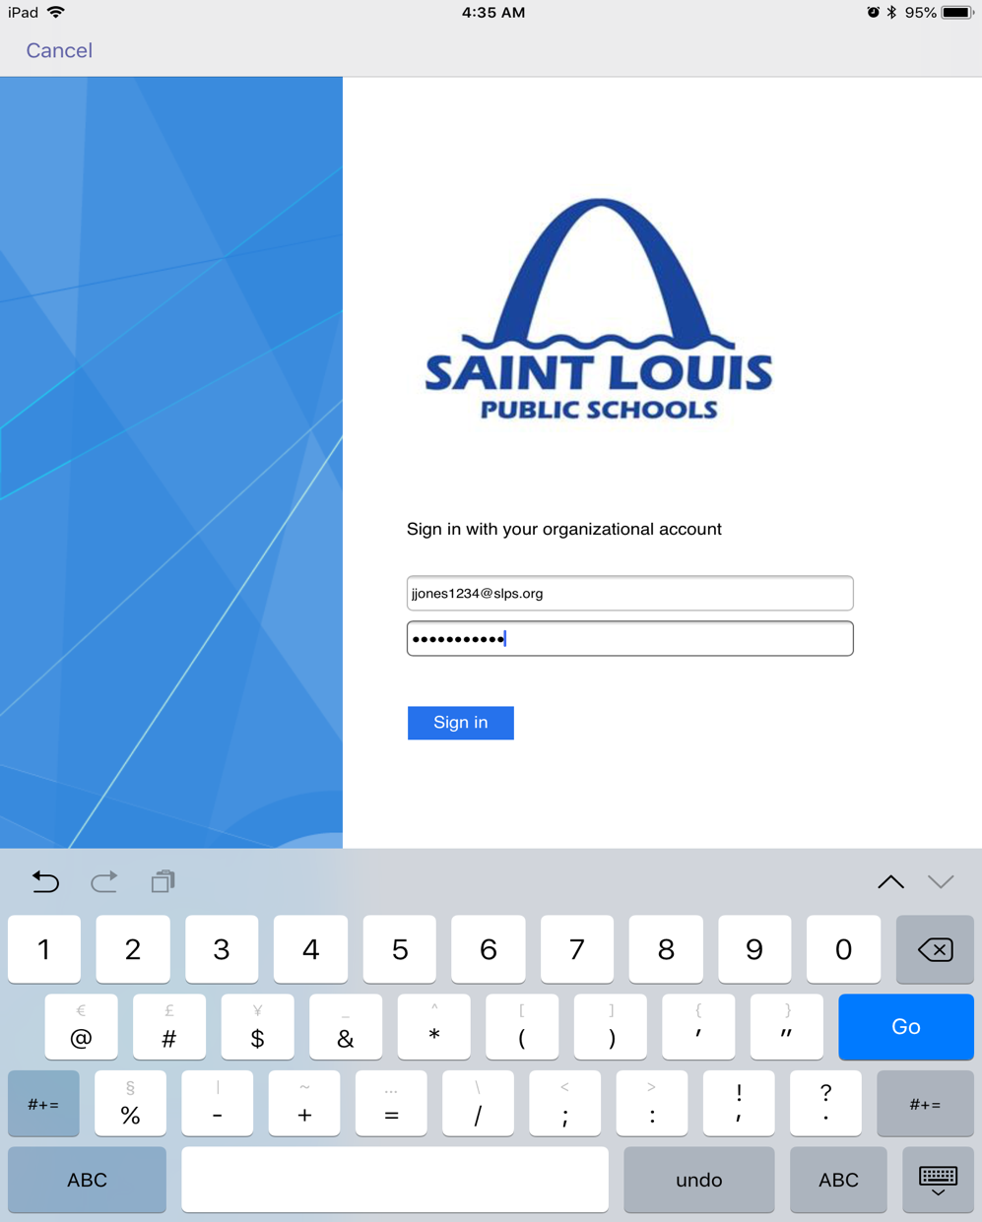

It may ask if you would allow Teams to send you notifications…Click Allow….
It may ask to you if you would allow Teams would like to access microphone…. Click Ok.

It will show you things you can do in Teams. Click next again to access the Teams Dashboard.



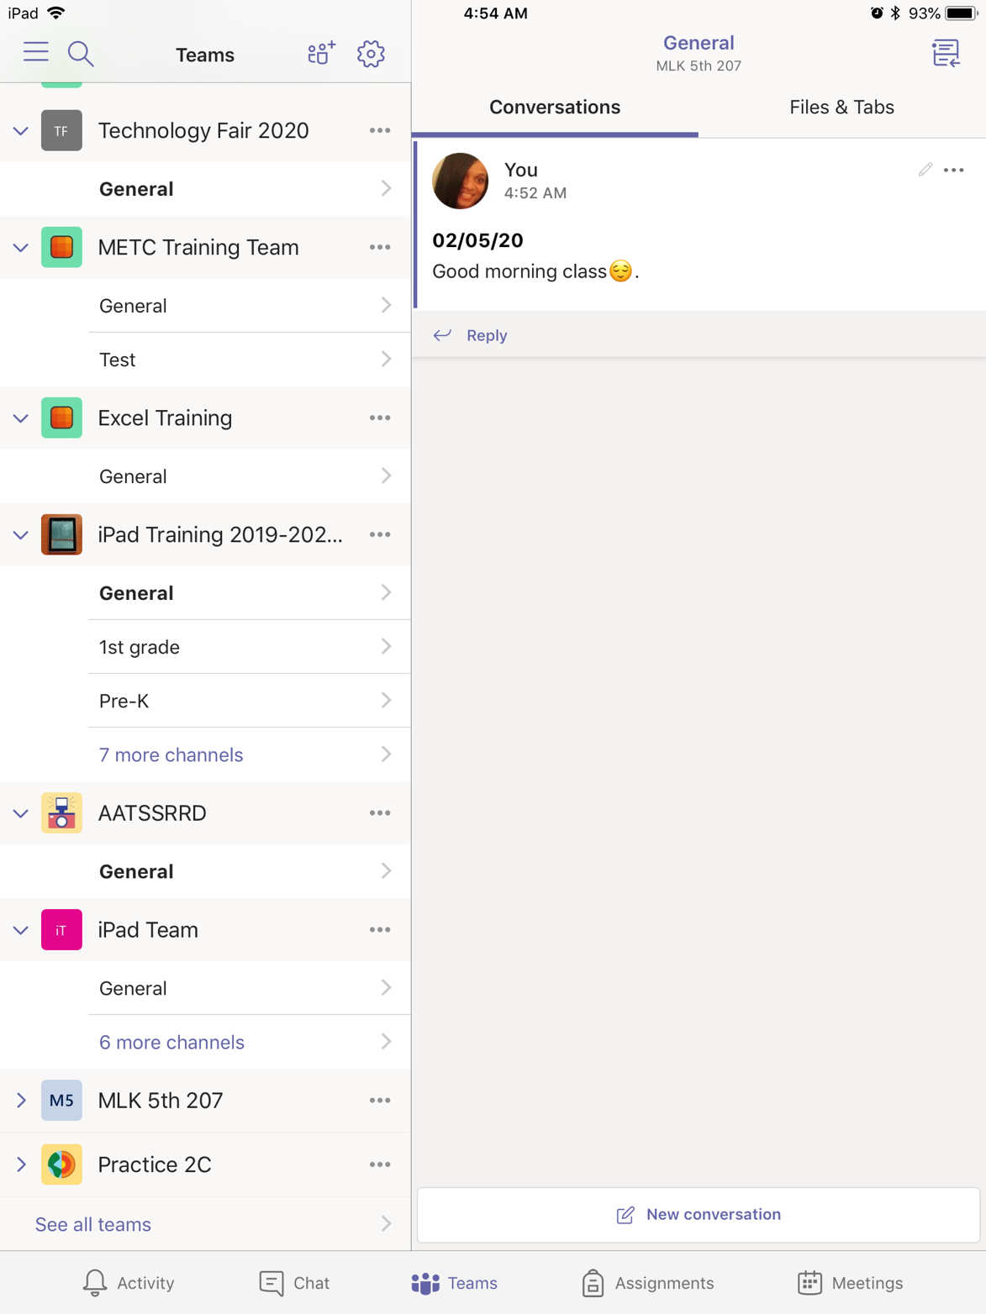
You are now in the Teams Dashboard. Click on the Team that your teacher has directed you to go to. You will find your Teams on the far- left side. See arrow. I have chosen the MLK 5th 207 Team. At the bottom you will see where you can keep track of activities, teams, assignments, and meetings. You can also post a response or new conversation.

