BUSCH MIDDLE SCHOOL
OF CHARACTER
2017-2018
Student Parent Handbook



A NATIONAL
SCHOOL of
CHARACTER
__________________________
Character.org

Table of Contents

Letter from the principal
School core values & mission
Lunch intervention program
Behavior intervention room
Promotion & PTO
School dress code
Incentives & rewards
August 2017
Dear Parents & Students,
Welcome to Busch Middle School of Character. We are excited to begin a new school year. As always our school culture is driven by our core values of RESPECT, RESPONSIBILITY, SELF-CONTROL, DETERMINATION & HONESTY. We have some brand new staff members that I think will be excellent additions to our culture.
Whenever anyone asks me “what is character education?” I always give them the same answer: character education is staff and students working together to become better people and working together to make our community a better place. I hope to model good character for your children and when I fail I will acknowledge it and apologize.
Please join us in this movement where we are all working together using skills such as empathy when dealing with others. Similar to most schools, we have had challenges in recent years with social media. I encourage you to monitor your child’s use of technology and talk to them about what are respectful and appropriate forms of communication.
We are continuing to advance our school by creating a schedule that should be more accommodating to individual student’s needs. We will also continue our training in character education so that we can continue to serve you and your child in and kind and caring manner.
Please take some time to review this booklet as well as the district’s Students Rights and Responsibilities booklet. These will give you an idea of some of the strategies, interventions and incentives we use to keep our school operating safely and orderly.
I look forward to working with you.
Sincerely,
Robert Lescher
Principal
BUSCH CORE VALUES
The students, staff and parents voted for the words below to be our school’s core values. There are many other good words that we have in our everyday vocabulary, but these are the special words that are the most important to us. Working together, the students and staff created our own definitions for them.
RESPECT- showing courtesy and kindness to everyone and yourself, and treating others as you would like to be treated.
RESPONSIBILITY- doing what is expected of you, including when no one is looking.
SELF CONTROL- managing your own actions under pressure.
DETERMINATION- to strive for something, to believe in yourself, to work hard and never give up.
HONESTY-telling the whole truth and being trustworthy and fair; acting with integrity and not deceiving people.

Mission Statement
Our mission at Busch Middle School is to inspire our students to value academic and personal growth through character education and to empower them to become contributing members of our global society.

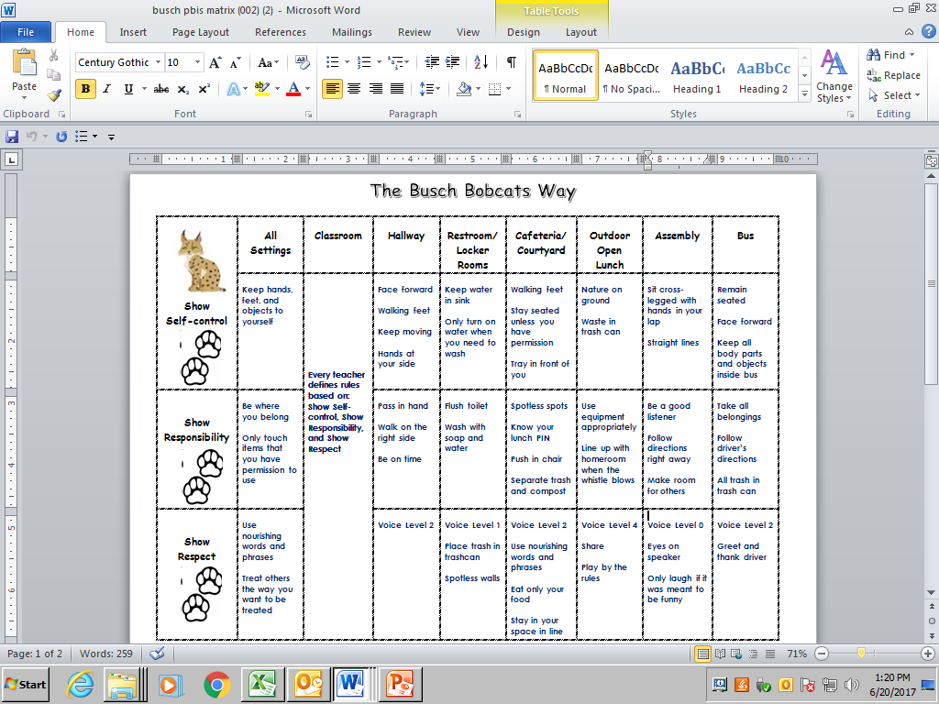
Discipline
In the last three years, Busch has reduced suspensions by nearly 80%. We attribute much of this to character education. That being said, we do have many different interventions that we utilize. We have found that these interventions have helped minimize disruption our classrooms and keep our school safe and orderly. Often students from elementary schools (in-coming 6th graders) say that our school is strict. That may be the case, but we have very few suspensions and very good test scores. We ask parents to support us in our efforts to keep this school moving in the right direction. The next few pages describe some of the interventions we use. In more serious matters we refer to the student handbook.
Lunch Intervention Program
A few years ago we never allowed our students to go outside and play during lunch time. There were too many arguments, sometimes fights, and poor behavior coming back inside. However, we were able to create a program that allows students to enjoy some free time outside if they have demonstrated behavior that reflects our core values. The program is designed to give students an incentive (open lunch), and-if needed- counselling and guidance to get back on track.
Open Lunch
We want our students to enjoy school. Still, the most important factor in keeping the school environment safe is to maintain order. Those students that follow the school rules and demonstrate good character (see our Core Values) get to engage in open lunch. Open lunch is basically recess after lunch. Our theory is that if trust is established between students and staff, we can have more recreational time. YOU MUST EARN OPEN LUNCH! Students begin both semesters having study hall instead of recess. If the student has good attendance and behavior and is showing effort in class, they get to participate in Open Lunch the next week.
Study Hall
Before one can participate in Open Lunch, they will have fifteen minutes after lunch to finish homework or read. Goals to attain Open Lunch the following week include cooperating with the Study Hall monitor, showing effort and good behavior in class (no referrals) and having perfect attendance for that week.
Intervention
When a student is having difficulty reaching Open Lunch, they enter the Intervention program. During this time the student works with the counselor learning strategies to help get them moving forward.
How It Works
At the end of each week, the counselor, principal, and school disciplinarian meet and discuss the progress of each individual student assigned to Study Hall or Intervention. The criteria that the group uses includes teacher referrals (or observed behavior), attendance, and possibly even grades. Every student has an opportunity to move up towards open lunch. If a student assigned Intervention shows enough improvement, they move to Study Hall. If a student in Study Hall shows enough improvement, they move to Open Lunch. If a student in Open Lunch receives a referral, they may be put in either Study Hall or Intervention, depending on their discipline history.
Lunch Intervention Model

Behavior Intervention Room
The purpose of this room is to give students an alternative to suspension. Criteria for this room will most likely be repeated acts of disruption. Mr. Maduekwe is the supervisor and monitor of this program. He may recommend suspension if he feels it is necessary. This program has helped us reduce our suspensions by 78%. The principal (or his designee) will determine who is assigned to the Behavior Intervention Room.
Once a student is assigned to the Behavioral Intervention Room, they are expected to complete all of their school work, a reflection exit packet and any other work that our Behavior Interventionist assigns. Failure to comply could result in suspension. Dress code is required and there is no eating, drinking or sleeping allowed in the room.
Suspension
Our goal is to reduce suspensions. However, once we have exhausted all other options, suspensions can be processed. There are some violations that can immediately lead to suspension. These violations are listed in the Students’ Rights and Responsibilities Handbook. There are also extreme situations in which the principal must recommend a change in site. These are also listed in the district handbook.

Promotion & Retention
Senate Bill 319 requires that the district “continually assesses students with Reading Improvement Plans” to ensure that students are making progress towards attaining proficiency in reading. Students two or more grades below level in reading will be required to attend summer school. Failure to attend summer school could result in retention. In addition to reading proficiency, students must receive passing grades in English Language Arts, Math, Science and Social Studies in order to be promoted. Students missing more than fourteen days of school will be required to attend summer school.
8th Grade Promotion & PTO
Last two years we had 8th Grade Promotion at Ball Park Village. This was arranged by a parent who had help from the NAACP. The year prior we did not have an 8th Grade Promotion, we had a dance instead. This year we are asking the Parent Teacher Organization to determine if 8th Grade Promotion is something that we want to do. Please contact our school’s Family and Community Specialist if you are interested in planning a promotion.
BUSCH MIDDLE SCHOOL DRESS CODE
BOYS
Boys are to wear pants or shorts that are khaki or navy blue in color. Blue denim jeans and athletic shorts are not approved attire except on dress-down days.
Boys are to wear shirts that have collars. This can include polo style shirts or sport or dress shirts. Shirts may be of any color including solids, stripes or plaids. T-shirts or collarless shirts are not approved attire except on dress-down days.
Girls
Girls are to wear pants, shorts, skirts, or jumpers that are khaki or navy blue in color. Shorts, skirts, and jumper lengths must be to the students’ fingertips when standing straight and arms are fully extended at sides. Girls may wear black leggings under skirts or jumpers in cold weather. Blue denim jeans and athletic shorts are not approved attire except on dress-down day. Leggings alone are not approved attire as pants even on dress-down days.
Boys/ Girls
Students may wear non-hooded sweaters or jackets in the classroom during cold weather.

Students must wear closed shoes such as tennis shoes, boots or dress shoes. Students may not wear slides, flip flops or house shoes at any times.

Accessorizing is to be kept to a minimum. Students should not wear anything that would distract the learning atmosphere of the school. This includes large belt buckles, buttons with slogans, ties, bandanas and hats. Students will be asked to remove any item of clothing or accessory that may cause distraction.
Items that caused problems last year were bandanas and head scarves for the girls and hoodies for the boys; these are not allowed. We do not want students to be cold, but hoodies have really been distracting in the past. We are asking for parents support with this.
Belts are encouraged for students. Students whose pants are too big around the waist will be required to use string around their waist to keep from sagging.
Busch T-Shirts
Anything that promotes the school is allowed to be worn. This does not include student generated Busch shirts.
Dress-down days
Students are asked to remember that they are dressing for a work place when dressing for dress-down days. Students may not wear ill-fitting clothing (too tight, short, or low cut). Students may wear dresses, skirts, shorts, pants or jeans of choice. T-shirts are acceptable on dress down days. Girls may not wear leggings as pants. The shoe code remains the same on dress-down days.
Infractions of the dress code will be addressed by the school. Busch will issue alternative clothing for the students to wear on the day the infraction occurs. Issued clothing will be returned at the end of the school day. Repeated offenses will result in further consequences.
Physical Education
Boys/ Girls
Students are to wear blue (any color blue) or black athletic shorts (elastic waist). Stripes down the sides of the shorts are acceptable. Students are to wear a plain, white T-shirt with no pictures or writing. The exception is a Busch t-shirt. This is acceptable wear for PE. In addition, students are to wear tennis shoes and socks for PE class.

MAP DOG
This is a school classic, put on by the staff of Busch. The MAP DOG occurs in the spring after MAP testing. It is a hot dog social that celebrates all the hard work that students put into test taking. In order to attend the MAP DOG, students must have perfect attendance during the MAP test; demonstrate good behavior and effort during the testing process and no referrals the week of the MAP DOG.

School Dances & Other Incentives
We use school dances for both fundraising purposes and as incentives for good behavior. In both cases only students that meet a certain behavioral expectation may attend. The criterion varies for each event, but the criterion is usually set a month in advance. For example:
Qualifications to Attend Dance: students must have 1 or fewer absences, 1 or fewer referrals and perfect attendance for the month of October.

Self-Control Field Trip
Criteria to Attend: Self Control & Respect (No Violence, No Fights)
Last year 280 of our 330 students attended a trip to Six Flags. The criterion was simple: no involvement in violence (or behaviors that could lead to violence) and no disruption during the testing. Violence includes fighting, instigating a fight, threatening, play fighting, slapping, wrestling and pushing.
Any occurrence of these behaviors could eliminate a student from the trip at any point of the year. However, the standards will intensify as the year progresses. In other words, if a student play fights in August, it will be documented but not necessarily held against him/her for the trip (especially if there is considerable improvement noticed on behavior). However, if a student play fights in April, the student could possibly be eliminated from the trip. We try to give warnings, but some acts are simply too dangerous for the school and its climate. Any incident the school considers a fight (actual intended violence), will result in the participants being excluded from the trip, regardless of the time of the year. PLEASE NOTE: striking someone back in retaliation can eliminate a student from the trip. Our goal and purpose of the trip is to reduce fighting. The school bus and bus stops also count towards this incentive.
Students not attending this trip are not being punished. It is still an activity based day in which games are played for most of the day. In fact, some students prefer to stay at the school.
Last year the trip was paid for largely from of the school fundraising account. The biggest contributions last year were the School Dress-Down Days. However, we had to charge $10.00 per student, which we did not do the prior year. The reason for this was a lack of participation in fund raising activities.
Overall, the five years we have done this were extremely successful and fun!

