
We are pleased to offer students at St. Louis Public schools the opportunity to access and utilize the internet through the use of a Hot Spot from Sprint. We have wiped and cleaned the Hot Spot prior to giving them to you. Please continue to disinfect them daily.

How to care for your Hot Spot
Avoid placing weight on the hot spot. Never throw or slide the hot spot. Never expose a hot spot to long-term temperature extremes or direct sunlight. An automobile is not a good place to store the Hot Spot. Keep the Hot Spot away from liquids.
Hot Spot Battery & Charger
The Hot Spot should be charged, using ONLY the provided wall charger. Families are encouraged to setup a safe Hot Spot charging space in their home for their child to charge the Hot Spot daily. Fully charged Hot Spot batteries will typically last ten hours of use. It is the student’s responsibility to charge the Hot Spot daily and ensure it is ready for use each day. Failure to do so may result in the student’s inability to participate in classroom learning activities. If there seems to be a problem with the charger at home, first try moving the charger to a different wall outlet. If the Hot Spot still will not charge or is not working correctly, please email techhelp@slps.org.
Hot Spot Screen
The Hot Spot is an electronic device; handle it with care. While the Hot Spot is scratch resistant, it is not scratch proof. Avoid using any sharp object(s) on the Hot Spot. The Hot Spot screen is glass and is vulnerable to cracking. Never place heavy objects on top of the Hot Spot and never drop your Hot Spot.
Avoid applying liquids to the Hot Spot. The Hot Spot can be cleaned with a soft, dry, lint-free cloth or dry microfiber cloth. Avoid getting moisture in the openings. Do not use window cleaners, household cleaners, aerosol sprays, solvents, alcohol, ammonia, or abrasives to clean the Hot Spot. The Hot Spot can be wiped with a Lysol wipe.
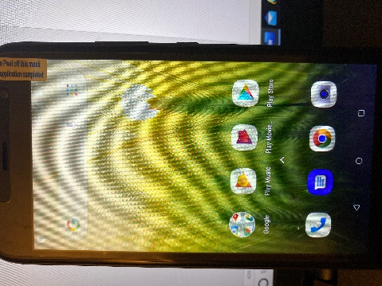
- To Turn on the Hot Spot
- Click on the right side of the phone to turn it on
- Swipe up from the bottom
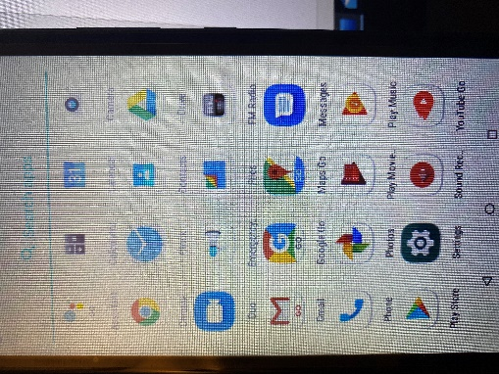

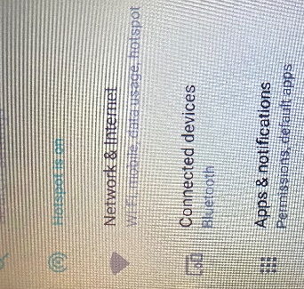
- Click on Settings
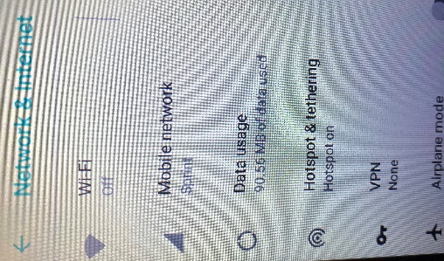
Click on Network & Internet

Click on hotspot & tethering
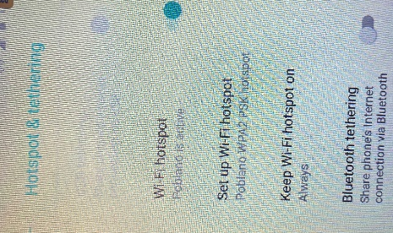
Make sure the WiFi is active
Make sure WiFi hotspot is on “always”
If the screen goes blank, click on the power button on the right again and the screen will turn back on. The Hot Spot will stay on until the battery dies or you turn it off.
After you charge it or turn it back on, follow the directions above – 1 through 4.

