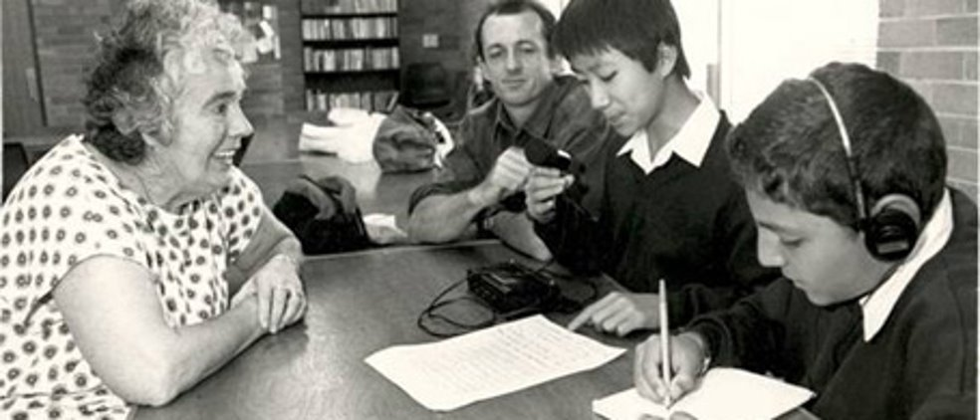

Conducting Oral History Interviews – Quick Tips

What is ORAL HISTORY and why is it SIGNIFICANT?
• collecting stories from participants in the past
• literally brings history to life
• reminds us that people are what history is really all about
• particularly important for “hidden histories”
• creates a new historical artifact

BEFORE your interview:
• contact your interview subject
• learn as much as you can about your subject
• formulate 5-10 questions
• prepare permission
• check your tech!
• create a division of labor within your group
• practice!

The DAY OF your interview:
• check your tech… again! Seriously!
• go over your roles one last time
• remember, comportment counts!
- look well-kept
- be polite… smile!
- be attentive and engaged
- be respectful
• you must be in charge of the interview
• you are there for business: get what you need!
• …but also have fun!

A few GO-TO PHRASES to use during interviews to get richer responses:
• “That is very interesting, can you say more about that…”
• “Can you think of a specific story, or example, that illustrates your point?”
• “What did you think of that? How did it make you feel?”
• What was the lasting impact of that on you, your family, or community?”
• “What do you think I should know that we have not yet talked about?
• “ Is there anyone else you think we should talk to about this topic?”
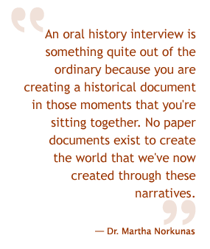
• “Do you have any historical artifacts related to this history that you might be willing to share with us?”

AFTER your interview:
• immediately back-up your interview files
• send a thank-you
• talk about what you each heard in the interview and what you each thought was important.
• re-listen and select best parts of the interview
• edit with iMovie
• reflect in your journal about your experience doing oral history!

A FEW MORE general tips…

• Avoid yes/no kind of questions. Craft questions that are open-ended and invite your subject to tell stories about your topic.
• Be sure that the interviewer and interviewee are at the same eye-level when conducting the interview.
• Think about how you are framing your subject in your camera and what it will look like afterward.
• Be mindful about lighting and how it falls on, or across, your subject. In general, natural light is best. And, you want light to fall on the front of your subject, not from behind.
• Be mindful about sound. Are you close enough to your subject to record their voice well? Are there other environmental sounds that will compete with your subject’s voice on the recording? Remember that voices closer to the recorder will sound louder on the recording than those farther away.
• Make sure other teammates not conducting the interview are not moving around a lot because that can be a distraction to the subject or seem disrespectful. Stay attentive and engaged!
• It is a conversation, and you are in charge. Do not let your subject wander too far away from your topic or become repetitive. When they do, it is the interviewer’s job to interject at a polite moment and steer the discussion back on topic. This is crucial!
• Remember, MEMORY is sometimes faulty, so think critically about what you are hearing from your subject in the interview and compare it and cross-check it with other resources you are looking at on your topic.

