
Rooted in Excellence
160 Years of Omaha Public Schools
OPS History: Part 1
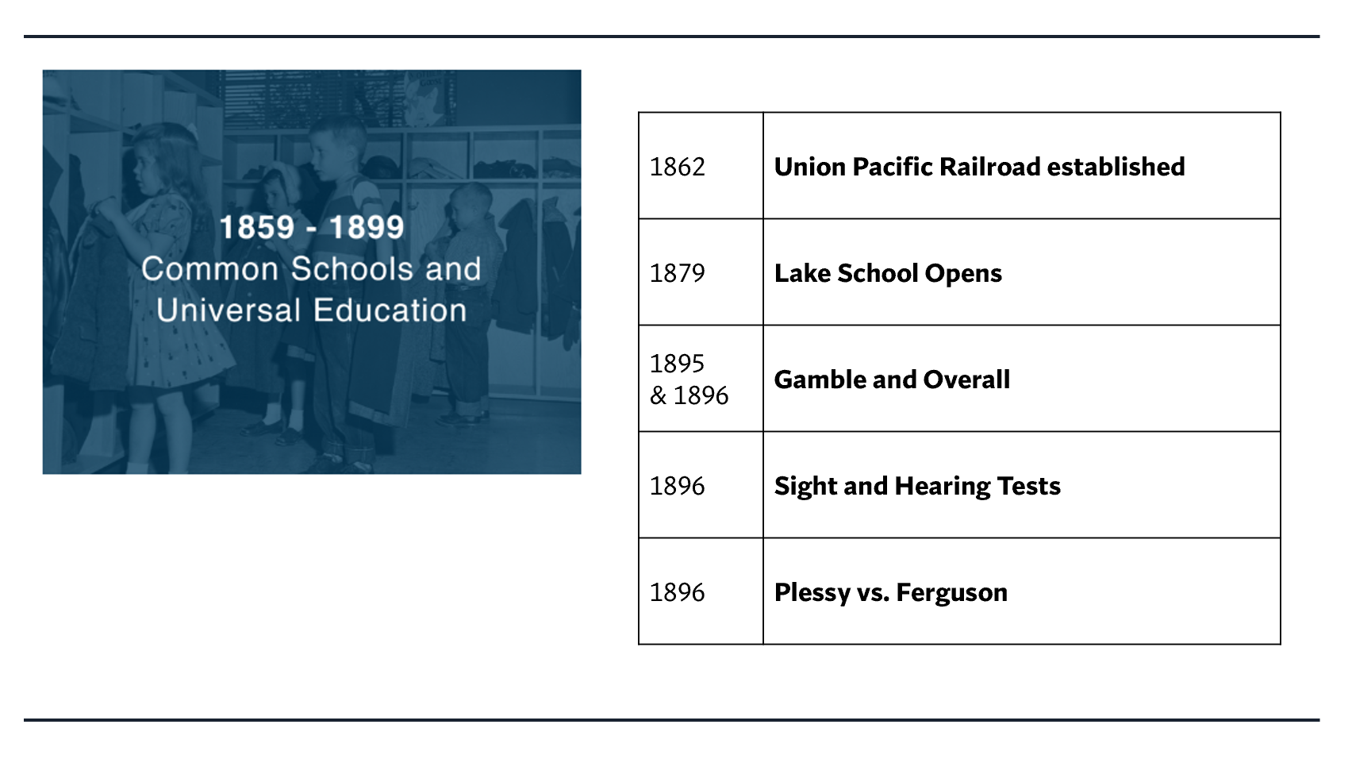
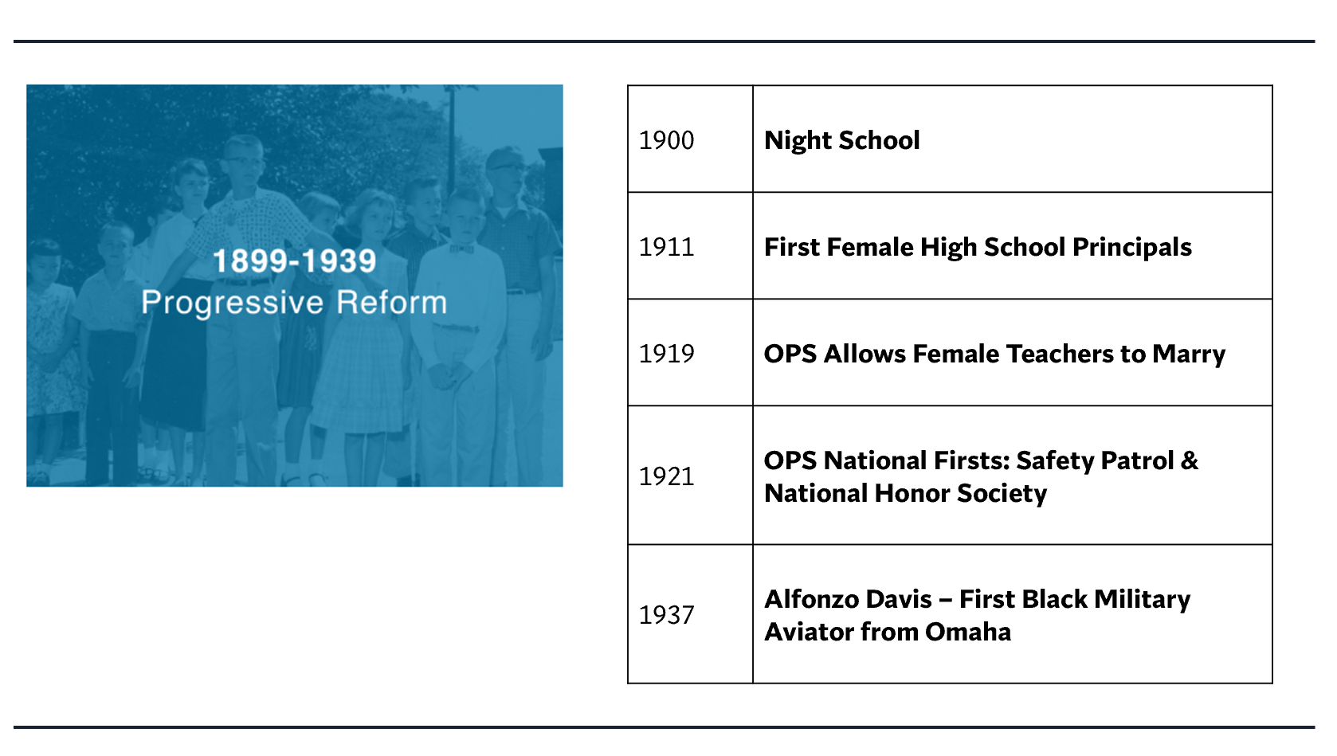
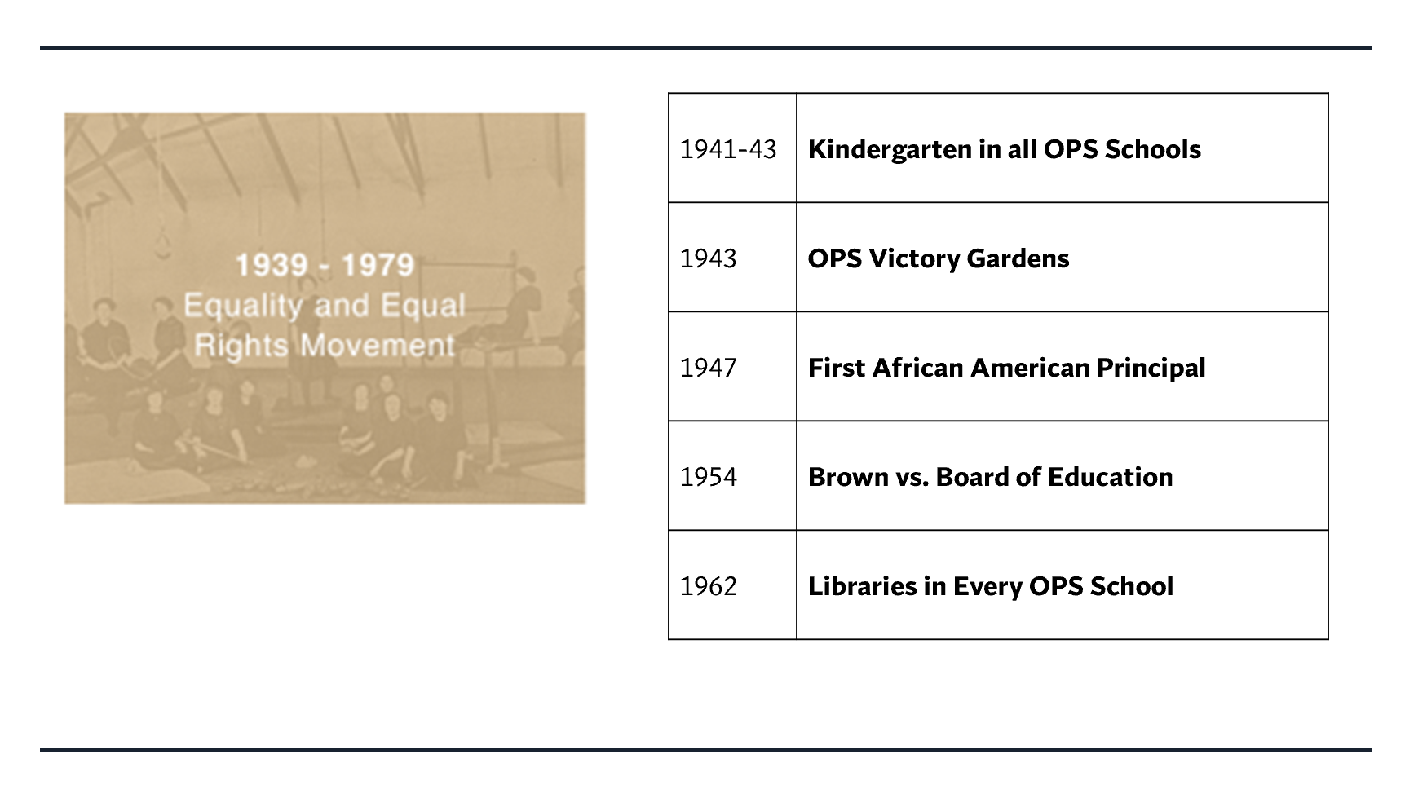
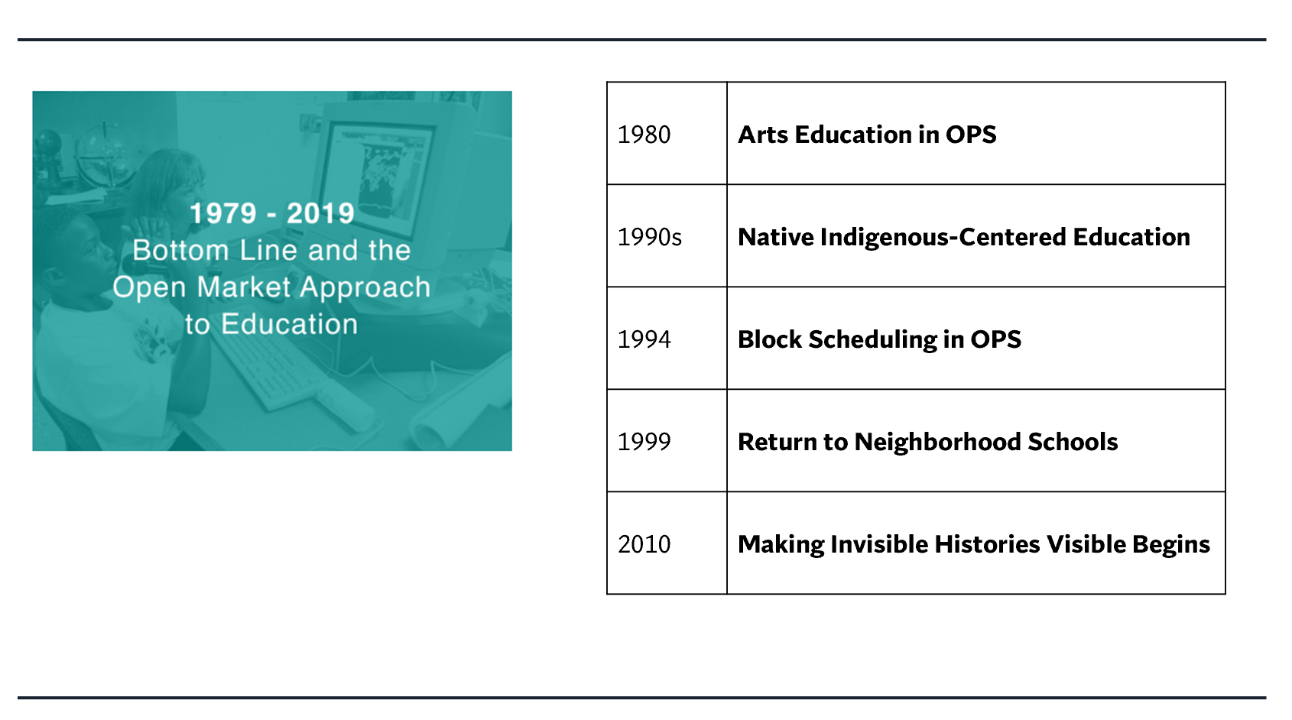
OPS History: Part 2
Claim  Make a claim (explanation, interpretation) about what you see in the mural. | Support  Identify support (things you see, feel, know) for your claim. | Question  Ask a question related to your claim. What isn’t explained?

