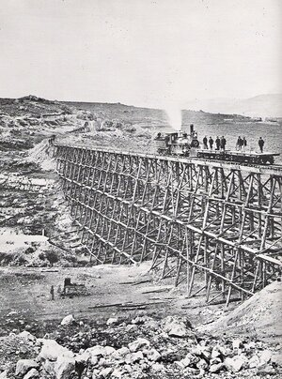
Event: Union Pacific Railroad established

A Union Pacific locomotive pushes two cars on the first transcontinental line.

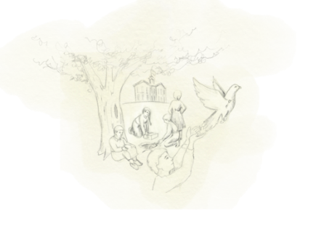
Event: Lake School Opens
Lake School Principal Emma Whitmore and students would plant trees on the school’s campus regularly. At graduation, the class would bury a box with all of their names in it underneath a tree. The key to the box was fastened around a pigeon. The pigeon would fly away, carrying the key to an unknown place.

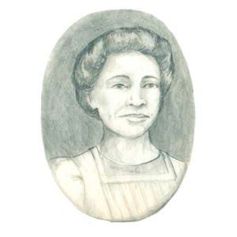
Event: Gamble and Overall
OPS hires Lucinda Gamble, its first African American teacher. After the district hires Lucinda Gamble to teach at Dodge Elementary, Eulalia Overall, another African American teacher, would also be hired by OPS, shortly after Gamble. Upon Overall’s retirement in 1910, there would be no African-American teachers working in the district until 1939.

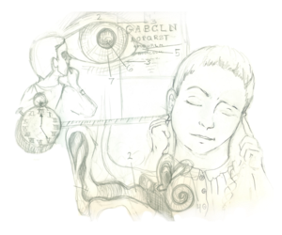
Event: Sight and Hearing Tests

Sight and hearing tests become mandatory in schools.

Event: Plessy vs. Ferguson
This national, landmark U.S. Supreme Court case upheld the constitutionality of "Separate but Equal" school facilities. The court ruled that racial segregation in schools was permissible as long as facilities were equal in quality.

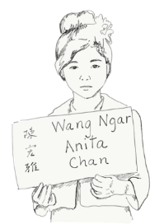
Event: Night School

OPS introduced a night school to educate immigrants.

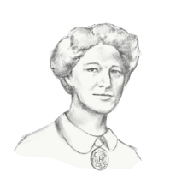
Event: First Female High School Principals
Omaha Public Schools hires its first two female high school principals. Kate McHugh leads Omaha High School
and Mary McNamara leads Benson High School.

Event: OPS Allows Female Teachers to Marry
OPS allows female teachers to marry. Prior to, the district did not hire or retain women who got married.

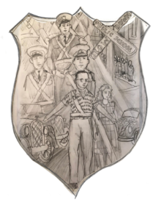
Event: OPS National Firsts – Safety Patrol & National Honor Society
Principal Marie Witzel establishes a safety patrol at Farnam School. It is the first-of-its-kind in the U.S.
An honors society, started by J.G. Masters goes national. The society emphasizes volunteering and high GPAs.

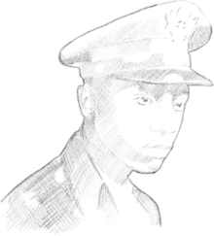
Event: Alfonzo Davis
Valedictorian from Technical High School, Alfonzo Davis, becomes the first black military aviator from Omaha to receive his wings from Tuskegee Field.

Event: Kindergarten in all OPS Schools
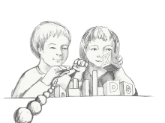
OPS implements kindergarten into all schools.
Emphasis in math, science, shop, physical fitness and military readiness throughout OPS education becomes more of a focus.

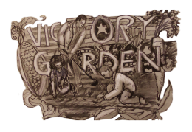
Event: OPS Victory Gardens
OPS plants victory gardens full of vegetables, fruits and herbs in 1943. These gardens were common during WWII. They helped boost morale and supplement food rations.

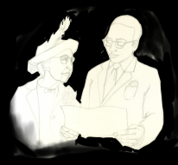
Event: First African American Principal
The district hires the first African American principal, Eugene Skinner. OPS becomes more open to the idea of hiring black faculty to work with students in the city’s predominantly black schools in North Omaha.

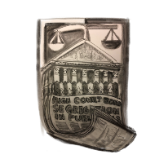
Event: Brown vs. Board of Education
The U.S. Supreme Court releases decision on Brown v. Board of Education in 1954, banning segregation in public schools. These bans on segregation, although not fully enforced at the time, paved the way for new efforts toward desegregation.

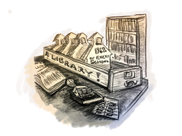
Event: Libraries in Every OPS School
By this year, OPS has libraries in every school, something that only 25% of school districts nationally could claim at the time.

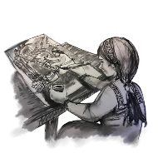
Event: Arts Education in OPS

OPS created Discipline-Based Arts Education curriculum.

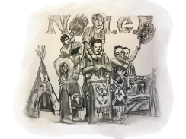
Event: Native Indigenous-Centered Education
OPS establishes the Native Indigenous-Centered Education (NICE) program to meet the needs of students who have been neglected and marginalized in the past.

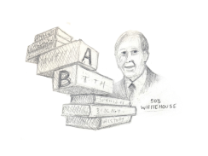
Event: Block Scheduling in OPS
Principal Robert Whitehouse implements a four-period block schedule at Bryan High School. Following its implementation, student failure rates decrease, more students make the honor roll and teachers find new and creative ways to teach.

Event: Return to Neighborhood Schools

OPS returns to neighborhood schools and open enrollment, effectively ending busing based on race. The design was meant to help integrate schools.

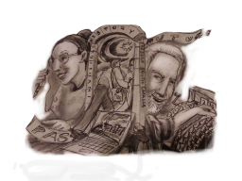
Event: Making Invisible Histories Visible Begins
Since the start of the program, Invisible Histories students have come together every summer with professors, community members and university students to tell stories about the history of different cultures within Omaha.

