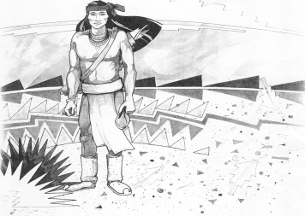
Cochise School District No. 26

5025 N. Bowie Ave.
P.O. Box 1088
Cochise, AZ 85606
(520) 384-2540 (520) 384-4836 Fax
Karl Uterhardt, Superintendent

COCHISE ELEMENTARY SCHOOL DISTRICT NO. 26

Notice is hereby given that the School District Governing Board will hold a public meeting on
November 5, 2025 following the public hearing in the school library, approximately 6:00pm.
The agenda for the meeting is as follows:

I. Call to Order Time _________

- Pledge of Allegiance to the Flag

- Adoption of Agenda Motion ____/____Vote____

IV. Call to the Audience (3 minute limit)

- The Governing Board may vote to go into Executive Session under A.R.S. 38-431.03 (A)(3) to receive legal advice either in person or telephonically, on any item on the Consent or Action agenda

VI. Consent Agenda
- Approve minutes of Regular Meeting of October 1, 2025
- Approve fund balances report for October 2025
- Approve vouchers Payroll #8-9 and Expenditure #2608-2609
- Approve Bootheel Foundation Teacher Grant $2,209.70 Motion ____/____Vote____

VII. Action Agenda
- Mrs. Bernadette Martiniez, 1st grade teacher Discussion Only
- Approve Ms. Katie Hake, Music/Art teacher Motion____/____ Vote____
- Approve one day school closure, Friday, October 10, 2025 Motion____/____ Vote____
- Discussion of Cochise School Performance grade of A for 2025 Discussion only
- Board reminder the superintendent’s evaluation is due by December 31, 2025 Discussion only

VIII. Summary of reports about current events
A. Superintendent’s Report
1. November calendar of events-Volleyball tournament results boys no tournament; girls 4th, No school November 11th for Veteran’s Day and November 26-28 for Thanksgiving. First BB game November 14th.
2. Future board meeting dates: December 3, January 7, 2026, February 4
B. Governing Board member’s report

IX. Adjourn Motion ____/____Vote____ Time ____

