
John F. Kennedy Elementary School-Parent Compact
JFK and the parents of the students participating in activities, services, and programs funded by Title I, Part A of the Elementary and Secondary Education Act (ESEA) (participating children), agree that this compact outlines how the parents, the entire school staff, and the students will share the responsibility for improved student academic achievement and the means by which the school and parents will build and develop a partnership that will help children achieve the challenging State academic standards.
This school-parent compact is in effect during school year 2025-2026.
School Responsibilities
JFK will:
- Provide high-quality curriculum and instruction in a supportive and effective learning environment that enables the participating children to meet the challenging State academic standards as follows;

Our school is engaging students in rigorous academic content including the Core Knowledge Language Arts program, iReady Math, skills-based reading instruction, and a hands-on approach to teaching content in the areas of Science and Social Studies.
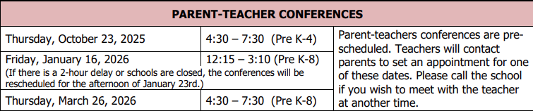
- Hold parent-teacher conferences (at least annually in elementary schools) during which this compact will be discussed as it relates to the individual child’s achievement. Specifically, those conferences will be held;
- Provide parents with frequent reports on their children’s progress. Specifically, the school will provide reports as follows;
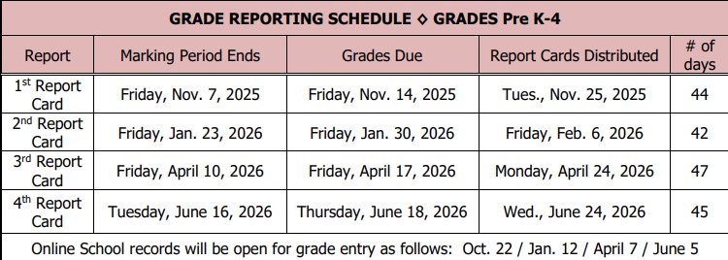
- Provide parents reasonable access to staff. Specifically, staff will be available for consultation with parents as follows;
Staff are always available via email and Teams communication, as well as by phone during non-teaching hours of the school day. Parents may schedule conferences on an as-needed basis during non-instructional portions of the day – 8:25 – 8:45 or 3:00 – 3:25, as well as other times that the teacher is able to make him or herself available.
- Provide parents opportunities to volunteer and participate in their child’s class, and to observe classroom activities, as follows;
Once approved as volunteers, parents are welcome to contact either their child’s teacher or the principal and request an opportunity to engage with students as a volunteer. The school will work to find appropriate opportunities. If parents would like to observe a class, we ask that they contact the principal to find an appropriate time to do so.
Parent Responsibilities
We, as parents, will support our children’s learning in the following ways:
- Monitoring attendance and getting my child to school on time.
- Making sure homework is completed when assigned.
- Engaging in conversation with my child about what is happening in their classroom each day.
- Monitoring amount of screentime that students are engaging in outside of school.
- Volunteering in my child’s classroom and school community.
- Participating, as appropriate, in decisions relating to my children’s education.
- Promoting positive use of my child’s extracurricular time.
- Staying informed about my child’s education and communicating with the school by promptly reading all notices from the school or the school district, either received by my child or by mail, and responding, as appropriate.
- Serving, to the extent possible, on policy advisory groups, such as being the Title I, Part A parent representative on the school’s School Improvement Team, the Title I Policy Advisory Committee, the LEA-Wide Policy Advisory Council, the State’s Committee of Practitioners, the School Support Team or other school advisory or policy groups.
Student Responsibilities (revise as appropriate to grade level)
We, as students, will share the responsibility to improve our academic achievement and achieve the State’s high standards. Specifically, we will:
- Do my homework every day and ask for help when I need to.
- Read at least 30 minutes every day outside of schooltime.
- Give to my parents or the adult who is responsible for my welfare all notices and information received by me from my school every day.
Additional Required School Responsibilities
JFK will:
- Involve parents in the planning, review, and improvement of the school’s parent and family engagement policy, in an organized, ongoing, and timely way.
- Involve parents in the joint development of any schoolwide program plan, in an organized, ongoing, and timely way.
- Hold an annual meeting to inform parents of the school’s participation in Title I, Part A programs, and to explain the Title I, Part A requirements, and the right of parents to be involved in Title I, Part A programs. The school will convene the meeting at a convenient time to parents, and will offer a flexible number of additional parent and family engagement meetings, such as in the morning or evening, so that as many parents as possible are able to attend. The school will invite to this meeting all parents of children participating in Title I, Part A programs (participating students), and will encourage them to attend.
- Provide information to parents of participating students in an understandable and uniform format, including alternative formats upon the request of parents with disabilities, and, to the extent practicable, in a language that parents can understand.
- Provide to parents of participating children information in a timely manner about Title I, Part A programs that includes a description and explanation of the school’s curriculum, the forms of academic assessment used to measure children’s progress, and the proficiency levels students are expected to meet.
- At the request of parents, provide opportunities for regular meetings for parents to formulate suggestions, and to participate, as appropriate, in decisions about the education of their children. The school will respond to any such suggestions as soon as practicably possible.
- Provide to each parent an individual student report about the performance of their child on the State assessment in at least math, language arts, and reading.
Optional School Responsibilities
To help build and develop a partnership with parents to help their children achieve the challenging State academic standards, JFK will:
1. Recommend to the local educational agency (LEA), the names of parents of participating children of Title I, Part A programs who are interested in serving on the State’s Committee of Practitioners and School Support Teams.
2. Notify parents of the school’s participation in Family Literacy Programs operating within the school, the district and the contact information.
3. Work with the LEA in addressing problems, if any, in implementing parent and family engagement activities in section 1116 of Title I, Part A.
4. Work with the LEA to ensure that a copy of the State educational agency’s (SEA’s) written complaint procedures for resolving any issue of violation(s) of a Federal statute or regulation of Title I, Part A programs is provided to parents of students and to appropriate nonpublic school officials or representatives.
Signatures
School: Date:
Parent: Date:
Student: Date:
Please note that signatures are not required.

