Hi Washington Families,
Now that the weather is changing it is important to remember to dress appropriately for recess. Students are responsible for taking care of their outside apparel by hanging up coats and snow pants in their locker, keeping track of their mittens and hats, and making sure their boots are placed either in their locker or right outside of their locker. Washington Staff are effective at helping students be responsible but know it is also important for students to be independent.

Below are the concert dates for the 2025-2026 School Year.
***There will be a form sent home closer to the concert date providing options to sign your students out for the concert and/or for the day (after the concert).

Other reminders:
-No School on November 3for Students. Staff workday
-Grade 6 to MHS Career 11/24 Day 11:15-2:30
-No School on November 27th, 28th, 29th

2024-2025 Concerts/Events
Dec 9th @ 1:45 pm (Kindergarten)
Dec 11th @ 1:45 pm (1st and 2nd Grade)
Mar 12th @ 1:45 pm (3rd and 4th Grade
April 24th @ 8:15 am (5th and 6th Grade)

Thank you for all that you do for Washington School! J
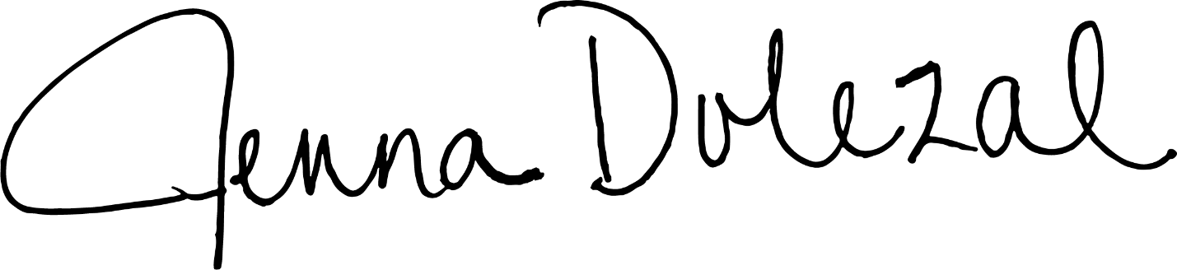
Mrs. Dolezal
Jenna Dolezal, Ph.D. / Principal
Washington Elementary School
School District of Marshfield

